

Space, Range and Merchandising Programme

Ranging Controls

Business System Design
for
Planned Space and Authorisation

Author: D. James

Date: 06/04/2006

Version: 2.0 – Draft

For sign-off:
Janet Smith | Space, Range & Merchandising Programme Director
Danielle Coe | Range Programme 3 Project Manager
Adam Harrison | IT SRM Project Manager
Marcel Borlin | IT SRM Programme Manager
Neil Hollins | Head of Space
Copied for information:
Steve Player | GT&A
Paul Moriarty | Range Programme 3 Project Manager
Mark Croft | Operations Manager
Jamie Awdry | Space Project Manager
Jim Clifton | SRM Planning and Change Manager

Document Control
Date | Author | Change Description | Version
31/01/2006 | D. James | Initial Draft | 0.0
16/02/2006 | L. Toussaint | Tracked feedback added | 0.1
20/02/2006 | D. James | Updated to reflect decision regarding Local Ranging Policy | 0.2
21/02/2006 | D. James | Consolidate tracked updates | 0.3
21/02/2006 | D. James | Issue for sign-off | 1.0
05/04/2006 | D. James | Feedback from sign-off meetings  Simplification of Screen Flows  The addition of indicative screen and report layout  The addition of the standards section  The addition of the non-functional requirements section | 1.1
06/04/2006 | D.James | Consolidated tracked updates from version 1.1 | 2.0

Contents

1 INTRODUCTION 6
1.1 Management Summary 6
1.1.1 Background 6
1.1.2 Project objectives 6
1.1.3 Objectives of this document 7
1.2 Ranging Controls Infrastructure Overview 8
1.2.1 Ranging Controls overview 8
1.2.2 Application overview 9
1.3 Planned Space and Authorisation Overview 10
1.3.1 Deliverables 10
1.3.2 Benefits 10
1.3.3 Assumptions 10
1.3.4 Out of scope 11
1.3.5 Dependencies 11
2 To be BUSINESS PROCESS 12
2.1 Introduction 12
2.2 Process Principles 13
2.3 To-Be Process Overview 13
2.4 New Processes 13
2.4.1 Space changes for a Scheduled Merchandising event 14
2.4.2 UKBE space changes 15
2.4.3 Store plans to change the fixtures allocated to a Merchandising Group 16
2.4.4 Store requests a change to their space target 17
2.4.5 Changing the Visibility of Target Space 18
2.4.6 The assignment of fixtures based on Target Space 19
2.5 The Impact of Target Space and Local Ranging 21
2.5.1 The impact of Target Space 22
2.5.2 The impact of Range Class 23
2.5.3 The impact of a centrally planned Range 23
2.5.4 The impact of the local ranging policy 23
2.5.5 The impact of stocking products within a merchandising group 24
2.5.6 The impact of recording space for a merchandising group 24
2.6 Space, Range and Merchandising events 24
2.7 The Retail Tools 24
2.8 The maintenance of the Target Space parameters 25
3 System Design 26
3.1 High Level Processing overview 26
3.2 Target Space application 26
3.2.1 Request a bulk load from a spreadsheet 27
3.2.2 Create a new change to Target Space 28
3.2.3 Amend a change to Target Space 29
3.2.4 Remove a change to Target Space 30
3.2.5 View changes to Target Space 31
3.2.6 Report any Space Target Changes outside Business Rules 32
3.2.7 Identify any conflicts within Target Space changes 34
3.2.8 Implications for the Corporate Branch Information system (CBI) 35
3.3 Operations Team Ranging Control System - Maintenance Screens application 37
3.3.1 Control whether Target Space is visible to stores 37
3.3.2 Amend the business rules and parameters for the Target Space System 39
3.4 Store facing application 41
3.4.1 Review Space Target by Merchandising group 41
3.4.2 Review Supported Merchandise Plans 42
3.4.3 Change the merchandising group assigned to a fixture 43
3.4.4 Check the local ranging policy 44
3.4.5 Request a merchandising plan 45
3.4.6 Merchandising Group Summary Report 45
3.4.7 Request a Space exception report 46
4 Detailed Screen Design 47
4.1 Ranging Control System -Target Space Component 47
4.1.1 Ranging Controls Menu 47
4.1.2 Upload Menu 48
4.1.3 Select File 49
4.1.4 Confirm Upload File 51
4.1.5 Upload Summary and Exception Report 54
4.1.6 Upload Confirmation 56
4.1.7 Add a single change too Target Space 57
4.1.8 Find an existing Target Space Change 60
4.1.9 Amendment confirmation Screen 64
4.1.10 Validation Against Business Rules - Selection Screen 66
4.1.11 Validation against Business Rules - Summary Screen 69
4.1.12 Validation against Business Rules - List Screen 72
4.1.13 Space Conflict Parameters 75
4.1.14 Space Conflicts List 78
4.1.15 CBI - Merchandising Group Information 81
4.2 Ranging Control System - Controls Component 82
4.2.1 Menu Screen 83
4.2.2 Setting Store Visibility of Target Space 84
4.2.3 Target Space Parameters 87
4.3 Store facing system - Space and Merchandising System (GR) 90
4.3.1 Merchandising Group Summary 91
4.3.2 Supported Merchandise Plans 92
4.3.3 Update Future Fixture details 94
4.3.4 Reserved Merchandising Group List 95
4.3.5 Equipment Type List 96
4.3.6 Local Ranging Policy List 97
4.3.7 Request a Merchandise Plan 99
4.3.8 Request a Space Exception Report 100
4.3.9 Head Office Edit Screen for Space 101
5 Detailed Report Design 103
5.1 Ranging Control System -Target Space Component 103
5.1.1 Upload Summary and Exception Report 103
5.1.2 Upload Confirmation Report 104
5.1.3 Report Target Space Changes 105
5.1.4 Validation against Business Rules - Summary Report 107
5.1.5 Validation against Business Rules - Detailed Report 109
5.1.6 Target Space Conflicts Report 111
5.2 Ranging Control System - Controls Component 112
5.2.1 Report Store Visibility of Target Space 113
5.2.2 Target Space Parameters Report 114
5.3 Store facing system - Space and Merchandising System (GR) 115
5.3.1 Merchandising Group Summary 115
5.3.2 Summary of Mods with Space Exception Issues Report 116
6 System Processes 118
6.1 Target Space and local ranging policy lead-time 118
6.2 Make future changes to Target Space visible to the store 118
6.3 Applying changes to Target Space 118
6.4 Product Mapping 118
6.5 Range to Space processing 119
6.6 Cascading Merchandise Plans 119
6.7 Commercial Range Support Tool (CRST) 120
6.8 Pre-Ranging 120
6.9 Prospace 120
6.10 Corporate Branch Information System 120
6.11 CR Automation and Retail Tools 121
6.12 Data Warehouse 121
6.13 CRS Merchandise Plan Coverage Report 121
6.14 Hard-lines allocation (MM) system 121
6.15 Range ODS 121
6.16 Stock Record System (SRS) 122
7 SOLUTION ISSUES & RISKS 123
7.1 Risks 123
7.2 Issues 123
8 Standards 124
8.1 Screen & Report Design 124
8.2 Error Handling 124
8.2.1 Error Codes 124
8.2.2 Message Handling 127
8.3 Login & Security 127
9 NON-FUNCTIONAL REQUIREMENTS 128

APPENDIX A ABBREVIATIONS
APPENDIX B DEFINITION OF TERMS

INTRODUCTION

Management Summary

Background
The current core Space, Range and Merchandising systems are having difficulty coping with the demands placed upon them by continued expansion of the business. Those difficulties include more flexible and varied ranges required for stores, a higher level of planning sophistication and an increased number of stores and formats.

The business is currently developing a new Ranging System to replace the existing tools and spreadsheets, thus removing the constraints and supporting future growth. To support the new ranging systems and other relevant developments within this area the Space, Range and Merchandising Ranging Controls will create an infrastructure, which will facilitate and support all current and known future Space, Range and Merchandising activities.

A series of projects within the Ranging Controls are planned to deliver the infrastructure required to support the new Ranging System and other systems

The Planned Space and Authorisation project is required to enable changes to the Space Target to be loaded into the system and made available to other processes and systems. The project will enable multiple future-dated changes to space targets to be managed, for every store/merchandising group combination. This information is required to determine the local ranging policy for stores, for each merchandising group, and will be used in the Supported Merchandise Plans and Ranges Matrix, to define the relationship between space and range class.

There is also a need to make multiple planned changes to space targets visible to stores to enable management of scheduled events and UKBE work in store.

Project objectives
Planned Space and Authorisation will be one of the core components of Space, Range and Merchandising, Ranging Controls. This set of projects was initiated to support the following objectives:

- To support the new ranging system, Assort
- To maintain all Ranging Controls settings and controls in one location
- To provide the ability to create changes in the Ranging Controls that will become effective at a future date
- To move the Ranging Controls legacy IT systems to new technology
- To ensure that changes to the Ranging Controls are simple for users to manage

Within the Ranging Controls and to support these goals, Planned Space and Authorisation has the following objective.

- To create a process to upload and make visible to the Centre and to stores multiple future-dated planned space changes for any store/merchandising group combination
- To allow store space to be assigned to the correct merchandising group based on the agreed local ranging policy and the space target

Objectives of this document
This document describes the Business System Design for Planned Space and Authorisation, which is part of Phase B of Space, Range and Merchandising, Ranging Controls.

This document has 2 main purposes:
- To facilitate the business system sign-off with the business
- To enable progression to the technical system design.

Sign-off for this document is required to ensure that the system design and final configuration will support the proposed processes and fulfil the business requirements.

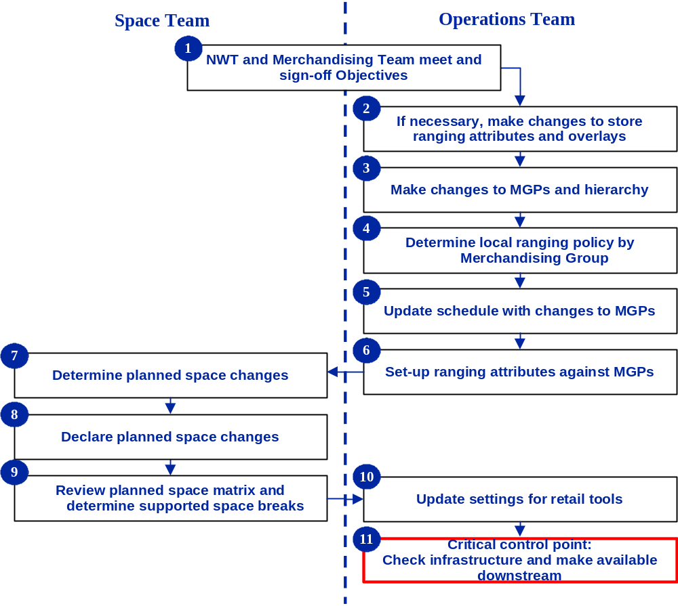
The full Ranging Controls Process is illustrated in the following diagram; this document represents Part 4: Determine local ranging policy by Merchandising Group and Part 8: Declare Planned Space Changes.

Ranging Controls Infrastructure Overview

Ranging Controls overview
The schematic below represents the high-level proposed Ranging Controls infrastructure and the relationships between to support the core business process.

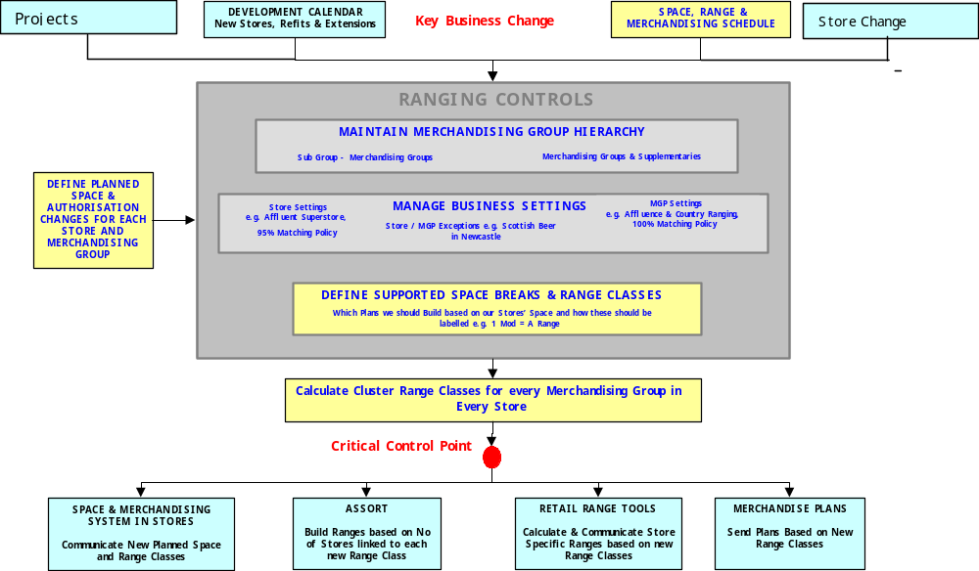

Figure 1: Ranging Controls Overview

The following will describe briefly the function of the main applications within the Ranging Controls system. The Ranging Controls will be configured, on a common platform, to support all Space, Range and Merchandising business processes. At this stage it is assumed that the following applications will be built to complete the infrastructure.

The applications will be built in three phases, with the Planned Space and Authorisation project delivered as part of Phase B. It is assumed in this document that Cluster Range Classes and the Supported Merchandise Plans and Ranges Matrix will not be delivered until Phase C.

For more details surrounding the core business process that Ranging Controls supports, please refer to the Ranging Controls Business Process document.

Application overview
Space, Range and Merchandise Schedule – This application will support the set up and maintenance of scheduled events. It will also be the control point for sending approved data to other systems

Merchandising Group Maintenance – This application will support the central maintenance of all merchandising group data.

Pre-Ranging – This application will support the set up and maintenance of characteristics used in ranging merchandising groups. It then associates these characteristics to groups of stores (known as clusters) which will then be used in ranging activities

Planned Space and Authorisation – This application will support the process to upload and make visible multiple future-dated planned space targets for any Merchandising group and store combination. Store merchandising group authorisation will be determined from these targets.

Equipment matrix – This application will allow the definition of equipment types and the Range to Space settings to be available to the Ranging Control System

Supported Merchandise Plans and Ranges Matrix – This application will facilitate the creation, maintenance and making visible the current and future relationship between range class and space.

Controlling Cluster Range Classes – This application will calculate the range class for each store by merchandising group for the current and any future dates

Impact Reporting – Although this is not a specific application, a suite of new reporting on the impact of any changes to the Ranging Controls will be available, to enable signoff of each event

Controls and Maintenance - This application will support the maintenance of all business parameters (controls), and also security and user access (maintenance) within all areas of the Ranging Controls infrastructure

Planned Space and Authorisation Overview

Deliverables
This project will deliver:
- A spreadsheet to add, amend or delete multiple future dated changes to Target Space for a store at Merchandising Group level.
- A series of screens to allow the user to validate the data within the spreadsheet against a set of business rules and then upload them into the Ranging Control system.
- An on screen/printable report to show errors and a summary of the upload.
- Mechanism to check how well changes to Target Space are supported by merchandise plans
- A series of screens to allow the user to enter, amend and delete changes to Target Space
- A series of screens to allow a store user to review planned space changes
- Mechanism to determine the local ranging policy for a store merchandising group, based on the local ranging policy defined for the merchandising group
- Multiple future dated planned space available to other systems
- An updated business process, and definition of the roles and responsibilities relating to the completion of these tasks
- Training and reference materials for the user

Benefits
This project will enable the:
- Efficient management of the relationship between multiple future space events (UKBE, Scheduled Events, store-led changes and projects)
- Visibility of all changes to Space over time across the estate
- Future development to use planned space changes when determining the range class to assign to a merchandising group in store
- Implementation of the local ranging policy in stores

Assumptions
The following assumptions have been made in order to design the solution to support the business process:
- Screen and report layouts included in this document are indicative only
- All formats/countries/product areas following the processes documented are in scope for this development
- Technical and business infrastructure will be in place
- Project can be delivered as a standalone piece of work
- IT support will be in place to sustain new technology
- Delivery of the Space Recommendations project will complement this application
- The Controlling Cluster Range Classes project and Supported Merchandise Plans and Ranges Matrix project will be delivered in Phase C of the Ranging Controls, after this project has been delivered
- The planned tactical solution for Supported Merchandise Plans and Ranges Matrix will remain in place until the strategic solution is ready
- The Corporate Branch Information (CBI) system will continue to work under 'Simpler Desktop

Out of scope
The following is out of scope for this project within the infrastructure:

- Changes to the ‘range to space’ calculation
- Developments to other systems that are not part of the core business process
- Design architecture for the Ranging Controls
- Changes to the space and ranging information used by the merchandise plan delivery system
- Any improvements to the quality or timeliness of the merchandise plans sent to the stores based on space
- Republic of Ireland (ROI) is out of scope, but where the business process for ROI overlaps with the UK, the ROI process must continue to function

Capability to manage planned space and authorisation for Express Stores and Petrol Filing Stations (PFS) is in scope for this project, but the delivery of a Space Database for these formats is out of scope.

Dependencies
The successful delivery of this project is dependent on changes to the following systems, which are described in more detail in section 4: -
- Corporate Branch Information (CBI)
- Merchandising Group Maintenance
- CR automation and Retail Tools
- New tables on the Data Warehouse
- CRS Merchandise Plan Coverage report
- The Range ODS
- The Commercial Range Support Tool

There may also need to be changes made to the Stock Record System to ensure the system continues to operate but currently it appears that this will not be necessary.

The Hard-lines allocation system could also be enhanced to make use of the future dated local ranging policy and space targets to identify which stores should receive allocations but will continue to use the existing interface based on the same lead time for every store and merchandising group..

The system to manage future dated target space changes will need further development to take full advantage of the project to make better space recommendations.

To be BUSINESS PROCESS

Introduction
The new business process for target space changes is fully described in the Business Process Design for Planned Space and Authorisation that was signed off in February 2006. This section provides a summary of that document but concentrates on the Business Processes that will be covered by this Business System Design. Other business processes will be covered in other project (see section 1.3.5 on Dependencies).

The business processes must make provision for:
- The launch of a new or updated merchandise plan (for all merchandising groups)
- The UKBE process (for new stores, refits, extensions and store refreshes)
- Store requests to start or stop stocking a merchandising group
- Store requests to change the space assigned to a merchandising group
- Space changes for seasonal stores (e.g. Ilfracombe, a highly seasonal store which has a different space layout in the summer when sales are very high, compared to the winter when sales are very low)
- Project work in the Centre (e.g. relay of Panel End space)

The following definitions describe terms most commonly used to to describe space within a store

Actual Space | Physical space in store.
Current Space | Space recorded within the computer system by the store for the current date.
Non-Trading Current Space | Space recorded for a new store that has not yet opened (i.e. the space is not yet effective
Space Recommendation | Ideal space for a merchandising group in-store based on the format plan, space rules and sales
Target space | Achievable space for a merchandising group in store, based on the space recommendation but tailored according to the specific layout of the store (e.g. pillars / wrapping around etc) and which space breaks are supported. This target will be valid for a period of time.
Planned Space | A change to the target space. This is valid for a date in the future and should be implemented by the store on that date.
Store-planned space | A change to the amount of space allocated to a merchandising group that the store intends to make on a future date.

Process Principles
The new business process uses the concept of whether a store has a space target or not to determine if the store has a centrally proposed range for the merchandising group. This information is combined with the local ranging attribute of merchandising group to control what freedom store has regarding the products to stock.

The other principles are summarised below.

Merchandising group | Store has a space target | Store does not have a space target
Local ranging allowed  E.g. Pre-Packed Bread: supply is not limited in this area, so stores with a space target of zero can make local decisions on tailoring the centrally proposed range | Store receives a range class, Centrally planned range, Merchandise Plans, Retail tools and is allowed to tailor the centrally planned range | Store does not receive a range class and hence there isn't a centrally planned range but can decide to stock some of the products. Store only gets a limited range of Retail tools and can only receive Merchandise Plans if they have space recorded
Local Ranging not allowed  E.g. Garden Furniture: supply is limited so stores may only stock their centrally proposed range. Local tailoring cannot be supported by the Supply Chain | Store receives a range class, Centrally planned range, Merchandise Plans, Retail Tools and is NOT allowed to tailor the centrally planned range | The store does not receive a range class, a centrally planned range, Merchandise Plans or Retail Tools. The store is prevented from stocking any of the products

To-Be Process Overview
The process to change the amount of space allocated to a merchandising group in store can be summarised into five steps.

- The space team agree the space target and enter it into the system
- The system determines if the store has a centrally planned range for this merchandising group based on the target space value
- The system determines the local ranging policy applicable to the merchandising group based on the Local Ranging indicator
- The system calculates the centrally planned range, if applicable.
- The system applies the Local Ranging Policy

New Processes
These new processes are applicable to Extras, Superstores and Metros in the UK. They are not applicable to Expresses, Petrol Filling Stations or stores in the ROI until such time as these stores use the GR system to maintain their current space and their merchandising events are included on the Space, Range and Merchandising Schedule.

Space changes for a Scheduled Merchandising event
This process will be carried out by the Space team, for any event on the Space, Range and Merchandising Schedule that requires a change to stores’ Target Space. The process starts around 20 weeks before the effective date of the event.

The following diagram shows the new process

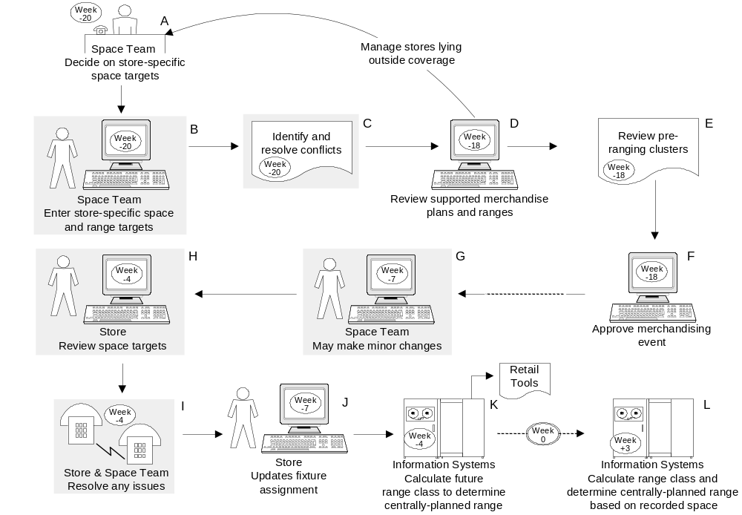
System Functions
To support this Business Process the System design must provide: -
- A screen to validate and load target space changes from a Spreadsheet (B, G, I)
- A report to identify conflicts (C)
- A set of screens to Add, Amend or Delete changes to Target Space either singularly or in bulk (B, G, I)
- A mechanism to make future changes to Target Space visible to the stores at an appropriate time (H)
- A mechanism to control whether stores can view the current space target (H)
- A screen to allow the store to review future changes to Target Space (H)
- A screen to allow the store to make future changes to the merchandising group assigned to a fixture (J)
- A mechanism to make Target Space changes and local ranging policy available to other system at the appropriate time (K, L)

This system design will not offer any support for the following, which are covered by other projects: -
- The Space Team deciding on the store specific space targets (covered by As-is process until Space Recommendations project)
- A process to identify the number of stores in each space break based on the Target Space, (available from the Data Warehouse until Phase C)
- The review of the store / merchandising group cluster exceptions within Pre-Ranging (covered the As-is process until the Supported Merchandise Plans and Ranges Matrix project)
- The approval of a merchandising event (covered by Space, Range and Merchandising schedule project)
- The process used in store to update fixture assignment (no change from the current process, described in the Space Toolkit)

UKBE space changes
The Space team will carry out this process, for any changes on the UKBE Development Calendar that require a change to Target Space. The process starts 8 weeks before the effective date of the UKBE change.

Applies to
This new process is applicable to opening new stores in the UK that are Extras, Superstores or Metros. It also applies to extensions, refits and refreshes of Extras Superstores and Metros in the UK.
The following diagram shows the new process

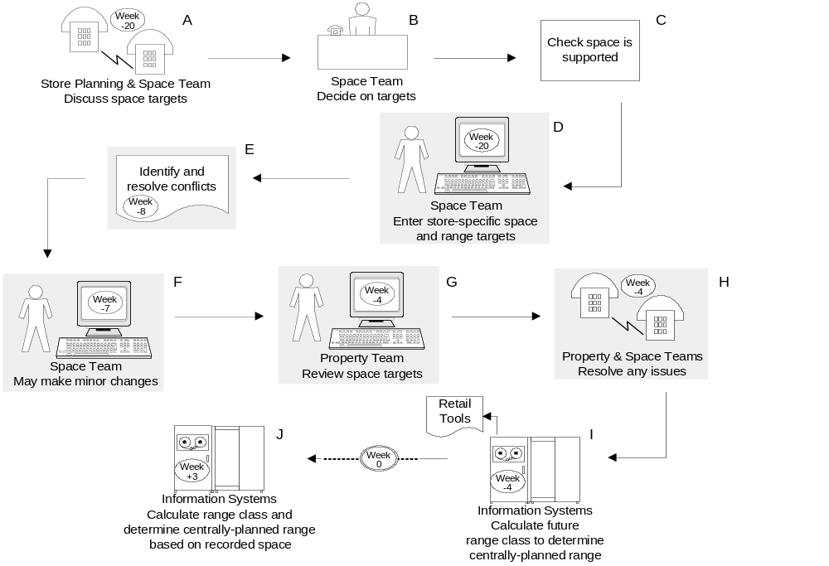
System Functions
To support this Business Process the System design must provide: -
- A screen to validate and load target space changes from a Spreadsheet (D, F, H)
- A report to identify conflicts (E)
- A set of screens to Add, Amend or Delete changes to Target Space either singularly or in bulk. (D, F, H)
- A mechanism to make future changes to Target Space visible to the property team in the store at an appropriate time (G)
- A mechanism to control whether stores can view the current space target (G)
- A screen to allow the property team to review future changes to Target Space whilst in store (G)
- A mechanism to make Target Space changes and local ranging policy available to other system at the appropriate time (I, J)

This system design will not offer any support for the following, which are covered in other projects: -
- The discussion of Space Targets (covered in Space Recommendations project)
- The Space Team deciding on the store specific space targets (covered in Space Recommendations project)
- The Space Team checking that the target space is supported by a merchandise plan (covered in Supported Merchandise Plans and Ranges project)

Store plans to change the fixtures allocated to a Merchandising Group
This process will be carried out by a store, on an ad hoc basis, whenever the store decides to review the assignment of ‘matched’ merchandising groups to space within the store. The decision to change the assignment of ‘matched’ merchandising groups is made by the Store Manager. Stores may not change the assignment of ‘fixed’ merchandising groups without permission from the Centre.

The following diagram shows the new process

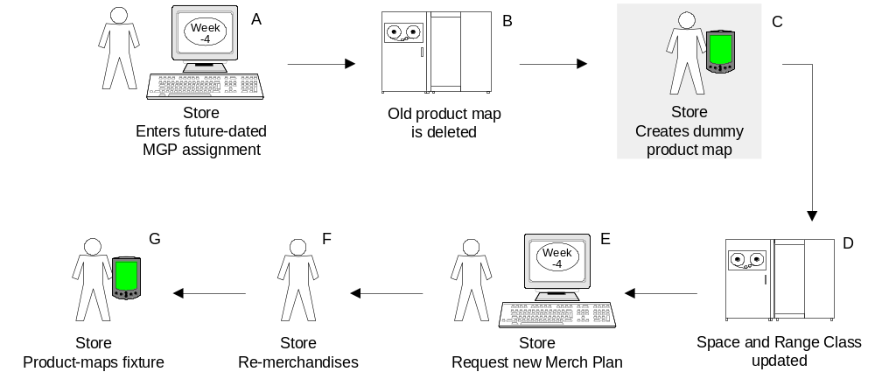

System Functions
To support this Business Process the System design must provide: -
- A screen to allow the store to make future changes to the merchandising group assigned to a fixture (A). There is no change to the format of the screen, however the rules for assigning space have changed (see section 3.4.3)

Store requests a change to their space target
Stores will carry out this process whenever a change is required to the Space Target for a particular store. This might be to enable the store to start stocking a merchandising group, stop stocking a merchandising group, or to change the space assigned to a ‘fixed’ merchandising group.

The following diagram shows the new process

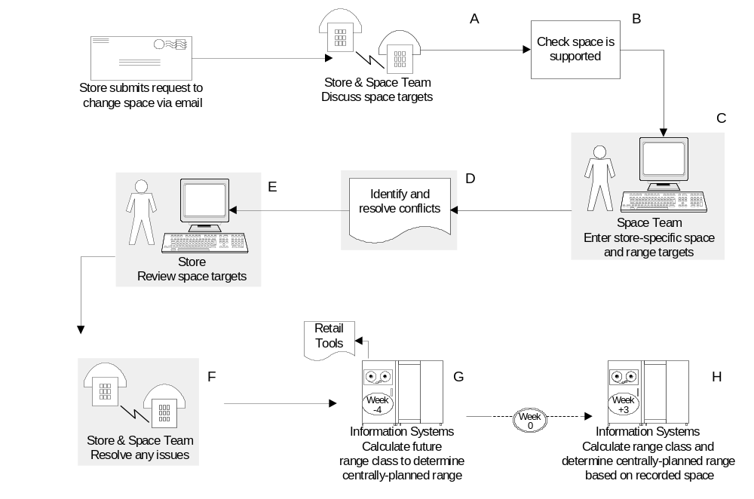
System Functions
To support this Business Process the System design must provide: -
- A set of screens to Add, Amend or Delete changes to Target Space either singularly or in bulk (C, F)
- A report to identify conflicts (D)
- A mechanism to make future changes to Target Space visible to the stores at an appropriate time (E)
- A mechanism to control whether stores can view the current space target (E)
- A screen to allow the store to review future changes to Target Space (E)
- A mechanism to make Target Space changes and local ranging policy available to other system at the appropriate time(G, H)

This system design will not offer any support for the following, which are covered by other projects: -
- The discussion of Space Targets (covered in Space Recommendations project)
- The Space Team checking that the target space is supported by a merchandise plan (covered by Supported Merchandise Plans and Ranges project)

Changing the Visibility of Target Space

The Operations Team uses this process to display or hide store Space Targets on the store facing GR system. Space Targets are hidden to avoid stores moving space towards the target, when the quality of the Space Target is not sufficient for reporting.

Applies to
This new process is applicable to both main and supplementary merchandising groups

The following diagram shows the new process

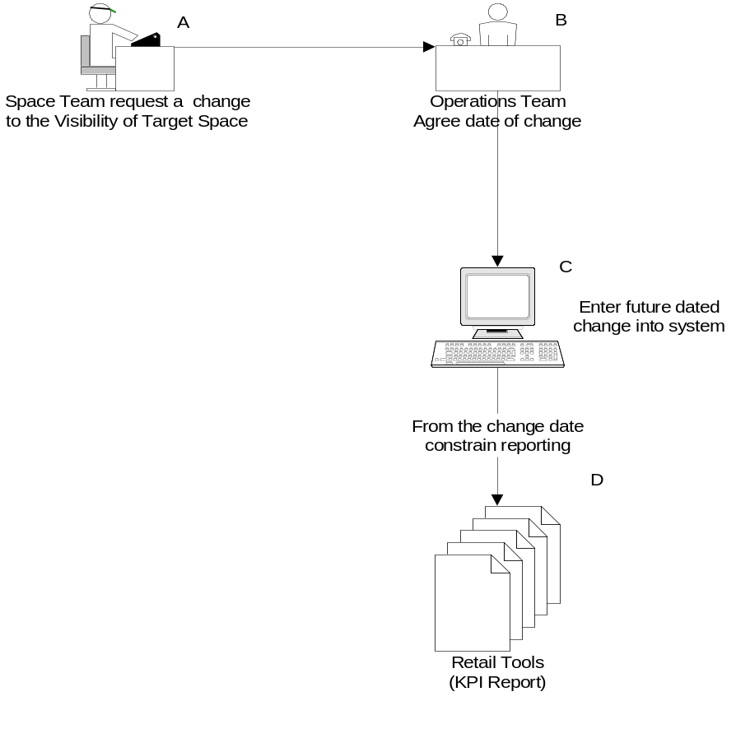

System Functions
To support this Business Process the System design must provide: -
- A screen to Add / Amend and Delete changes to the visibility of Target space parameter by merchandising group (C)
- A screen to Add / Amend and Delete changes to the visibility of Target space parameter by store (C)
- A mechanism to make changes to the visibility of Target Space available to other systems at the appropriate time (C)
- The Space and Merchandising System refers to this parameter for all screens and reports that use Target Space. (C)
- Constrain the reporting of Target Space on the Retail Tools KPI report if the Target Space isn't visible for the merchandising group in store.

The assignment of fixtures based on Target Space
The Space and Merchandising system (GR) uses the details scanned by the Space, Range and Merchandising Assistants in store to assign a merchandising group to each fixture. The Space, Range and Merchandising Assistant will, whenever there is a change to the products on a fixture scan each product on the shelf using a Hand-held Computer to record the exact location of the product. This information is used overnight by the Space and Merchandising system to assign a merchandising group to the fixture. The system initially decides which merchandising group contains each product on the fixture and then assigns the predominant merchandising group to the fixture.

The existence of a space target for a merchandising group at a store is used to help determine whether the parent or supplementary merchandising group is assigned to a product when it is product mapped. The decision tree used is shown below.
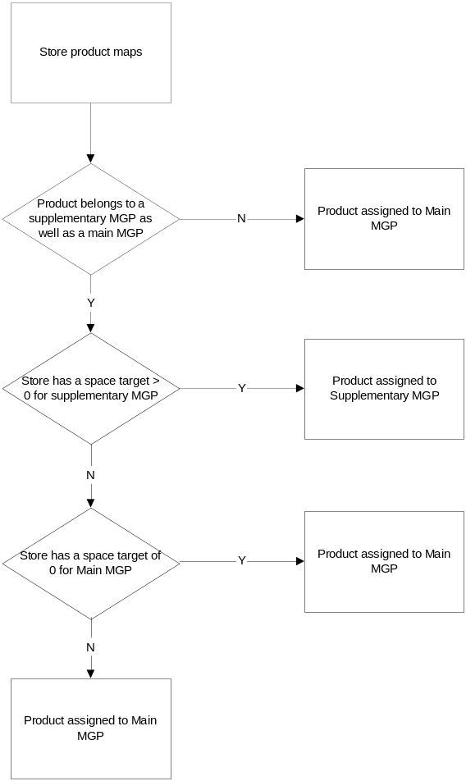
Once all the products on a fixture have been assigned to a merchandising group the fixture is assigned to the predominant merchanding group provided that the store either has a space target for the merchandising group (for the current date or in the next few weeks) or alternatively that Local Ranging is allowed for the merchandising group. If this prevents the assignment of a merchandising group to the fixture then the fixture remains unassigned.

System Functions
The system must ensure that the existing assignment of a merchandising group to a fixture is re-examined whenever any of the following happen: -
- The store product maps any products on the fixture
- Any of the products on the fixture change merchandising group
- The links between main and supplementary merchandising group are changed
- The target space for any of the merchandising groups that have a product on the fixture changes from or to 0.
- The Local ranging policy is changed for the merchandising group assigned to the fixture

The Impact of Target Space and Local Ranging
The overall control flow showing the impact of Target Space and Local Ranging is summarised in the diagram below.

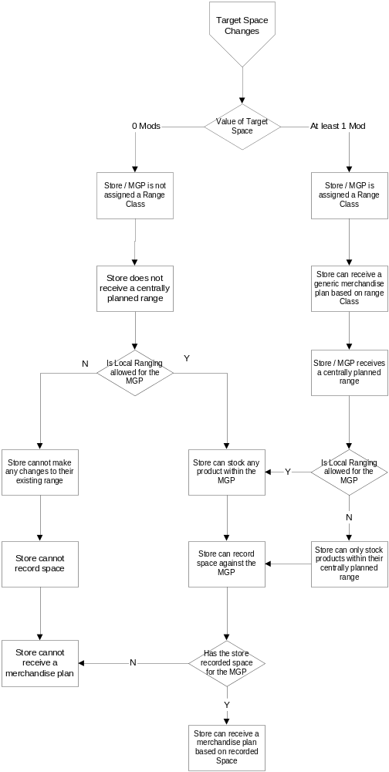

The impact of Target Space
If a store has a target space of at least 1 mod for a merchandising group
Then
- The store will be assigned a range class for the merchandising group based on their recorded space
- The store can assign space directly to a merchandising group using the online screens in the Space and Merchandising System.
- The store can record space against the merchandising group
- The store can view the supported space breaks for the merchandising group within the Space and Merchandising System
- The store receives the Weekly Range Change Update Report (WRCU)
- The I4B Weekly SRM Summary report lists the merchandising group as an exception if there isn't any recorded space
- The I4B KPI report reports the merchandising group unless there is no recorded space and the Range To Space indicator is 'N'
- The CRS - Merchandise Plan Coverage report will include this store and merchandising group in it's analysis of coverage if the store has any recorded space
- The sales are included in the historical sales used by CRST to support ranging decisions
- The sales are used to develop the store plans within PROSPACE

If a store has a space target of less than 1 mod for a merchandising group or doesn't have a space target for a merchandising group
Then
- The store will not be assigned a range class for the merchandising group
- The store cannot assign space directly to a merchandising group using the online screens in the Space and Merchandising System
- The store can only record space against the merchandising group if local ranging is allowed
- If the store records any space against the merchandising group it will be reported on the exception report in the Space and Merchandising System
- The store cannot view the supported space breaks for the merchandising group within the Space and Merchandising system
- The store will receive the Weekly Range Change Update Report for discontinued lines only
- The I4B Weekly SRM Summary report lists the merchandising group as an exception if any space has been recorded for it.
- The I4B KPI report only reports the merchandising group if the store has recorded space and the Range to Space indicator is 'Y'
- The CRS - Merchandise Plan Coverage report will not include the store and merchandising group in it analysis of coverage
- The sales are excluded from the historical sales used by CRST to support ranging decisions
- The sales are not used to develop the store plans within PROSPACE

The impact of Range Class
If a store has a range class for a merchandising group
Then the existing process remains
- The store will have a centrally planned range for the merchandising group
- The store will receive a Managing Your Range report for the merchandising group
- The store can receive a generic merchandise plan based on range class
If a store does not have a range class for a merchandising group
Then
- The store will not have a centrally planned range for the merchandising group
- The store will not receive a Managing Your Range report for the merchandising group
- The store cannot receive a generic merchandise plan based on range class

The impact of a centrally planned Range
There is no change to the existing process
- All products stocked that are outside the store's centrally planned range are listed as out of range on the Customer Focussed Range Report (CFRR)
- All processing of new products within the store's centrally planned range is automated
- Stores can be allocated products within their centrally planned range

The impact of the local ranging policy
If local ranging is allowed for a merchandising group
Then
- The store can record space against the merchandising group
- The store can order any product within the merchandising group
- The store can discontinue any product within the merchandising group
If a store cannot locally range a merchandising group
Then
- The store can only record space against the merchandising group if they have a space target for it
- The mandatory blocking control within the Continues Replenishment (CR) system will default to M999 for the merchandising group which will: -
- Prevent stores from discontinuing any products in the merchandising group
- Prevent stores from deciding to start stocking any products in the merchandising group
All changes to the stores current stocked range will therefore need to be managed centrally.
- Any products outside the store's centrally planned range doesn't allow local range are discontinued if the Range Matching Tool is set to enforce range
N.B. The local ranging policy has no impact on whether a store can change the amount of space they have allocated to a merchandising group provided a space target exists. I.E. The local ranging policy does not enforce the Target Space.

The impact of stocking products within a merchandising group
- All processing of discontinued products stocked by the store is automated

The impact of recording space for a merchandising group
There is no change to the existing process
- A store can receive a store specific merchandise plan based on their recorded space
- A store can receive a generic merchandise plan based on their recorded space, for generic areas where plans are based on space not range class

Space, Range and Merchandising events
An event on the Space, Range or Merchandising Schedule will affect a store if: -
- The store belongs to a cluster affected by the event
AND
- Either the store has a space target of at least 1 mod on the day before the event or as a result of the event.
- Or the store has space recorded for the merchandising group at week-4

Even if the store is excluded from the event by the above conditions it is still possible they may be impacted if they are currently stocking a product that is discontinued by the centre. The impact would be fairly minimal and covered by the normal procedures used when a line is discontinued outside of the normal merchandising cycle.

The Retail Tools
The detailed Business System Design for the Retail Tools is excluded from this document, as it will be the subject of a separate detailed Business System Design once the requirements have been fully defined. The Retail Stream of the Space, Range and Merchandising Programme will carry out this work. The Retail Tools include the following functions: -
- The Weekly Range Change Update report
- The Managing Your Range report
- The Managing New Products report
- The Managing discontinued products report
- The I4B Weekly Summary report
- The I4B KPI report
- The Automation of new and discontinued lines
- The enforcement of Range Conformance
- Merchandise Plan Tracker

The older Retail Tools include the: -
- The Customer Focussed Ranging report

The Target Space set for a merchandising group in store can only be reported and the store's compliance monitored if the Space Team have made the Target Space for the merchandising visible to the store.

The maintenance of the Target Space parameters
Applies to
This new process is applicable to all stores and merchandising groups where the target space is controlled via the Ranging Control System.

The following diagram shows the new process

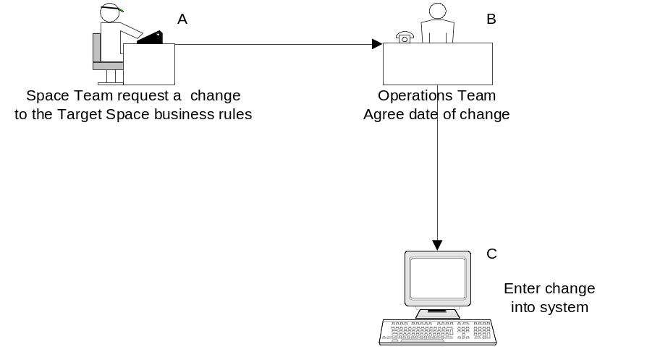

System Functions
To support this Business Process the System design must provide: -
- A series of screens to Add, Amend or Delete changes to the Target Space parameters (C)
- A mechanism to apply appropriate changes to the parameters to Target Space changes already loaded to the system (C)

System Design

High Level Processing overview
The application to maintain the Target Space for a merchandising group in a store comprises a set of screens to:
- Create a new space target
- Add a future dated change to a space target
- Amend an existing future dated change to a space target
- View an existing target or change to a space target
- Delete a future dated change to a space target
There is no facility to delete the Target Space assigned to a merchandising group in store as this is achieved by changing the target space to zero mods. The application also provides comprehensive reporting of the details held within the system.

The Controls component of the Ranging Controls system is being enhance in parallel to the development of the Target Space component so that the controls and parameters required by the Target Space component can be maintained.

The Store personnel also require access to a system so that they can view forthcoming changes to the Target Space for any merchandising group

Target Space application
Within the Ranging Controls system, there will be a menu option of ‘Target Space’. When the Space team select the Target Space option the first screen presented is always the 'Find Screen'.

The left-hand pane of each screen contains a navigation bar to allow access to:
- Create a new Target Space change
- Find an existing Target Space change

- Identify Target Space conflicts
- Validate Target Space Changes against Business Rules
- Return to the main Ranging Control System Menu screen
- Logging off the system

These options will only be available from the Find screens, , the Target Space Conflicts and the Target Space validation screens. When the user is using a screen capable of changing any of the details held in the system they must either confirm or cancel the update which will then always return to the Find screen.

The Space Team will also use the 'Target Space Uploads' option from the 'Uploads' section of the Ranging Control System to request a bulk upload of the Target Space changes they have created in a spreadsheet.

The overall structure of the Ranging Control system is shown below, with the areas affected by this project shaded.
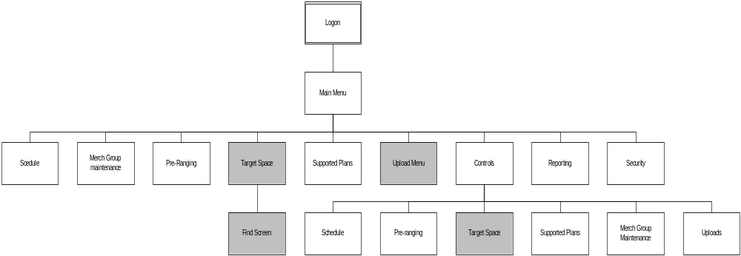

The screens will meet the standards for the Ranging Controls system, as defined in the Business System Design document ‘Ranging Controls System - Screen Design standards’.

Request a bulk load from a spreadsheet

Purpose
These screens allow the user to easily load a series of target space changes from a spreadsheet, into the Ranging Controls system

Screen Flow
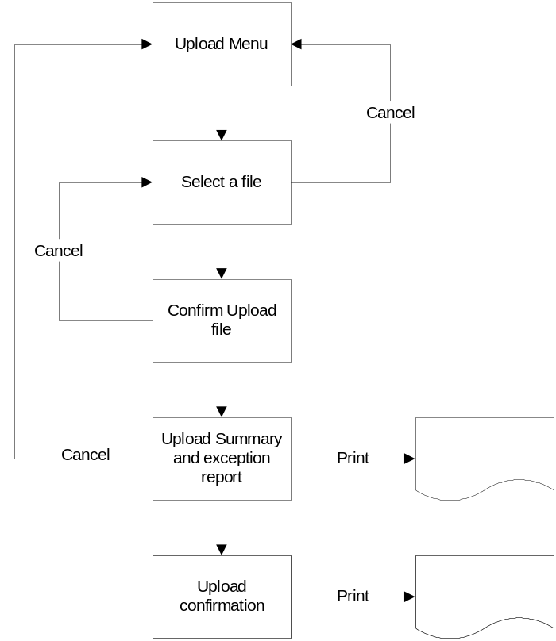

Process Flow
The screens to request a bulk load for the changes to target space are entered via the Upload menu on the Ranging Control system. This screen allows the user to select the required upload, in this case the Changes to Target Space load. The screen flow will then allow the user to select the correct file, which will produce a validation report. Once all the entries on the spreadsheet are valid the user can then load all of the target space changes.

The Space Team user needs to use the standard spreadsheet that contains
- Event id
- Store
- Merchandising group
- Type of change
- Action indicator
- Range class
- Either the value of Mods or the equipment type and number of Mods

The 'Type of change' field is used to identify whether the Target Space change is due to an Event on the Space, Range and Merchandise schedule, a UKBE change or a store request.

If the change to the Target Space is required for any reason other than an event on the Schedule, the same details are required but instead of an event id the user must supply the actual implementation date and all of the changes must be for the same store. The action indicator is either 'C' - Create a new Target Space change or 'D' - Delete an existing change to Target Space. There is no option to update an existing change to Target Space so this is achieve by deleting the existing change and then adding a new target space in two separate uploads.

Create a new change to Target Space

Purpose
The Space team can add a single change to the Target Space for a merchandising group in store directly into the Ranging Control System. This screen replaces the existing Head-office screen to enter a planned space change within the Space and Merchandising System (GR).

Screen Flow
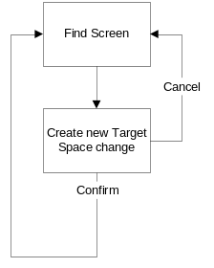

Process Flow
When the User needs to change the Target Space for a merchandising group in store they can enter this screen by clicking the 'Create New Target Space change' on the left-hand side of screen. If the Target Space change is due to an event on the Space, Range and Merchandising schedule then the event id must be selected otherwise the implementation date should be entered. Once the User confirms the details on the screen are correct they are added to the system and the User is returned to the 'Find' Screen.

Amend a change to Target Space

Purpose
These screens are used by the Space team if they need to amend a Target Space change that they have previously entered for a merchandising group in a store. This screen replaces the existing Head-office screen to amend a planned space change within the Space and Merchandising System (GR).

Screen Flow
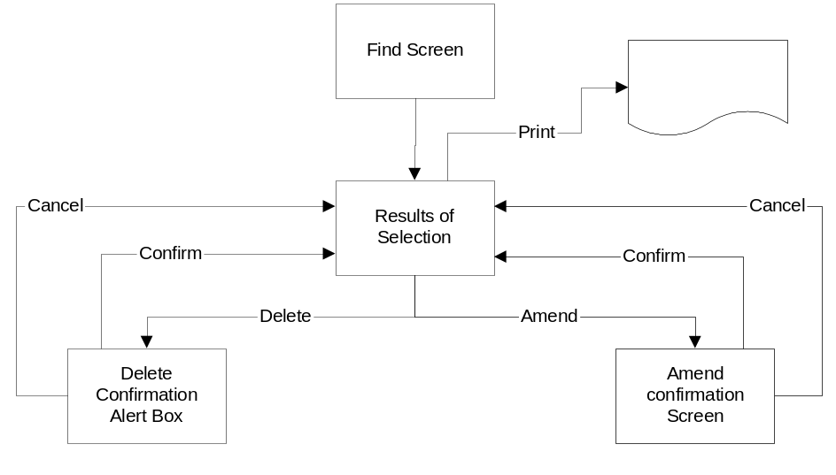

Process Flow
When the User needs to amend an existing change to Target Space for a merchandising group in store they can enter details into the Find screen to locate the entry they want to change.

If the User wants to amend the target space changes associated with an Event on the Space Range and Merchandising schedule they must enter the Event id. If required they can also enter the store number and/or the merchandising group code to cut down the number of rows returned. When working on target space changes associated with an Event the Implementation date is always left blank.

If the User wants to amend the target space changes that aren't associated with an Event, e.g. UKBE changes; they must enter the Store number and leave the Event Id blank. The user will also want to enter the implementation date and/or merchandising group code to cut down the number of rows returned but neither of these are compulsory.

The User can then select the entry to be amended and make the necessary changes to Target Space and Range Class on the result grid. Once the User clicks the 'Amend' button they are taken to the 'Amend Confirmation Screen' where they can confirm or cancel the amendments.

If the entry that has been changed has already been passed to the Store facing screens then the updated details must be reflected within the Store Facing systems by the following morning.

Remove a change to Target Space

Purpose
The Space team uses this screen if they need to remove a change to the Target Space for a Merchandising Group in Store. This screen does not provide the facility to remove the current Target Space for a store as this is achieved by entering a zero target space for a future date. If a change to the Target space for a Merchandising Group in Store is removed the result is always that the Target Space in effect on the day before the implementation date will remain in effect.

Screen Flow
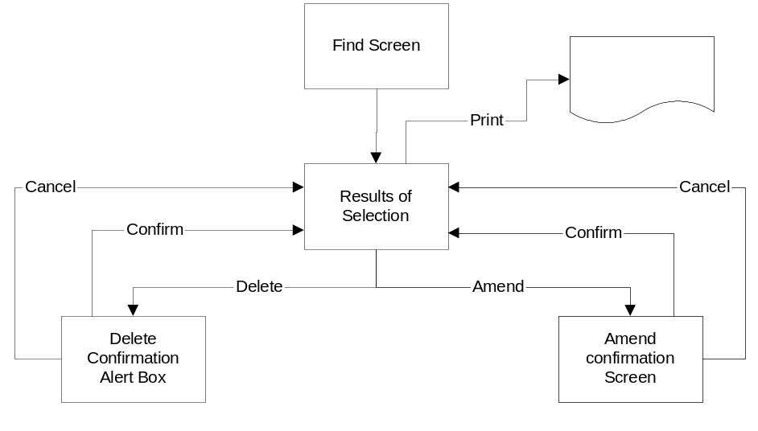

Process Flow
When the User needs to remove an existing change to Target Space for a merchandising group in store they can enter details into the Find screen to locate the correct entry.

If the User wants to remove a target space change associated with an Event on the Space Range and Merchandising schedule they must enter the Event id. If required they can also enter the store number and/or the merchandising group code to cut down the number of rows returned. When working on target space changes associated with an Event the Implementation date is always left blank.

If the User wants to remove a target space change that isn't associated with an Event, e.g. UKBE changes; they must enter the Store number and leave the Event Id blank. The user will also want to enter the implementation date and/or merchandising group code to cut down the number of rows returned but neither of these are compulsory.

The User can then select the entries to be removed and confirm the removal of the to Target Space and Range Class via the Alert Box that summarises the number of entries being deleted. Once the User confirms the details on the screen are correct the details are removed from in the system and the User is returned to the 'Results of Selection' Screen.

If the entry that has been removed had already been passed to the Store facing screens then the details must be removed from the Store Facing systems as soon as possible.

View changes to Target Space

Purpose
The Space team uses this screen if they want to view a future change to the Target Space for a Merchandising Group in Store.

Screen Flow
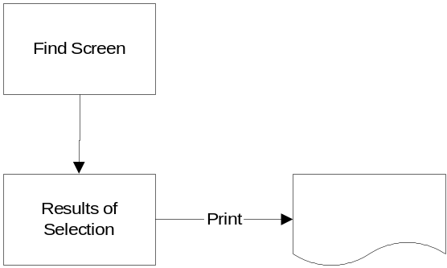

Process Flow
When the User wants to view the changes to Target Space that have been entered into the system they use the find screen to locate the entry they are interested in. The User can either enter the Event ID or and optionally the store and/or merchandising group if the change is associated with an scheduled Event or alternatively they can enter the store and optionally the implementation date and/or merchandising group if the change isn't associated with an Event.

If the User wants a print of the changes to Target they can select the 'Print' option on screen listing the results of the 'Find' operation. This allows the user to print either all the entries that met the selection criteria or alternatively just the entries they have highlighted.

Report any Space Target Changes outside Business Rules

Purpose
The Space team uses these screens to identify any merchandising groups in a store where the change in target Space does not meet the objectives of the Space Change. E.g. If the objective of the scheduled event is to increase the target space for red wine so the Space Team request a list of any stores where the Target Space for red wine will be less than the current target space.

Screen Flow
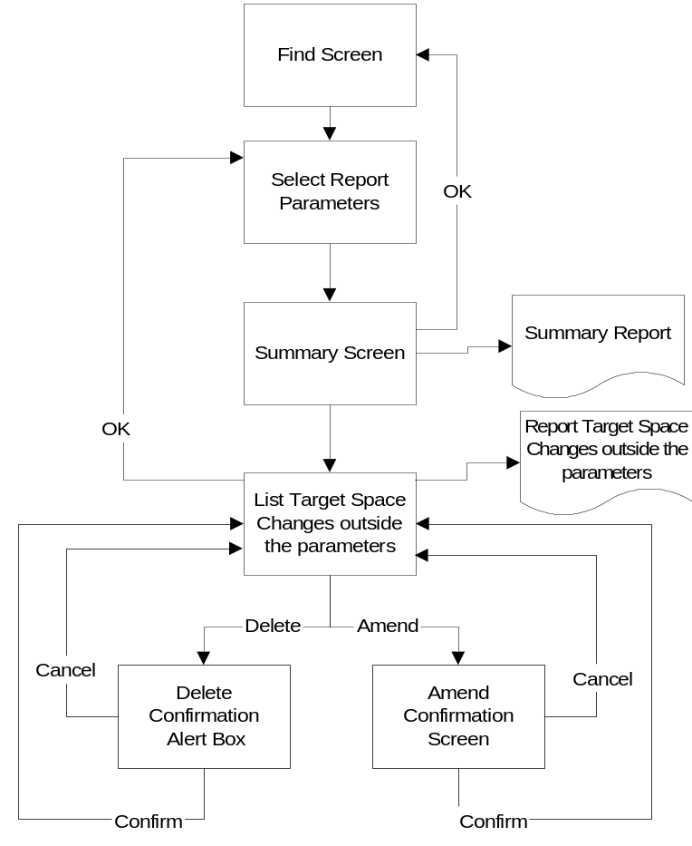

Process Flow
When the User wants to validate the changes to Target Space they select the Validation against Business Rules report from the left-hand navigation pane which then provides a screen where they can enter the selection details.

If the User wants to check on the target space changes associated with an Event on the Space Range and Merchandising schedule they must enter the Event id. If required they can also enter the store number and/or the merchandising group code to cut down the number of rows returned. For example if G1D, Rice and Cooking Sauces merchandising group is increasing space while the G1A - Canned Vegetable merchandising group is reducing space the user would probably validate each of these separately. This allows the user to see if any of the stores were their target space for G1D or increasing their target space for G1A directly from the summary screen.

If the User wants to check target space changes that aren't associated with an Event, e.g. UKBE changes; they must enter the Store number and implementation date but leave the Event Id blank. The user may also want to enter the merchandising group code to cut down the number of rows returned but neither of these are compulsory

Once the User clicks the search button the system returns a summary screen to show the number of target space changes where on the implementation date the: -

- Target Space is greater than the Target Space the previous day
- Target Space is less than the Target Space the previous day
- Target Space equals the Target Space the previous day
- Target Space is changing from zero
- Target Space is changing to zero

The user may select one or more of the above categories if they want a breakdown of the target space changes within each category. Once the list of affected Target Space changes is available the user can either print the details or amend or remove any of the changes by selecting the relevant entries from the result grid in a similar manner as the results from the 'Find' screen. Whenever a change is made to the Target Space changes the list of affected target space changes is re-calculated based on the selected categories

The implementation date for a scheduled event is determined from the implementation date for the store cluster and merchandising group held in the Space, Range and Merchandising Schedule, and the details of stores in each cluster held within Pre-Ranging.

If the Space Team need to produce any other reports on Target Space then this can be achieved from the Data Warehouse as all changes to Target Space will be loaded to the Data Warehouse each evening.

Identify any conflicts within Target Space changes

Purpose
The Space team uses this screen to identify any merchandising groups in a store where there is more than one change to the space target within a short period of time.

Screen Flow
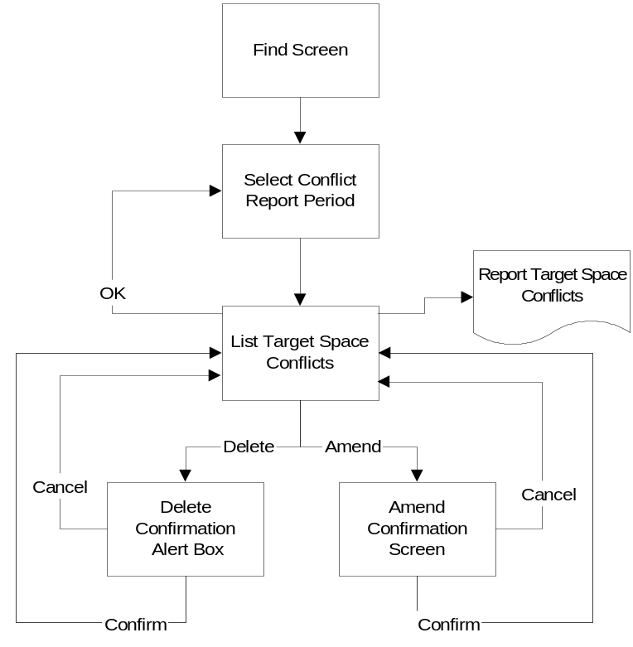

Process Flow
When the User wants to check for any conflicts on the Target Space they select the Conflict Report from the left-hand navigation pane which then provides a screen where they may enter the date range to be checked. The date range can be entered one of three ways: -
- Select an Event id and the number of weeks to check either side (to a maximum if 6 weeks)
- Enter the Start date and the number of weeks to check. (to a maximum of 6 weeks)
- Enter the start and end date of the period to be checked (to a maximum of 6 weeks)

Once the date range has been entered the system will identify any instances where there is more than one space change for a merchandising group in a store during the reporting period. The implementation date for a scheduled event is determined from the implementation date for the store cluster and merchandising group held in the Space, Range and Merchandising Schedule, and the details of stores within each cluster, held in Pre-Ranging. Once the list of affected Target Space changes is available the user can either print the details or amend or remove any of the changes by selecting the relevant entries from the result grid in a similar manner as the results from the 'Find' screen. Whenever a change is made to the Target Space changes the list of affected merchandising groups in a store is re-calculated based on the original date range.

Implications for the Corporate Branch Information system (CBI)

Purpose
The Corporate Branch Information System is currently used by the Space Team to control the authorisation of merchandising groups within the store and to record the amount of space used by each merchandising group. It will no longer be possible to change this information directly within the Corporate Branch Information system for any Extra, Superstore, Homeplus or Metro (including Classic Metro) unless the store is in the Republic of Ireland. The current functionality will remain in place for ALL other stores.

Screen Flow
There is no change to the current screen flow, which is shown below:

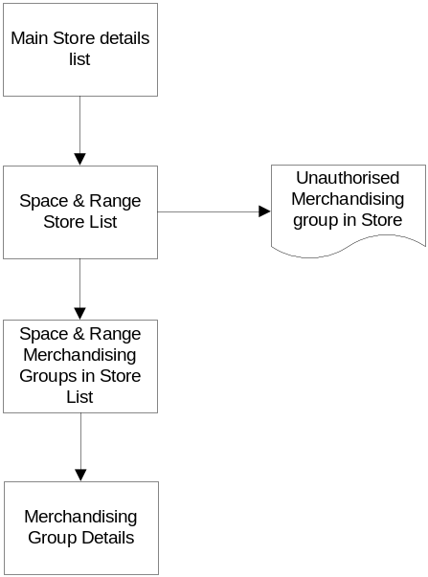

Process Flow
The authorisation indicator in CBI will be shown as N/A for all Extras, Superstores, Homeplus and Metros (including Classic Metros), unless the store is in the Republic of Ireland. The Space team may still amend the authorisation indicator and current space, directly in the system, for all other stores including Republic of Ireland.

The Space Team also currently have the option to apply bulk changes to the Corporate Branch Information Database via spreadsheet. This will be changed to reject any authorisation and current space changes to Extra's, Superstores, Homeplus and Metros (including Class Metros) unless the store is in the Republic of Ireland.

The User can also use the Corporate Branch Information system to add a new merchandising group to a store or remove an existing merchandising group from a store. Both of these functions will remain except that the authorisation indicator will not be used for Extras, Superstores, Homeplus and Metros (including Classic Metros) unless the store is in the Republic of Ireland. In addition to directly adding a merchandising group to a store within the Corporate Branch Information System, any new merchandising group will continue to be added to the Corporate Branch Information Database once a store product maps it.

If it is decided to change the format classification of a store, for example from an Express to a Metro then the authorisation indicator will be shown as N/A if the new format is Extra, Superstore or Metro (and the store is not in the Republic of Ireland).

There is a report available within CBI to list any merchandising groups in store that are unauthorised. This function will continue to be available but will not list any merchandising groups with an authorised status of 'N/A'. If a member of the Space Team requires the equivalent information for Extras, Superstores and Metros they wil need to use the Data Warehouse tables to identify merchandising groups in store with a target space of zero and no local ranging is allowed.

Operations Team Ranging Control System - Maintenance Screens application
The Operations Team is responsible for maintaining the business rules and parameters required by the Target Space system. The Ranging Control System menu contains an entry for Controls to allow members of the Operation Team access to the screens used to maintain the controls.

Control whether Target Space is visible to stores

Purpose
The Operations team will use this series of screens to control the visibility of target space by either store or merchandising group. A store will always be able to see a change to the target space set by the centre prior to the implementation date as this will be shown as a planned space change. This control setting allows the centre to decide if they want the store to be able to refer to the target space within the Space and Merchandising system after the implementation date, and whether the Target Space is available for measuring within the Retail Tools. The Retail Tools controls will continue to be used to decide which stores have their compliance to Target Space measured. If the centre is confident that the space target is achievable then they will want the store's compliance to be measured however if the Target Space may not be achievable due to store constraints then their compliance would not be measured.

Screen Flow
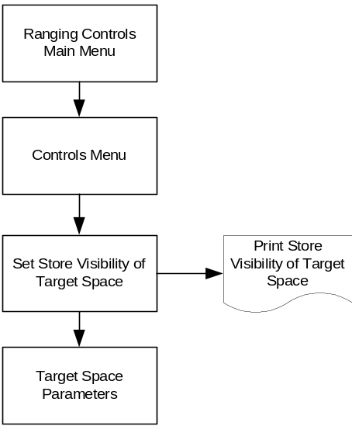

Process Flow
The screen to maintain the 'Store Visibility of Target Space' is accessed by selecting the Target Space option from the Controls Menu within the Ranging Controls System. The 'Store Visibility of Target Space' is changed either as a result of an Event on the Space, Range and Merchandising schedule, in which it applies to a merchandising group across all stores or alternatively as a result of a UKBE change in a store. If it changes as a result of the UKBE process then the new setting applies to all merchandising groups within the store.

A change associated with an Event will become effective in all stores on the earliest launch date for that merchandising group within the Event. This means that it is possible for the visibility of Target Space to change for a store even if the store is not part of an event

If the User needs to change the value of the 'Store Visibility of Target Space' indicator they enter the details into the 'Add' row on the screen and click the Add button. The User will either enter the change against a single merchandising group or a single store depending on whether the change is due to a scheduled Event or not..

If the User needs to remove a future change to the 'Store Visibility of Target Space' indicator they must first enter either the Event ID, the store or the merchandising group code so that the entry to be deleted is in the result grid. Once the entry to be deleted is in the result grid it should highlighted and then removed by clicking the 'Delete' button. This will remove it from the result grid but not actually delete it from the Database until the User clicks the 'Confirm' button.

The User can also use this screen to review how the Target Space has changed for a store or part of the merchandising hierarchy over time by entering one or the other into the Search fields. The system will then show how the indicator has changed during the last year and any future changes. If the User wants to check the setting of the indicator for a scheduled event then the Event ID is entered into the search field and every merchandising group for that event will be reported in the result grid. If the 'Store Visibility of Target Space hasn't yet been entered for a merchandising group then it will be reported as Not Visible when viewing the setting for an Event.

Once the Target Space result grid has been populated the User can print the details via the 'Print' button.

There is no facility in the system to immediately change the Target Space visibility so if the user needs to change the value immediately they must enter a change with tomorrow's date which will therefore change the store's visibility within the Space and Merchandising system from tomorrow morning. This is because the store facing systems are only updated overnight.

Amend the business rules and parameters for the Target Space System

Purpose
This screen allows the Operations Team to maintain the controls and settings needed to ensure the efficient operation of the system to maintain changes to target space.

Screen Flow
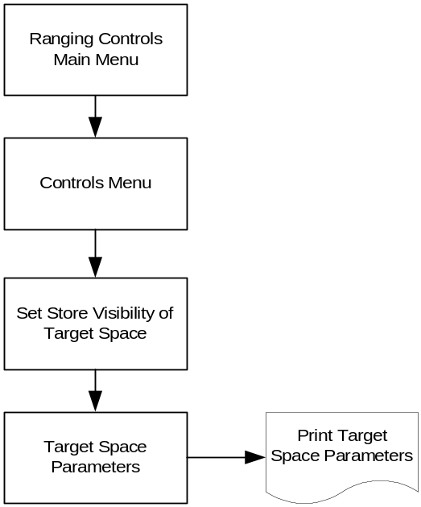

Process Flow
Two types of parameter will be used by the application to maintain target space. One set of parameters apply generally to all changes to target space whilst the second type of parameter may vary dependant on the Type of Space Change (e.g. scheduled event, UKBE etc).

The General Parameters are:
- The minimum lead-time for a change to Target Space (a warning that changes should not be created in the system after this point)
- The maximum Lead Time for a change to Target Space (a warning that changes should not be created in the system until this point)
- The maximum number of weeks that can be requested on the Target Space conflict report

Whenever any of these parameters are changed the effect takes place immediately within the Ranging Control system but the following day within the Space and Merchandising System (GR) and other legacy systems.

The parameters that vary by the Type of Space change are the lead-time for a change to target space to be made visible to a store and whether or not this Type of Space change is associated with an Event on the Space, Range and Merchandising Schedule.
(E.G. A target space change for a New Merchandise Plan would be associated with an Event whereas a target space change due to a store refit wouldn't).

While it is possible to amend the visibility lead-time for a Target Space change it is not possible to change whether a Type of Space change is associated to an event if there are any Target space changes for that Type of Space within the system. There is also no facility to amend the description of a Type of Space change code so instead it is necessary to delete the old Type of Space change and add a new one. A Space change type can only be deleted from the system if there aren't any Target Space changes, either historical or future dated, for of that of type within the system.

The visibility of Target Space lead-time parameter will not cause the target space to become visible exactly on the date but instead will always be visible from day 1 of the fiscal week indicated by the lead-time. E.g. If the implementation date of the space change is Wednesday 29th March and it should be made visible to stores four weeks before the implementation date then it will appear within the GR system from Sunday 5th March.

Store facing application
The Space, Range and Merchandising assistants in store will continue to use the existing Space and Merchandising (GR)system to manage the space allocated to each merchandising group in store. There are no significant changes to most of the current screens with the exception of the screen to review future changes to Target Space, which will be enhanced to show more than one future planned space change, and some new enquiry screens.

There will however be some changes to the processing behind the screens due to the new business rules regarding store's ability to determine their local range, and holding multiple space changes over time.

Review Space Target by Merchandising group

Purpose
This screen provides the Space, Range and Merchandising assistant in store with a summary of the amount of space assigned to each merchandising group in the store and the associated Range class.

Screen Flow
There is no change to the screen flow, which is shown below:
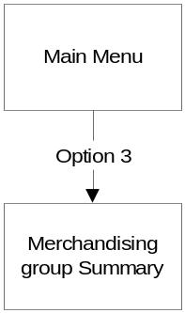

Process Flow
There is no change to the existing process flow but the Merchandising Group Summary screen will be enhanced to show extra information. The screen will include all merchandising groups with recorded space and all merchandising groups with either a current or future space target effective in the next few weeks, greater than 0 Mods, or a planned space change entered by the store. This means that if a merchandising group doesn't have any space recorded and the current space target isn't visible to the store then the only details shown for the merchandising group are the merchandising group code and description.

The screen will also show all future planned space changes that become effective over the next few weeks (both from the centre and the store) rather than just the first change from the centre and the current local ranging policy. The lead-time for a change to be visible in store will be controlled via a parameter maintained within the Ranging Control System at the Centre. The variance from Target will only be shown if the target visibility, maintained by the Space Team, permits it.

If the Target Space change is due to an event on the Space, Range and Merchandising Schedule then the change will only be visible if the event has been approved and the lead-time of the change is within the defined number of weeks.

Review Supported Merchandise Plans

Purpose

This screen lists the amount of space by equipment type for the store's cluster, that the centre has built a merchandise plan for and the associated range class. This information is used by the store to understand how their range class has been determined, from their recorded space for a merchandising group. It also helps stores to ensure that any space changes they wish to make will move the merchandising group to an amount of space that is supported by a merchandise plan and a range. Screen Flow
There is no change to the screen flow, which is shown below:
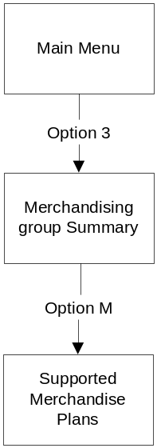

Process Flow
There is no change to the existing process flow or to the details on the screen however it should be noted that the existing restriction that the screen only uses the information about current merchandise plans still holds true. This means that it is possible that the store could see that there isn't a merchandise plan for a future change to their planned space, despite the fact that by the time the change is due then that amount of space will be supported. This should be resolved as part of the Phase C design.

A store can only view the Supported Merchandise Plans if they either have space currently recorded for the merchandising group or the centre have currently set a Space Target of at least 1 Mod.

Change the merchandising group assigned to a fixture

Purpose
This series of screens allows the Space, Range and Merchandising Assistant to enter a future dated change to a fixture such as changing the merchandising group assignment.

Screen Flow
There is no change to the screen flow, which is shown below:
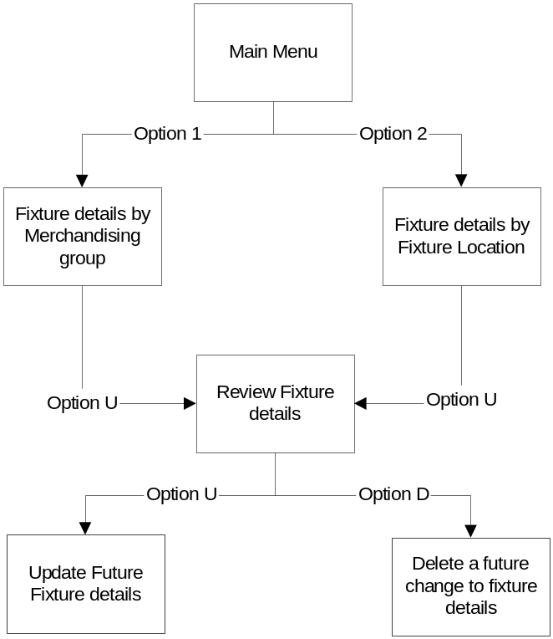

Process Flow
There is no change to the existing process however the logic for screen 'Update Fixtures' will change. In principle, stores will only be able to assign a merchandising group to a fixture if a space target exists for that merchandising group or if local ranging is allowed. However, stores must update their space record in advance of a planned change to ensure they receive the correct merchandise plan. Therefore it must also be possible for stores to assign a merchandising group to a fixture if, within the next few weeks, there is a space target greater than zero or the store will be allowed to make local ranging decisions. The number of days used to check for a future change to Target Space or the local ranging policy is five days more than the Planned Space to CBI parameter within GR. The Planned Space to CBI parameter is currently a support maintained parameter.

Check the local ranging policy

Purpose
This screen allows the Space, Range and Merchandising assistant to check the Local Ranging Policy for each merchandising group to understand when a merchandise plan will be received, and where space can be recorded, by merchandising group. The other use for screen is check why product mapping may not have assigned the merchandising group that the Space, Range and Merchandising assistant expected. This could be due to the local ranging policy, as it is not possible to assign space to a merchandising group without a space target unless the store is allowed a local choice.

Screen Flow
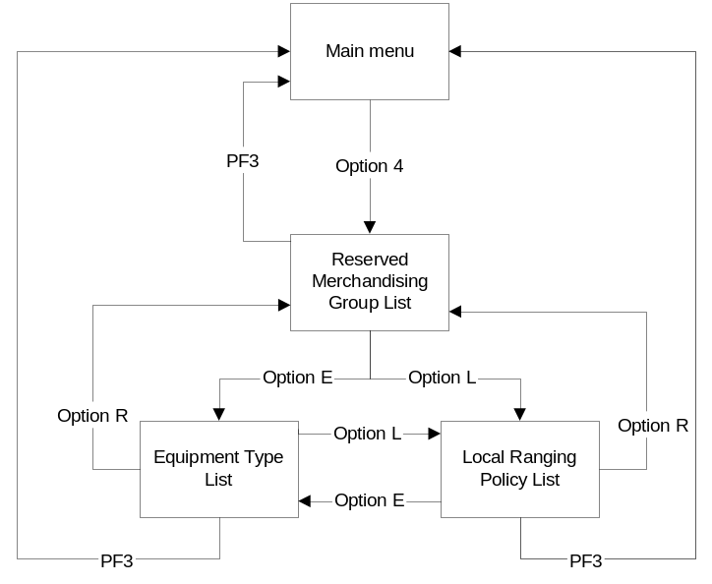

Process Flow
The User initially selects Option 4 from the Space and Merchandising System, which shows the list of reserved merchandising groups (a reserved merchandising group is used to identify space in store where the type of products changes frequently e.g. Seasonal Space and Promotion Ends). The user can then select either 'E' to see the list of valid equipment types or will be able to select 'L' to see the list of merchandising groups where they are allowed to make a local choice regarding the products stocked. The user will enter a merchandising group into the Local Ranging Policy List to allow the screen to scroll to that merchandising group without the user needing to scroll through a lot of screens to check the last merchandising group. The user will exit the list of merchandising groups by either switching to the equipment list screen, the reserved merchandising group screen or returning to the main menu.

The Local Ranging Policy screen will only list a merchandising group if the store can make a local choice now or in the future. The screen will also show the date of the next change to the Local Ranging Policy, if one has been entered into the system for an approved event and the change is within the Local Ranging Policy store visibility window.

Request a merchandising plan

Purpose
This screen allows the Space, Range and Merchandising Assistant to request a merchandising plan.

Screen Flow
There is no change to the screen flow, which is shown below:
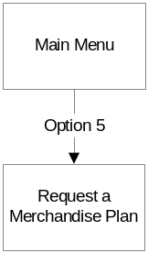

Process Flow
There is no change to the existing process flow however it will no longer be possible to request a merchandise plan unless the store currently has space recorded for the merchandising group or will have a space target greater than zero on the requested date.

Merchandising Group Summary Report

Purpose
This report provides the Space, Range and Merchandising assistant with a summary of the amount of space assigned to each merchandising group in the store and the associated Range class. The report will show exactly the same information as the merchandising group summary screen (section 3.4.1).

Screen Flow
There is no change to the screen flow, which is shown below:
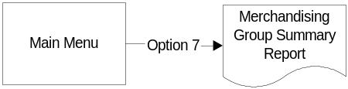

Process Flow
There is no change to the existing process flow but report will be enhanced to show extra information. The report will include all merchandising groups with recorded space and all merchandising groups with either a current or future space target, greater than 0 Mods, or a planned space change entered by the store. This means that if a merchandising group doesn't have any space recorded and the current space target isn't visible to the store then the only details shown for the merchandising group are the merchandising group code and description.

The report will also show all future planned space changes (Both from the centre and the store) rather than just the first change from the centre and the current local ranging policy. The variance from Target will only be shown if the target visibility, maintained by the Space Team, permits it.

This report will only use the centre's space change once the event has been approved and the lead-time of the change is within the defined number of weeks.

Request a Space exception report

Purpose
The Space, Range and Merchandising Assistant can request seven different reports to help them manage space in store. Each of the reports lists a different type of space error.
The seven reports are: -
- Mods with no Merchandising Group assigned
- Mods with unrecognised dimensions and/or equipment
- Mods with no Product Map
- Mods where the Product Map is more than 26 weeks old
- Mods where the Merchandising Group is Not Authorised
- Mods with shelves not Product Mapped
- Summary of the Mods with any of the Space Exception issues

The only reports that requires change as part of this project is the 'Mods where the Merchandising Group is not authorised' report and the 'Summary of the Mods with any of the Space Exception issues'

Screen Flow
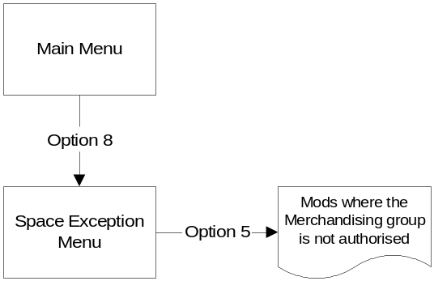

Process Flow
There is no change to the existing process flow apart from report 5, which is currently the 'Mods where the Merchandising Group is Not Authorised' Report. This report is no longer relevant for Extras, Superstores, Homeplus and Metros (including classic Metros) unless the store is located in the ROI, as the concept of authorisation has now been replaced by the Local Ranging Policy. There will also be an associated change to report 7, 'Summary of the Mods with any of the Space Exception issues' to reflect that the 'Mods where the Merchandising Group is Not Authorised' report is no longer valid for the above stores.

If the store now has any Mods where the predominant merchandising group does not allow Local Choice and the store does not have a space target then those Mods will be list as unassigned.

Detailed Screen Design

Ranging Control System -Target Space Component
The Target Space Component of the Ranging Control System consists of fourteen screens that allow the Space Team to maintain the Target Space for every merchandising group within each store. The Target Space component is accessed from an option on the main menu screen of the Ranging Control System.

The screens will meet the standards for the Ranging Control system, as defined in the Business System Design Document - Screen Design Standards.

Ranging Controls Menu

Navigation
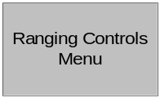

Once the User has successfully logged onto the Ranging Control System the first screen they see is the Ranging Controls Menu. The User can click on any of the options they have access to transfer to the relevant component within the Ranging Control System.

Screen Layout
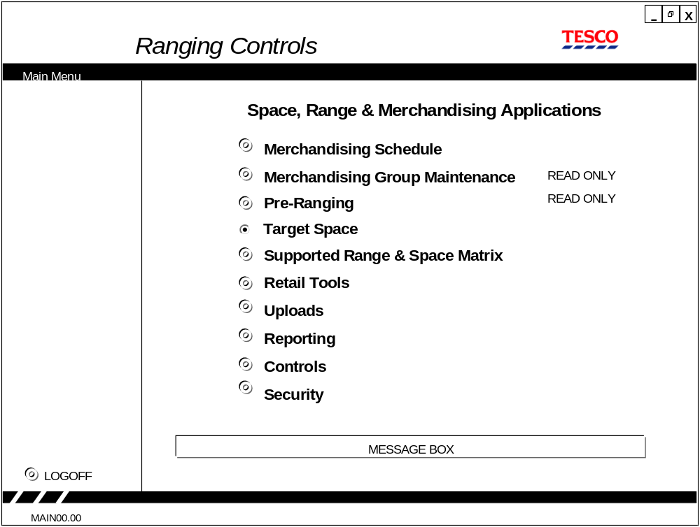
A new option, Target Space, has been added to the existing screen.

Field Descriptions
No new fields have been added to the screen.

Description of Screen Function
The Ranging Controls Menu screen allows the user to select the component he needs.

Validation and error handling
The users security access must be verified using the standard procedures within the Ranging Control System before the User can access the Target Space component.

Upload Menu

Navigation
The Upload menu is selected from the main flight-deck menu.

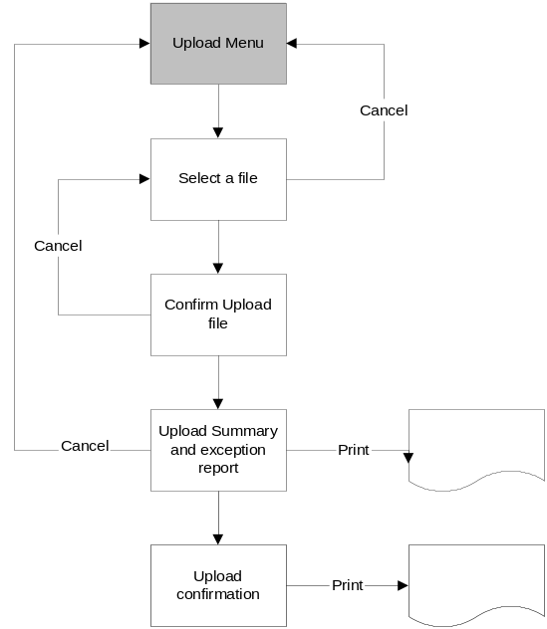

Screen Layout
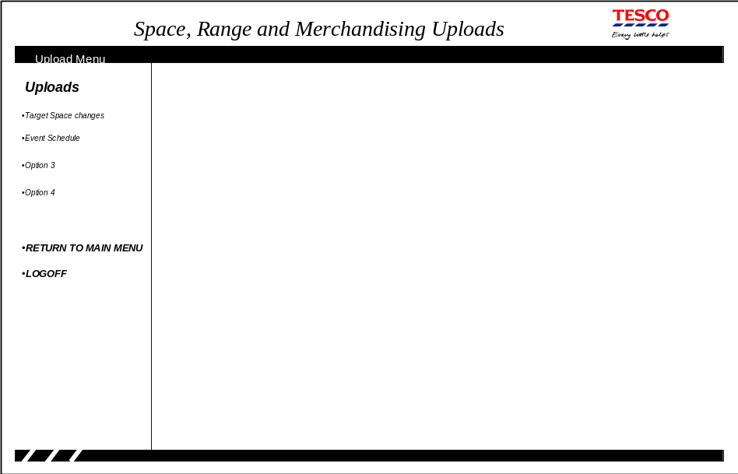

Field Descriptions
There are no fields entered or displayed on this first screen.

Description of Screen Function
The first screen is a menu allowing the User to select the required Upload.

Validation and error handling
This screen doesn't require any specific validation.

Select File
This screen allows the user to select the file to be upload to the Target Space system

Navigation
The screen is entered by selecting Target Space changes from the UPLOAD screen

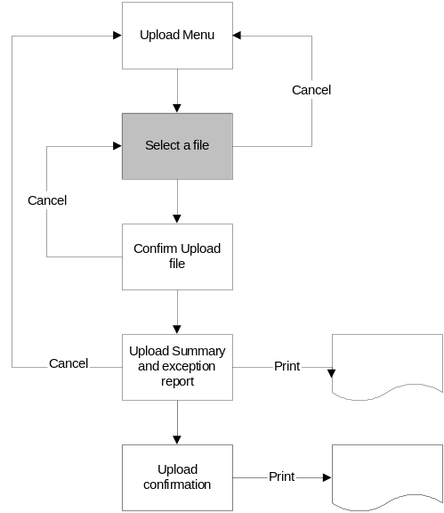

If the User selects the CANCEL button on this screen they are returned to the UPLOAD menu screen.

Screen Layout
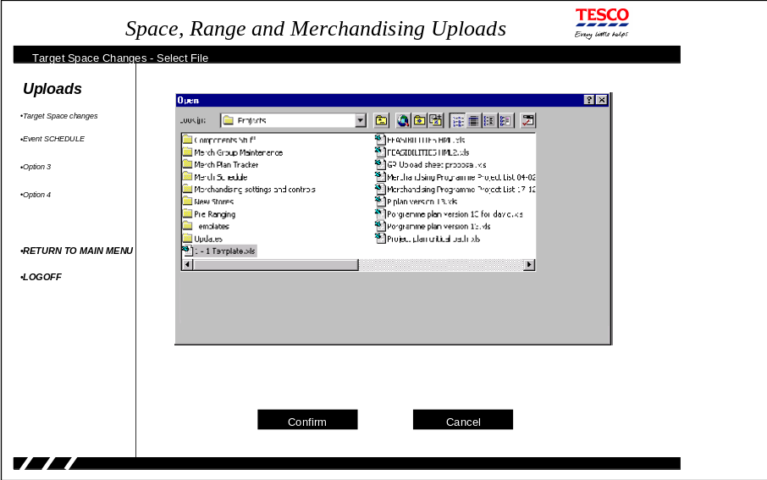

The screen consists of the standard Windows Disk Navigation screen to allow the User to navigate to the file they wish to upload.

Field Descriptions
Field | Description | Comments
File name | The file that contains the Target Space Changes. | Selected by the standard Windows Disk navigation screen

Description of Screen Function
The screen allows the User to select the file that contains the Target Space changes. It is possible for the User to navigate to any local or network drive they are connected, the screen initially defaults to the standard windows file path.

Validation and error handling
This screen doesn't require any specific validation.

Spreadsheet format
The spreadsheet used to store the Target Space changes before the bulk load process must contain at the following columns: -
- Event id
- Store number
- Merchandising Group
- Type of Target Space change
- Action Indicator
- Implementation Date
- Value of Mods
- Number of Mods
- Equipment Type
- Range Class

If the target space change is due to an event on the Space, Range and Merchandising Schedule then the Implementation Date must not be completed as the system will derive the implementation date from the Event id, Merchandising Group and Store number. If the target space change isn't due to an event on the Space, Range and Merchandising system then the Implementation date must be completed and the Event id left blank and all of the entries must be for the same store.

The Action Indicator is either a 'C', Create a new Target Space change, or 'D', Delete an existing Target Space change'.

Confirm Upload File
This screen allows the user to check that the correct file has been selected for the Target Space changes load.

Navigation
Choosing a file from the SELECT file screen brings the user to this screen.

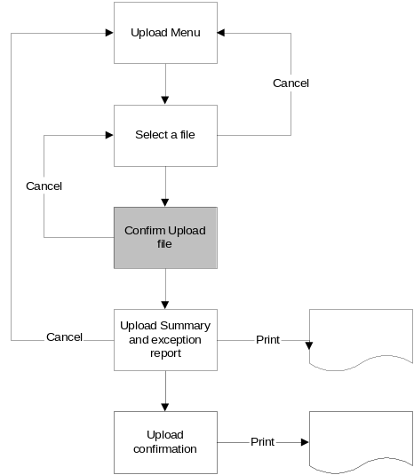

If the User selects the CANCEL button on this screen they are returned to the SELECT file screen so the correct file can be chosen.

Screen Layout
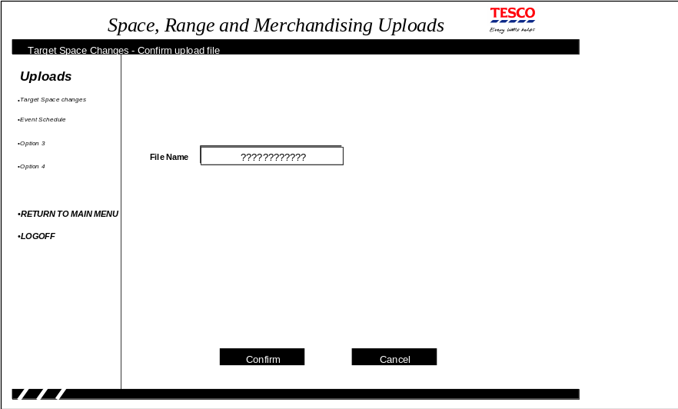

Field Descriptions
Field | Description | Comments
File name | The file that the User wants to load to the Target Space application | The file name cannot be changed on this screen

Description of Screen Function
The screen shows the file selected from the SELECT file screen so that the user can confirm that they have chosen the correct file. When the User confirms that this is the correct file the system validates the file contents and produces a report of any errors found.

Validation and error handling
Screen validation
Field | Validation
File name | If the file doesn't exist then error 17

Spreadsheet validation
Field | Validation
Event Id | If the 'Type of Target Space change' field is associated with a scheduled event, according to the Target Space parameters, then the event id must exist on the Space, Range and Merchandising Schedule. If it doesn't exist then error 211.  If the 'Type of Target Space change' field isn't associated with a scheduled event then the if event id isn't blank error 212.
Store number | If the store doesn't exist on the Store reference database or will be closed prior to the implementation date then error 214.
Merchandising group | If it is not going to be live on the implementation date then error 215
Type of Target Space Change | If it doesn't exist on the Target Space parameters then error 18
Action Indicator | If this is 'C' and a Target Space change already exists for the Store, merchandising group and either the Event id or implementation date then error 216  If this is 'D' and a Target Space change doesn't already exist for the Store, merchandising group and either the Event id or implementation date then error 15.
Implementation Date | If the 'Type of Target Space change' field is associated with a scheduled event then if the event isn't blank error 212.  If the 'Type of Target Space change' field isn't associated with a scheduled event then the implementation date is validated as follows  If invalid dd/mm/yy date format then error 4  If not in the future then error 5  If to far in the future based on the control parameter then warning 6  If within the minimum lead-time based on the control parameter then warning 213.
Value of Mods | If not numeric then error 2 or entered to more than two decimal places
Number of Mods | If not integer numeric then error 2
Equipment Type | If the equipment type isn't a valid equipment type for the merchandising group according to the equipment matrix then error 223
Range Class | If not in the Range A-Z excluding X then error 217
 | If the 'Type of Target Space change' field is associated with a scheduled event then the store and merchandising group must be part of a cluster associated with the event. If it isn't then error 218
 | If the value of Mods contains a value and either the equipment type or number of mods contains a value then error 219
 | If value of Mods doesn't contain a value and either the equipment type or number of mods is blank then error 220
 | If the 'Type of Target Space change' field isn't associated with a scheduled event then all of the Target Space changes must be for the same store. If not then error 221
 | If the 'Type of Target Space change' field is associated with a scheduled event then all of the Target Space changes must be for the same event. If not then error 222
If the 'Type of Target Space change' field is associated with a scheduled event then calculate the implementation date based on the event id, merchandising group and the store cluster that contains the store. Once the implementation date has been calculated: -
If it is not in the future then error 5
If it is to far in the future based on the control parameter then warning 6
If within the minimum lead-time based on the control parameter then warning 213.

Upload Summary and Exception Report
The screen reports any errors in the Target Space change spreadsheet that the user wants to load.

Navigation
Once the user has confirmed that the correct file was selected for the upload the details are validated and they can view the results on this screen.

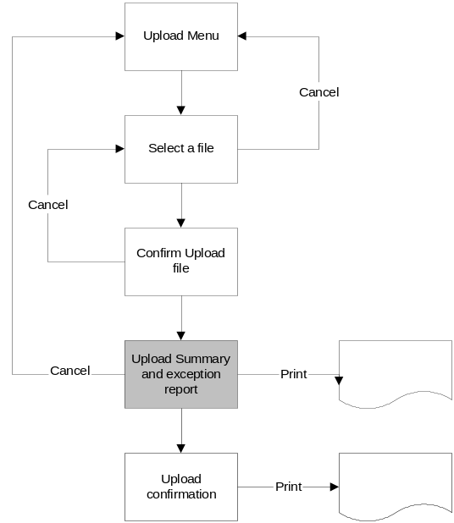

If the User selects the CANCEL button on this screen they are returned to the main Upload menu screen.

Screen Layout
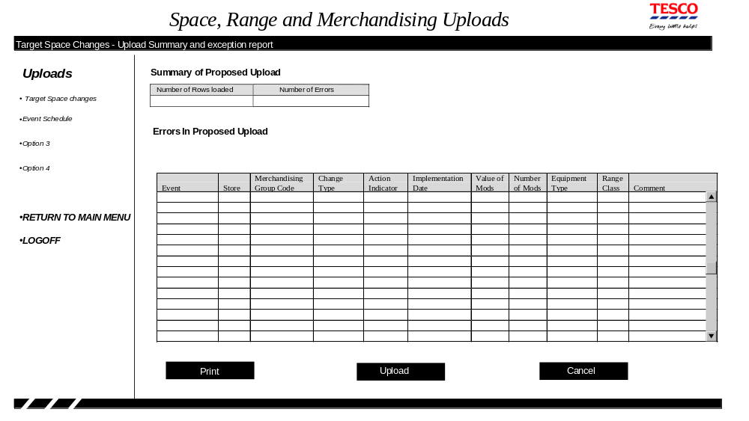

Field Descriptions
Field | Description | Comments
Number of Rows Loaded | The number of rows on the spreadsheet
Number of Errors | The number of rows on the spreadsheet that contained errors
Event ` | The Event id from the spreadsheet | The full event name is available as a tool-tip
Store | The store number from the spreadsheet | The store name is available as a tool-tip
Merchandising Group Code | Merchandising group code from the spreadsheet | The merchandising group description is available as a tool-tip
Change Type | Change Type from the spreadsheet
Action Indicator | The action indicator from the spreadsheet
Implementation Date | The implementation date from the spreadsheet or calculated from the event, merchandising group and store cluster containing the store | If the implementation date has been obtained from the schedule it is 'greyed' out.
Value of mods | Value of Mods from the spreadsheet | May contain two decimal places
Number of Mods | Number of Mods from the spreadsheet | Always an integer
Equipment Type | Equipment type from the spreadsheet
Range class | Range class from the spreadsheet
Comment | Description of the error | The reasons for the errors are described in 4.1.4.5 and the text of the error is in 8.2.1 Error Codes

Description of Screen Function
The screen lists any errors found when validating the target space spreadsheet prior to the user uploading the information to the target space application. If any errors are found with the spreadsheet data the user must CANCEL the upload and correct the errors on the spreadsheet.

The error report can be printed via the PRINT button.

While this screen is active it must be impossible for anybody to change the file being loaded until either the User has completed the load or selected Cancel from this screen.

Validation and error handling
If any errors have been reported on this screen the UPLOAD button must be 'greyed' out as the User is only allowed to continue with the upload if there are no errors in the spreadsheet.

Upload Confirmation
This screen reports the results of loading the spreadsheet to load the changes to Target Space.

Navigation
Once the user has validated the spreadsheet and corrected any errors they can continue with the actual load. Once the load has completed they will see the results on this screen.

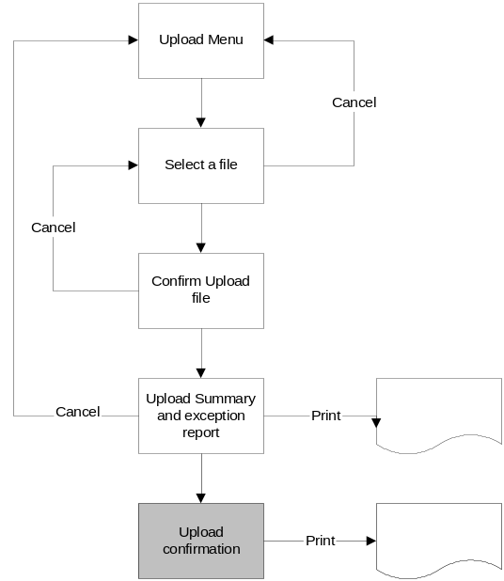

Once the User has reviewed the upload report they can exit the screen using one of the options on the left-hand menu.

Screen Layout
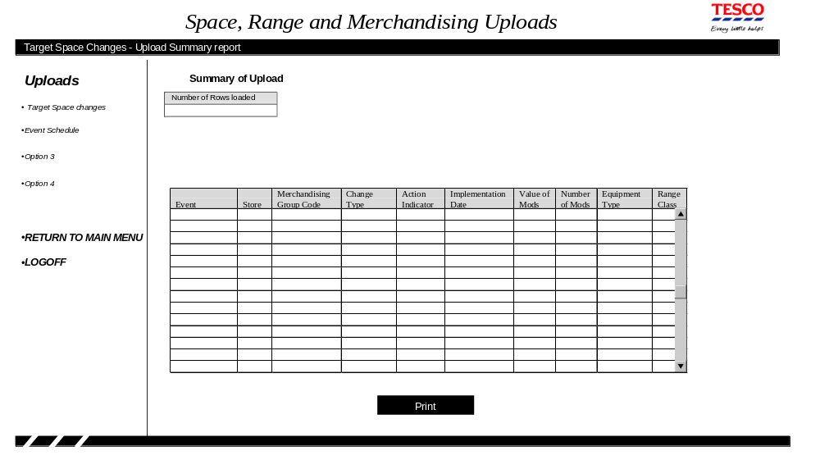

Field Descriptions
Field | Description | Comments
Number of Rows Loaded | The number of rows on the spreadsheet
Event ` | The Event id from the spreadsheet | The full event name is available as a tool-tip
Store | The store number from the spreadsheet | The store name is available as a tool-tip
Merchandising Group Code | Merchandising group code from the spreadsheet | The merchandising group description is available as a tool-tip
Change Type | Change Type from the spreadsheet
Action Indicator | The action indicator from the spreadsheet
Implementation Date | The implementation date from the spreadsheet or calculated from the event, merchandising group and store cluster containing the store | If the implementation date has been obtained from the schedule it is 'greyed' out.
Value of mods | Value of Mods from the spreadsheet | May contain two decimal places
Number of Mods | Number of Mods from the spreadsheet | Always an integer
Equipment Type | Equipment type from the spreadsheet
Range class | Range class from the spreadsheet

Description of Screen Function
The spreadsheet will not be validated as part of the processing for this screen, as the previous screen will already have ensured that all entries on the spreadsheet are valid.

The screen will show every row loaded from the spreadsheet.

The load report can be printed via the PRINT button.

The contents of the screen can be sorted by clicking on the column heading.

Validation and error handling
There is no validation required on this screen.

Add a single change too Target Space
The Space Team uses this screen to add a single change to the Target Space for a merchandising group in store directly into the Ranging Control System.

Navigation
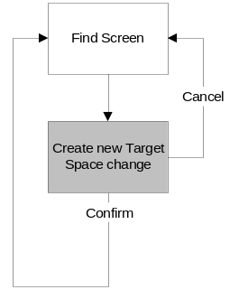
This screen is entered when the user clicks on the 'New Target Space Change' option on the left-hand menu. Once the screen has been entered none of the left-hand menu options are active so the only way to exit the screen is via the Confirm or Cancel button.

Screen Layout
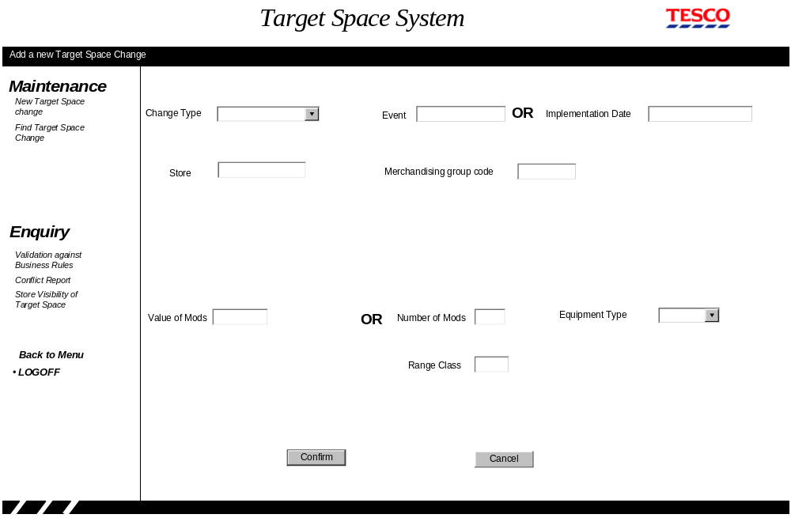
When the user initially enters this screen all of the fields are blank to allow the user to enter the relevant details. Whenever the user selects a drop-down list the available choices must only contain entries that would be valid based on the other details already entered on the screen. E.g. the equipment type drop down boxes would only contain the equipment types that are valid for the entered merchandising group.

Whenever the user moves away from the Event, Store or merchandising group code edit-boxes the relevant description should be displayed on the screen just below the box. It should only be necessary to display the single description field rather than re-display the complete screen.

Once all of the details have been entered the User will click the 'Confirm' button to update the system provided all the details are valid. The user can decide to cancel the entry at anytime prior to the system update by clicking the 'Cancel' button.

Field Descriptions
Field | Description | Comments
Change Type | A list of the Target Space change types defined within the Controls component | The User must select a single entry
Event | The Event Ids for an entry on the Space, Range and Merchandising schedule | Only entered when the change type is associated with an event
Event Name | The name of the event from the Space, Range and Merchandising schedule. | This is directly under the event edit box and is filled in once the event id is entered
Implementation Date | The date that the Target Space change is effective in store | Only entered when the change type is not associated with an event.
Store | Store number
Store Name description | The store name from the store reference database | This is directly under the store edit box and is filled in once the store number is entered
Merchandising group code | Merchandising group code
Merchandising group code description | Merchandising group code description from MGM | This is directly under the merchandising group code edit box and is filled in once the merchandising group code is entered
Value of Mods | The Target Space should equate to the value of Mods for the merchandising group in the store
Number of Mods | The Target space for the merchandising group in store is the number of Mods of the specified equipment type
Equipment Type | The type of equipment that the store should use to implement the target space | The drop down box only lists the equipment types valid for the merchandising group
Range Class | The Range class associated to this amount of Space for the merchandising group.

Description of Screen Function
The screen allows the user to enter a single change to the Target Space for a merchandising group in a store.

The user will either enter the event id or the Implementation date depending on whether the change type they have selected is associated to an Event on the Space, Range and Merchandising schedule. The list of valid change types and whether they are associated with an Event is maintained within the Ranging Control System parameters for Target Space.

The Event name, store name and merchandising group description fields are populated by the system whenever the user leaves the event, store or merchandising group code fields respectively.

The Target Space for a merchandising group in store can either be specified as 'Value of Mods' or alternatively as the 'Number of Mods' of a specified equipment type.

Once all of the details have been entered onto the screen and the users confirms the update then all the fields are validated and the database updated. If any of the fields aren't valid a suitable message is displayed on the screen to allow the user to correct the error before confirming the update once again.

Validation and error handling
Field | Validation
Event | If the 'Type of Target Space change' field is associated with a scheduled event, according to the Target Space parameters, then the event id must exist on the Space, Range and Merchandising Schedule. If it doesn't exist then error 211.  If the 'Type of Target Space change' field isn't associated with a scheduled event then the if event id isn't blank error 212.
Implementation Date | If the 'Type of Target Space change' field is associated with a scheduled event then if the event isn't blank error 212.  If the 'Type of Target Space change' field isn't associated with a scheduled event then the implementation date is validated as follows  If invalid dd/mm/yy date format then error 4  If not in the future then error 5  If to far in the future based on the control parameter then warning 6  If within the minimum lead-time based on the control parameter then warning 213.
Store number | If the store doesn't exist on the Store reference database or will be closed prior to the implementation date then error 214
Merchandising group | If it is not going to be live on the implementation date then error 215
Range Class | If not in the Range A-Z excluding X then error 217
Value of Mods | If not numeric or entered to more than 2 decimal places then error 2
Number of Mods | If not integer numeric then error 2
 | If the 'Type of Target Space change' field is associated with a scheduled event then the store and merchandising group must be part of a cluster associated with the event. If it isn't then error 218
 | If the value of Mods contains a value and either the equipment type or number of mods contains a value then error 219
 | If value of Mods doesn't contain a value and either the equipment type or number of mods is blank then error 220
If the 'Type of Target Space change' field is associated with a scheduled event then calculate the implementation date based on the event id, merchandising group and the store cluster that contains the store. Once the implementation date has been calculated: -
If it is not in the future then error 5
If it is to far in the future based on the control parameter then warning 6
If within the minimum lead-time based on the control parameter then warning 213.

Find an existing Target Space Change

Navigation
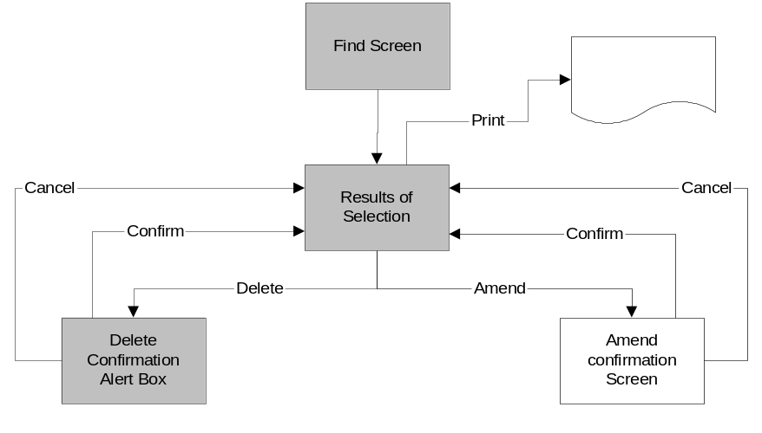
The Find screen is the first screen seen by the user when they log onto the system and can also be accessed from the menu in the left-hand pane. The screen will initially be empty to allow the use to enter the details to identify the target space changes they wish to work on. Once the user presses the search button the screen grid contains all of the Target Space changes that meet the search criteria.

The user can Amend, Delete or Print one or more of the Target Space changes. If the user selects one or more Target Space changes to delete the system responds with an Alert Box to summarise the number of entries to be deleted so that the user can confirm or cancel the delete. If the User selects one or more Target Space changes to amend the system responds with another screen listing all of the changes so that the user can confirm or cancel the amendments. Once the user either confirms or cancel the change the results of the find screen are re-displayed.

The user may, at any time, change the selection criteria in the top half of the screen and click the Search button to refresh the result grid. If the user does this while after making any changes to the details on the grid which haven't yet been applied the system display an Alert Box to warn them that their changes will be lost.

The use may also use the left-hand navigation screen to transfer to another function from this screen if they haven't entered any amendments.

Screen Layout
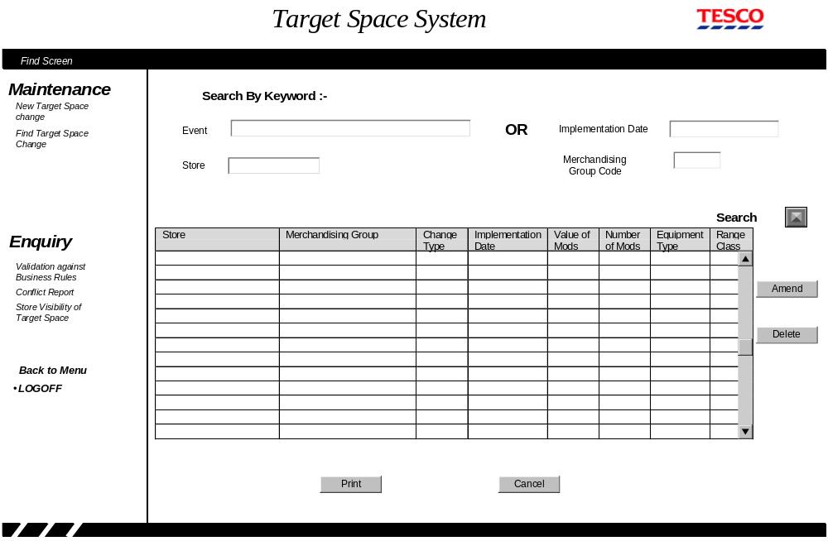
The same screen layout is used for the both the 'Find Screen' and the 'Results of Selection' screen. When the user first enter the screen it doesn't initially contain any data.

Field Descriptions
Field | Description | Comments
Search fields
Event | The Event Ids for an entry on the Space, Range and Merchandising schedule
Event Name | The name of the event from the Space, Range and Merchandising schedule. | This is directly under the event edit box and is filled in once the event id is entered
Implementation Date | The date that the Target Space change is effective in store
Store | Store number
Store Name description | The store name from the store reference database | This is directly under the store edit box and is filled in once the store number is entered
Merchandising group code | Merchandising group code | The user may just enter the merchandising department or section instead.
Merchandising group code description | Merchandising group code description from MGM | This is directly under the merchandising group code edit box and is filled in once the merchandising group code is entered
Results Grid
Store | Store number and name | This cannot be amended
Merchandising group code | Merchandising group code and description | This cannot be amended
Change Type | The change type of the target space change | This cannot be amended
Implementation Date | The date that the Target Space change is effective in store | If the target space change is due to a scheduled event this is calculated from the schedule and the store clusters and 'greyed out' on this screen.  This cannot be amended for a schedule event but can for other changes
Value of Mods | The Target Space should equate to the value of Mods for the merchandising group in the store | The current target space change details. This field may be amended
Number of Mods | The Target space for the merchandising group in store is the number of Mods of the specified equipment type | The current target space change details. This field may be amended
Equipment Type | The type of equipment that the store should use to implement the target space | The current target space change details. This field may be amended
Range Class | The Range class associated to this amount of Space for the merchandising group. | The current target space change details. This field may be amended

Description of Screen Function
This screen allows the user to make any necessary changes to the Target Space changes that have already been entered into the system.

If the User wants to work on the target space changes associated with an Event on the Space Range and Merchandising schedule they must enter the Event id. If required they can also enter the store number and/or the merchandising group code to cut down the number of rows returned. When working on target space changes associated with an Event the Implementation date is always left blank.

If the User wants to work on target space changes that aren't associated with an Event, e.g. UKBE changes; they must enter the Store number and leave the Event Id blank. The user will also want to enter the implementation date and/or merchandising group code to cut down the number of rows returned but neither of these are compulsory.

Instead of entering the full three character merchandising group code on this screen the user may enter either the one character merchandising department code or the two character merchandising section code. This will then return all entries for the merchandising department or section respectively.

The Event name, store name and merchandising group description fields, situated under each edit box are populated by the system whenever the user leaves the event, store or merchandising group code fields respectively.

Once the user has clicked on the 'Search button' and the result grid has been populated then the user can amend, delete or print the one or more target space changes.

To amend a target space change the user over-types the existing values (either value of mods or Number of Mods and equipment type) and once they have amended all of entries they need to on the grid they click on the Amend button. Once the 'Amend' button is clicked the system validates all of the changes and assuming they are valid produces the 'Amend Confirmation Screen' described in Section 4.1.9. If the user attempts to navigate away from this screen or refresh the screen after amending any entries a warning is displayed to high-light that their changes will be lost and giving them the option to return to the results grid and apply the changes.

To delete one or more target space changes the user selects the rows involved using the standard window's keys to select more than one row if required. Once all the rows on the grid have been select the User clicks the 'Delete' button, which will produce an Alert box, shown below, stating the number of rows that will be deleted. This will allow the user to either confirm or cancel the deletes.
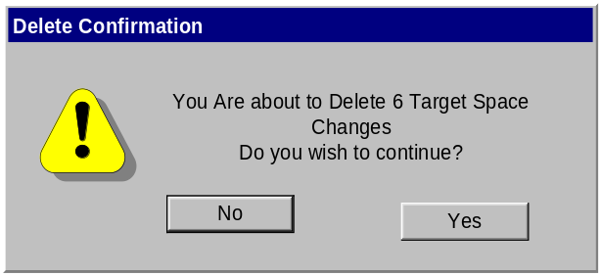
If the User wants to print the Target Space details they have the option of either printing all of the results in the grid or just selected rows.

Validation and error handling

Search Fields
Field | Validation
Event | If the event isn't on the Schedule then error 211
Implementation Date | If invalid dd/mm/yy date format then error 4
Store number | If the store doesn't exist on the Store reference database then error 15
Merchandising group | If it doesn't exist in MGM then error 15

Amendments
Implementation Date | This can only be amended if the target space change isn't associated with an Event.  If invalid dd/mm/yy date format then error 4  If not in the future then error 5  If to far in the future based on the control parameter then warning 6  If within the minimum lead-time based on the control parameter then warning 213.
Value of Mods | If not numeric or entered to more than 2 decimal places then error 2
Number of Mods | If not integer numeric then error 2
Equipment Type | If not valid for the merchandising group then error 223
Range Class | If not in the Range A-Z excluding X then error 217
 | If the value of Mods contains a value and either the equipment type or number of mods contains a value then error 219
 | If value of Mods doesn't contain a value and either the equipment type or number of mods is blank then error 220
 | If the user clicks the 'Amend' button without making any changes to the result grid then Information message 224
 | If the user attempts to navigate away from this screen after updating any details on the grid then question 11

Deletions
Existing Implementation Date | If not in the future then error 5  If to far in the future based on the control parameter then warning 6  If within the minimum lead-time based on the control parameter then warning 213.
 | If the user clicks the 'Delete' button without selecting any rows on the result grid then information message 225

Amendment confirmation Screen

Navigation
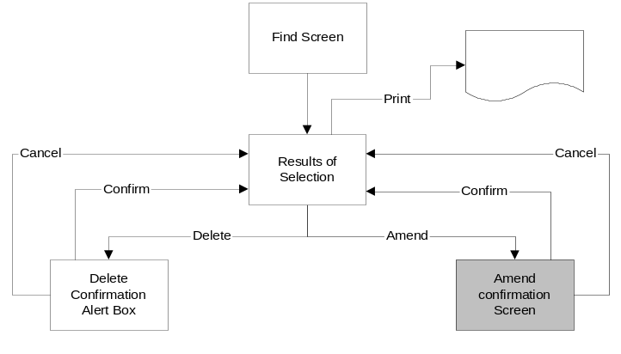
This screen can only be accessed from the Results screen from the Find Screen once the user has amended the space targets and clicked on the 'Amend' button. The user has the option of either confirming the amendment or cancelling the update, in both cases the user is returned to the 'Results of Selection' screen.

Screen Layout
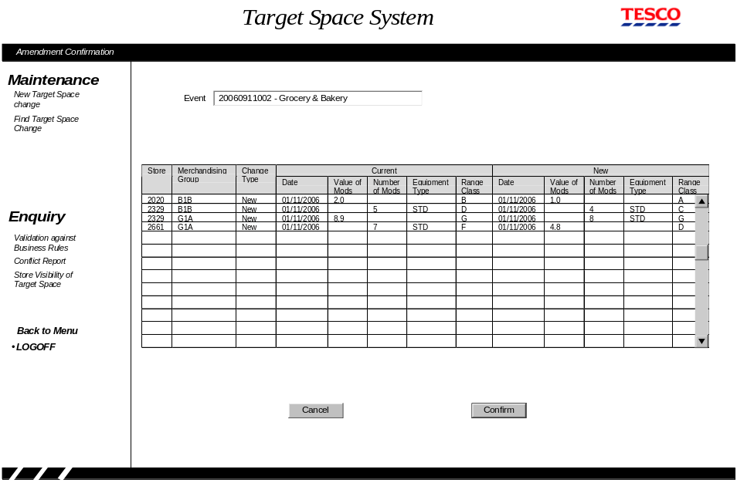

The screen grid is split into three distinct parts. The 3 left most columns identify the target space change that was amended on the previous screen. The next five colums, labelled current, show the value of target space held on the database while the last 5 colums, labelled new, show the amended values.

Field Descriptions
Field | Description | Comments
Event | The Event Id and name associated with the target space change | The system only fills this in if the target space changes being amended are associated with an Event.
Store | Store number
Merchandising group code | Merchandising group code
Current Values
Implementation Date | The existing implementation date for this target space change
Value of Mods | The existing 'value of mods' for this target space change
Number of Mods | The existing 'number of mods' for this target space change
Equipment Type | The existing equipment type for this target space change
Range Class | The existing range class for this target space change
New Values
Implementation Date | The amended implementation date for this target space change
Value of Mods | The amended 'value of mods' for this target space change
Number of Mods | The amended 'number of mods' for this target space change
Equipment Type | The amended equipment type for this target space change
Range Class | The amended range class for this target space change

Description of Screen Function
This screen provides the user with confirmation of the changes they have made on the 'Find' screen results grid before they confirm the changes and which would then be applied to the database. If the user isn't happy with the changes they entered on the previous screen they can cancel the update from this screen so no changes are made to the database.

None of fields can be amended on this screen.

Validation and error handling
Field | Validation
 | If any of the current values on the Database have changed since the screen was displayed then error 226. If this error occurs none of the amendments should be applied.

Validation Against Business Rules - Selection Screen

Navigation
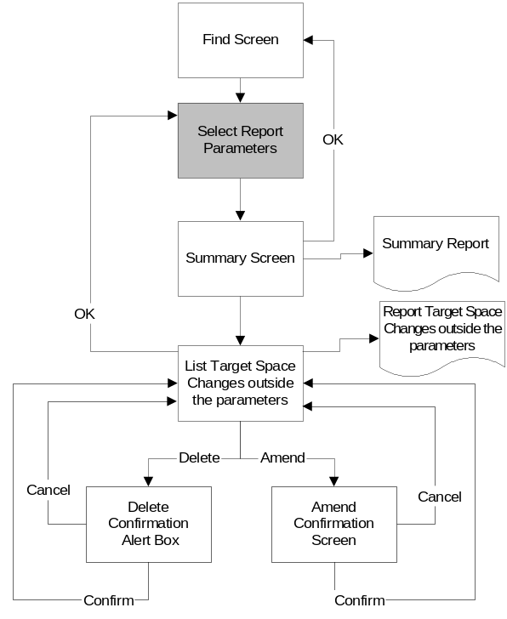
Clicking on 'Validation against Business Rules' option in the left-hand menu pane takes the user to the first screens used to validate the target space changes. This screen allows the user to enter enough details to identify the Target Space changes that should be validated. When the search button is clicked the system produces a summary of the Target Space changes.

Screen Layout
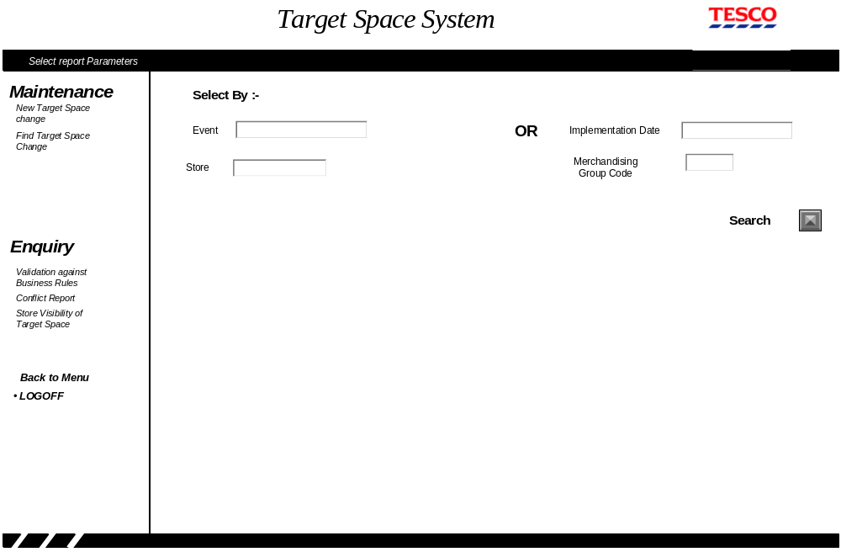
When the user enters this screen all of the fields are blank to allow the user to enter enough detail to identify the Target Space changes they wish to check.

Field Descriptions
Field | Description | Comments
Event | The Event Ids for an entry on the Space, Range and Merchandising schedule
Event Name | The name of the event from the Space, Range and Merchandising schedule. | This is directly under the event edit box and is filled in once the event id is entered
Implementation Date | The date that the Target Space change is effective in store
Store | Store number
Store Name description | The store name from the store reference database | This is directly under the store edit box and is filled in once the store number is entered
Merchandising group code | Merchandising group code | The user may enter the merchandising department or section code instead
Merchandising group code description | Merchandising group code description from MGM | This is directly under the merchandising group code edit box and is filled in once the merchandising group code is entered

Description of Screen Function
This screen allows the user enter sufficient details to identify the target space changes they wish to check.

If the User wants to check on the target space changes associated with an Event on the Space Range and Merchandising schedule they must enter the Event id. If required they can also enter the store number and/or the merchandising group code to cut down the number of rows returned. For example if G1D, Rice and Cooking Sauces merchandising group is increasing space while the G1A - Canned Vegetable merchandising group is reducing space the user would probably validate each of these separately. This allows the user to see if any of the stores were their target space for G1D or increasing their target space for G1A directly from the summary screen.

If the User wants to check target space changes that aren't associated with an Event, e.g. UKBE changes; they must enter the Store number and implementation date but leave the Event Id blank. The user may also want to enter the merchandising group code to cut down the number of rows returned but neither of these are compulsory.

Instead of entering the full three character merchandising group code on this screen the user may enter either the one character merchandising department code or the two character merchandising section code. This will then check all entries for the merchandising department or section respectively.

The Event name, store name and merchandising group description fields, situated under each edit box are populated by the system whenever the user leaves the event, store or merchandising group code fields respectively.

Once the user has clicked on the 'Search button' and the validation summary screen is produced.

Validation and error handling
Field | Validation
Event | If the event isn't on the Schedule then error 211
Implementation Date | If invalid dd/mm/yy date format then error 4
Store number | If the store doesn't exist on the Store reference database then error 15
Merchandising group | If it doesn't exist in MGM then error 15
 | If the implementation date has been entered without a store number then error 3
 | If neither an event id or implementation date has been entered then error 3

Validation against Business Rules - Summary Screen

Navigation
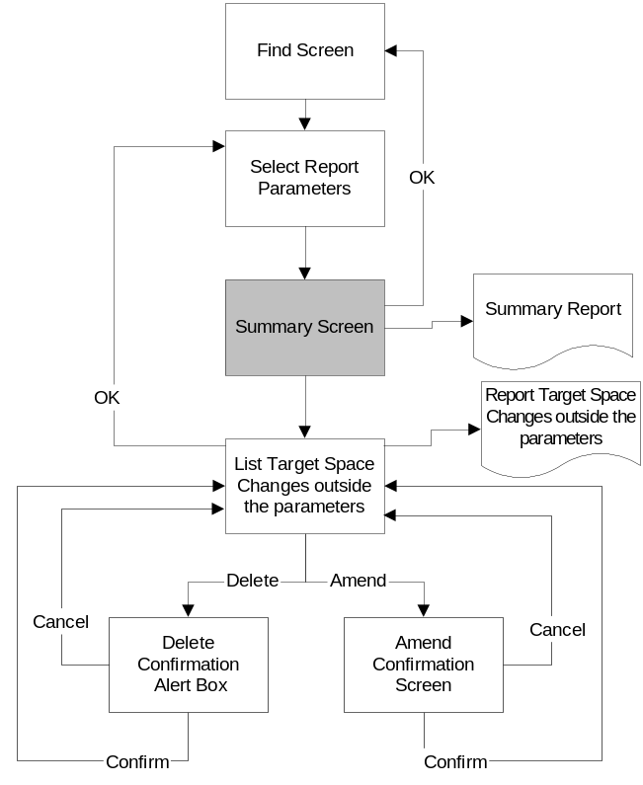
The summary screen is entered from the Validation against Business Rules selection screen. Once at this the user may print the summary report, transfer to the detailed list screen or return to the screen to the find screen via the OK button. In addition to this the user can change the selection parameters on this screen to produce another summary screen once they click the search button.

The use may also use the left-hand navigation screen to transfer to another function from this screen.

Screen Layout
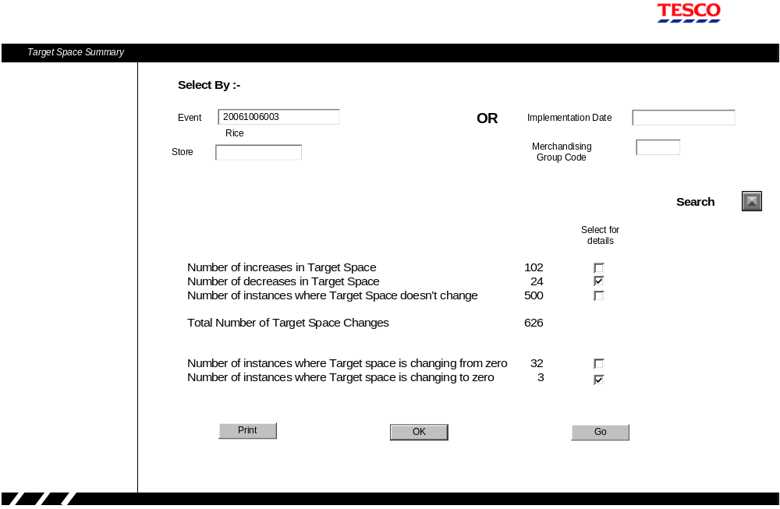

Field Descriptions
Field | Description | Comments
Event | The Selected Event ID entered on the previous screen | This maybe blank and can be changed
Event Name | The name of the event from the Space, Range and Merchandising schedule. | If a new event id is entered then this must be updated
Implementation Date | The implementation date entered on the previous screen | Maybe blank and can be changed
Store | Store number entered on the previous screen | Maybe blank and can be changed
Store Name description | The store name from the store reference database | This is directly under the store edit box and must be updated if the store number changes.
Merchandising group code | Merchandising group code entered on the previous screen | The user may enter the merchandising department or section code instead. This field maybe blank and can be changed.
Merchandising group code description | Merchandising group code description from MGM | This is directly under the merchandising group code edit box and must be updated if the merchandising group code is changed.
Number of increases in target Space | The count of the number of instances where the target space for the selection criteria is increasing compared to the value in effect immediately before this date
Number of decreases in target Space | The count of the number of instances where the target space for the selection criteria is decreasing compared to the value in effect immediately before this date
Number of instances where target Space doesn't change | The count of the number of instances where the target space for the selection criteria is increasing compared to the value in effect immediately before this date | This figure only includes instances where a target space change has been entered, therefore if a target space exists for store 2008 and implementation date 06/10/2006  And there is a target space change for G1D then this figure will not include all other merchandising groups.
Total number of Target Space changes | The total number of target space changes that meet the selection criteria
Number of instances where target Space is changing from zero. | The count of the number of instances where the target space for the selection criteria is greater than zero but was zero immediately before this date | This includes all instances were there is a target space change and one didn't exist beforehand
Number of instances where target Space is changing to zero. | The count of the number of instances where the target space for the selection criteria is now zero but was greater than zero immediately before this date

Description of Screen Function
This screen provides the user with a summary of how the Target Space changes are broken down so that if there are instances that don't match the overall objectives of the Target Space change the user can request a list of those that require further investigate. When calculating the amount of target space for each store merchandising group then if the Target Space has been entered as the number of mods of a particular equipment type it must be converted to the value of Mods before being compared using the information on the equipment matrix.

The user can select a list of the target space changes in any category by selecting the relevant tick-boxes and clicking the 'GO' button.

Clicking the 'Print' button prints the target space change summary.

Once the user has finished with the summary screen they can either enter new selection criteria, click the 'OK' button to return to 'Find' screen or navigate to another function via the left-hand menu. If the user starts to enter any new details into the selection criteria the counts should be blanked out until the 'Search' button is clicked, apart from this the validation and processing of the selection criteria follows the same rules as the Validation Against Business Rules - Selection Screen 4.1.10.

Validation and error handling
The validation only applies if the User changes any of the selection criteria.
Field | Validation
Event | If the event isn't on the Schedule then error 211
Implementation Date | If invalid dd/mm/yy date format then error 4
Store number | If the store doesn't exist on the Store reference database then error 15
Merchandising group | If it doesn't exist in MGM then error 15
 | If the implementation date has been entered without a store number then error 3
 | If neither an event id or implementation date has been entered then error 3

Validation against Business Rules - List Screen

Navigation
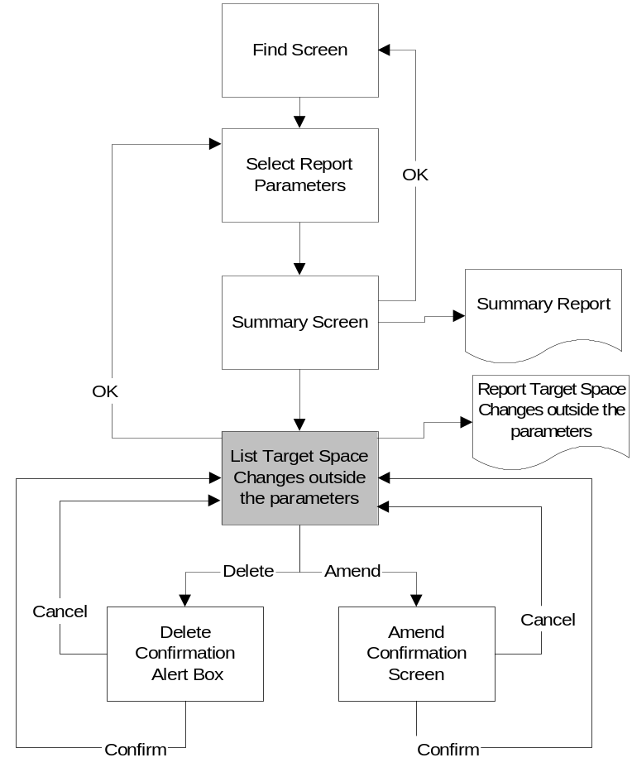
The list of Target Space changes screen is entered by selecting the categories that the user wants to investigate from the Validation against Business Rules - Summary Screen.

From the 'List of Target Space changes' screen the user can amend or delete any of the entries which will result in either the 'Amend Confirmation Screen' or the 'Delete Confirmation Alert Box' respectively. Once the User has completed all of the required changes they can either click 'OK' to return to the Validation Against Business Rules - Selection Screen or use the left-hand menu pane to choose another function.

Screen Layout
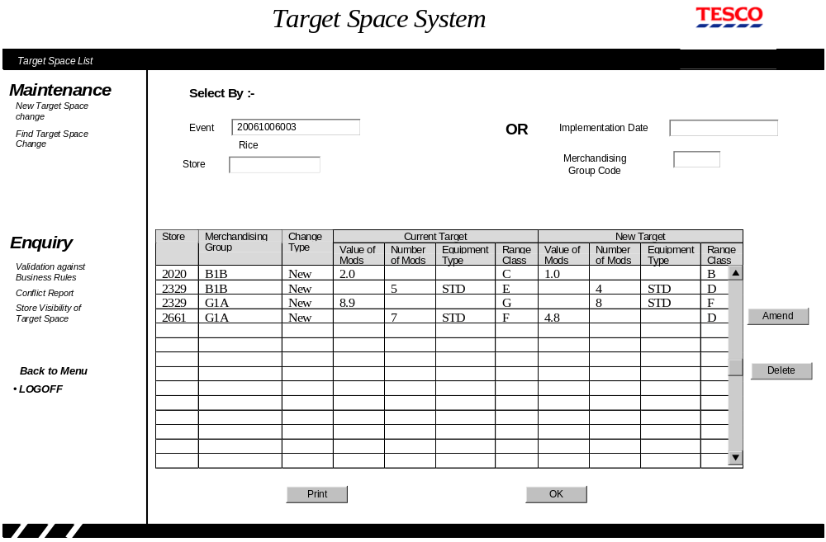

Field Descriptions
Field | Description | Comments
Selection heading
Event | The Selected Event ID entered on the previous screen | This maybe blank
Event Name | The name of the event from the Space, Range and Merchandising schedule.
Implementation Date | The implementation date entered on the previous screen | Maybe blank
Store | Store number entered on the previous screen | Maybe blank
Store Name description | The store name from the store reference database | This is directly under the store edit box.
Merchandising group code | Merchandising group code entered on the previous screen | Maybe blank
Merchandising group code description | Merchandising group code description from MGM
Results Grid
Store | Store number | This cannot be amended
Merchandising group code | Merchandising group code | This cannot be amended
Change Type | The change type of the target space change | This cannot be amended
Current Value of Mods | The Value of Mods that exists on the day prior to the Target Space change | This cannot be amended
Current Number of Mods | The Number of Mods that exists on the day prior to the Target Space change | This cannot be amended
Current equipment Type | The type of equipment that exists on the day prior to the Target Space change | This cannot be amended
Current Range Class | The Range class that exists on the day prior to the Target Space change. | This cannot be amended
New Value of Mods | The new Target Value of Mods | This can be amended
New Number of Mods | The new target Number of Mods. | This can be amended
New equipment Type | The new type of equipment. | This can be amended
New Range Class | The new Range class. | This can be amended

Description of Screen Function
The screen shows every target space change that meets the criteria entered on the previous screen and allows the user to amend or delete any of the entries.

To amend the target space change for the selected Event or implementation date the user over-types the existing values (either value of mods or Number of Mods and equipment type) and once they have amended all of entries they need to on the grid they click the Amend button. Once the amend button is clicked the system validates all of the changes and assuming they are valid produces the 'Amend Confirmation Screen' described in Section 4.1.9 Amendment confirmation Screen. If the user attempts to navigate away from this screen or refresh the screen after amending any entries a warning is displayed to high-light that their changes will be lost and giving them the option to return to the results grid and apply the changes.

To delete one or more target space changes for the Event or implementation date the user selects the rows involved using the standard window's keys to select more than one row if required. Once all the rows on the grid have been selected the User clicks the 'Delete' button, which will produce an Alert box, shown below, stating the number of rows that will be deleted. This will allow the user to either confirm or cancel the deletes.

If the User wants to print the Target Space details they have the option of either printing all of the results in the grid or just selected rows.

Validation and error handling

Amendments
Value of Mods | If not numeric or entered to more than 2 decimal places then error 2
Number of Mods | If not integer numeric then error 2
Equipment Type | If not valid for the merchandising group then error 223
Range Class | If not in the Range A-Z excluding X then error 217
 | If the value of Mods contains a value and either the equipment type or number of mods contains a value then error 219
 | If value of Mods doesn't contain a value and either the equipment type or number of mods is blank then error 220
 | If the user clicks the 'Amend' button without making any changes to the result grid then Information message 224
 | If the user attempts to navigate away from this screen after updating any details on the grid then question 11

Deletions
Existing Implementation Date | If not in the future then error 5  If to far in the future based on the control parameter then warning 6  If within the minimum lead-time based on the control parameter then warning 213.
 | If the user clicks the 'Delete' button without selecting any rows on the result grid then information message 225

Space Conflict Parameters
The term Space Conflict is used to describe the situation where there is more than one Target Space changes for the same store and merchandising group within a short time period.

Navigation
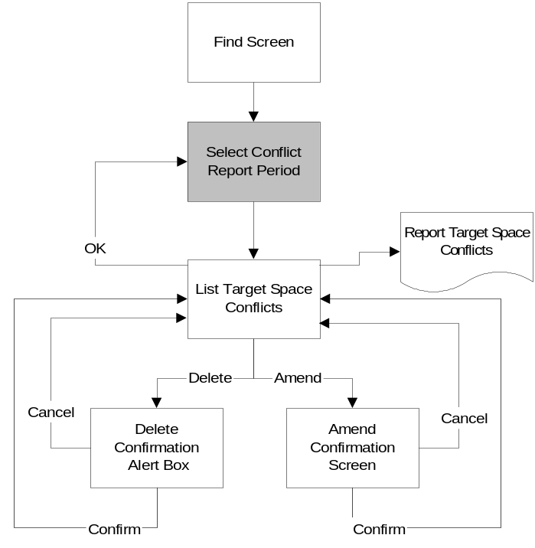

The screen to enter the parameters to identify any Space Conflicts is entered by clicking on the 'Conflict Report' entry on the left-hand menu pane. Once the parameters have been entered the system will list any Conflicts found.

Screen Layout
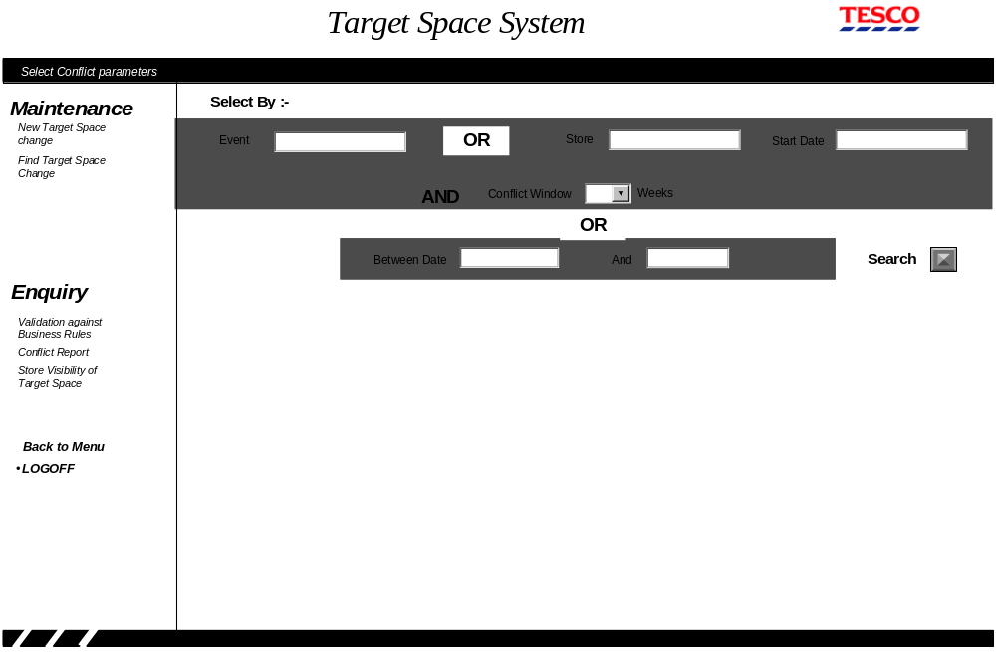

Field Descriptions
Field | Description | Comments
Event | The required Event ID if entered User wants to check for conflicts for a scheduled even | This maybe blank
Event Name | The name of the event from the Space, Range and Merchandising schedule. | This is directly under the Event ID edit box and is filled in once the event id is entered.
Store | Store number | Maybe blank
Store Name description | The store name from the store reference database | This is directly under the store edit box and is filled in once the event id is entered.
Start Date | The start date for the conflict report
Conflict Window | The number of weeks to check for conflicts
Between Dates | The start and end date of the conflict report

Description of Screen Function
This screen allows the User to specify the time period they wish to check for any space conflicts. There are three different methods of entering the details depending on whether the user wants to check for conflicts with a scheduled Event or for any conflicts with changes entered as part of the UKBE process or just a general check.

If the User wants to check for any conflicts with a scheduled Event they must enter the event id and the number of weeks to be checked. The system will then look for any conflicts that involve the stores and merchandising groups that are part of the event within the following time period when the search button is clicked.

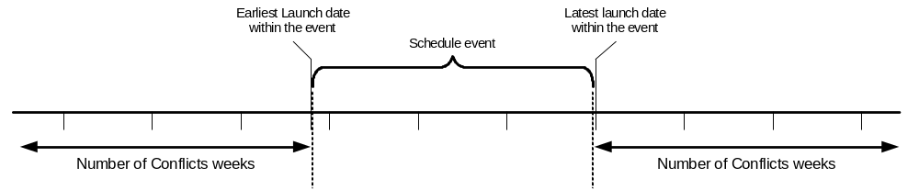 If the User wants to check if there are any conflicts that affect the UKBE process within a store they will enter the store number, the start date they wish to check from and the number of week to check. The system will then look for any conflicts within the selected store from the specified start date when the search button is clicked.

The third option available to the User is enter the start and end date to check which will then produce a report of all the Space conflicts that exist within the Target Space system when the search button is clicked.

The maximum number of weeks that may be selected in the conflict window drop-down box is limited to the value of the parameter maintained within the Controls component of the Ranging Control System.

Whenever the User enters an Event ID or a store number the system responds with the Event name or store respectively when they move away from edit-box.

Validation and error handling
Event | If the event doesn't exist on the Space, Range and Merchandising schedule then error 211
Store | If the store doesn't exist on the Store reference database or will be closed prior to the implementation date then error 214
Start Date | If invalid dd/mm/yy date format then error 4  If not in the future then error 5
Between Dates | If invalid dd/mm/yy date format then error 4  If not in the future then error 5  If the number of weeks between the two dates is greater than the parameter limiting the number of weeks on the Conflict report then error 227

Space Conflicts List

Navigation
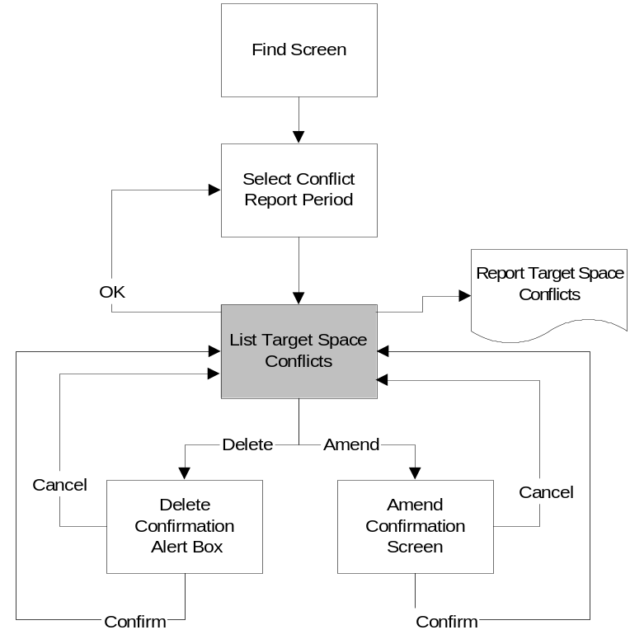
The screen to list Target Space conflicts is entered by clicking the Search button on the Select Conflict report period screen.

From the 'List of Target Space conflicts' screen the user can amend or delete any of the entries which will result in either the 'Amend Confirmation Screen' or the 'Delete Confirmation Alert Box' respectively. Once the User has completed all of the required changes they can either click 'OK' to return to the Space Conflict Parameters screen or use the left-hand menu pane to choose another function.

Screen Layout
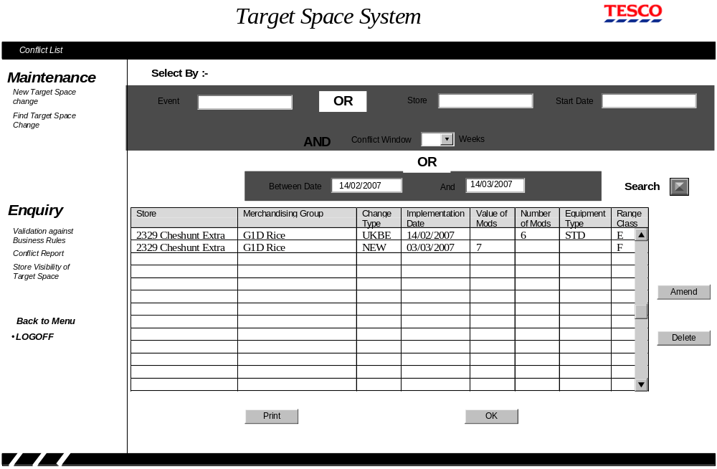

Field Descriptions
Field | Description | Comments
Selection heading
Event | The Selected Event ID entered on the previous screen | This maybe blank
Event Name | The name of the event from the Space, Range and Merchandising schedule. | This is directly under the Event ID edit box and is filled in once the event id is entered.
Store | Store number | Maybe blank
Store Name description | The store name from the store reference database | This is directly under the store edit box and is filled in once the event id is entered.
Start Date | The start date for the conflict report
Conflict Window | The number of weeks to check for conflicts
Between Dates | The start and end date of the conflict report
Results Grid
Store | Store number and name | This cannot be amended
Merchandising group code | Merchandising group code and description | This cannot be amended
Change Type | The change type of the target space change | This cannot be amended
Current Value of Mods | The Value of Mods that exists on the day prior to the Target Space change | This cannot be amended
Value of Mods | The Target Value of Mods | This can be amended
Number of Mods | The target Number of Mods. | This can be amended
equipment Type | The type of equipment. | This can be amended
Current Range Class | The Range class. | This can be amended

Description of Screen Function
The screen shows any target space change that exists in the system where the implementation date is close to another target space change for the same store and merchandising group.

Once all of the conflicts have been listed the User can amend any of the Target Space details by over-typing the existing values (range class and either value of mods or Number of Mods and equipment type). Once all of the entries have been amended the User clicks Amend button to validate the changes. If all the changes are valid the system outputs the 'Amend Confirmation Screen' described in Section 4.1.9 Amendment confirmation Screen. If the user attempts to navigate away from this screen or refresh the screen after amending any entries a warning is displayed to high-light that their changes will be lost and giving them the option to return to the results grid and apply the changes.

To delete one or more target space changes in the result grid the User selects the relevant rows using the standard Window's keys to select more than one row if required. Once all the rows on the grid have been selected the User clicks the 'Delete' button, which will produce an Alert box, shown below, stating the number of rows that will be deleted. This will allow the user to either confirm or cancel the deletes.

If the User wants to print the Conflict report they have the option of either printing all of the results in the grid or just selected rows.

Validation and error handling

Amendments
Value of Mods | If not numeric or entered to more than 2 decimal places then error 2
Number of Mods | If not integer numeric then error 2
Equipment Type | If not valid for the merchandising group then error 223
Range Class | If not in the Range A-Z excluding X then error 217
 | If the value of Mods contains a value and either the equipment type or number of mods contains a value then error 219
 | If value of Mods doesn't contain a value and either the equipment type or number of mods is blank then error 220
 | If the user clicks the 'Amend' button without making any changes to the result grid then Information message 224
 | If the user attempts to navigate away from this screen after updating any details on the grid then question 11

Deletions
Existing Implementation Date | If not in the future then error 5  If to far in the future based on the control parameter then warning 6  If within the minimum lead-time based on the control parameter then warning 213.
 | If the user clicks the 'Delete' button without selecting any rows on the result grid then information message 225

CBI - Merchandising Group Information

Navigation
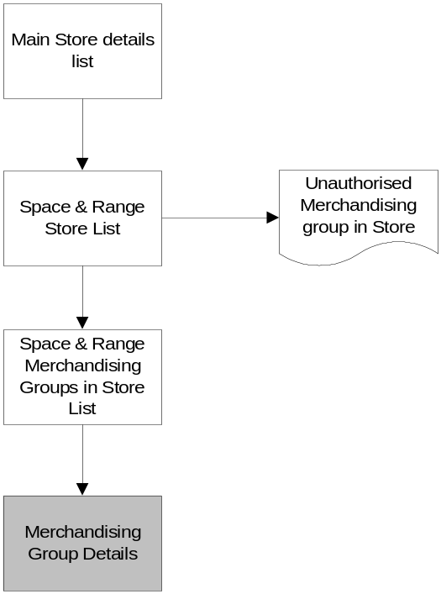
There is no change to the existing navigation.

Screen Layout
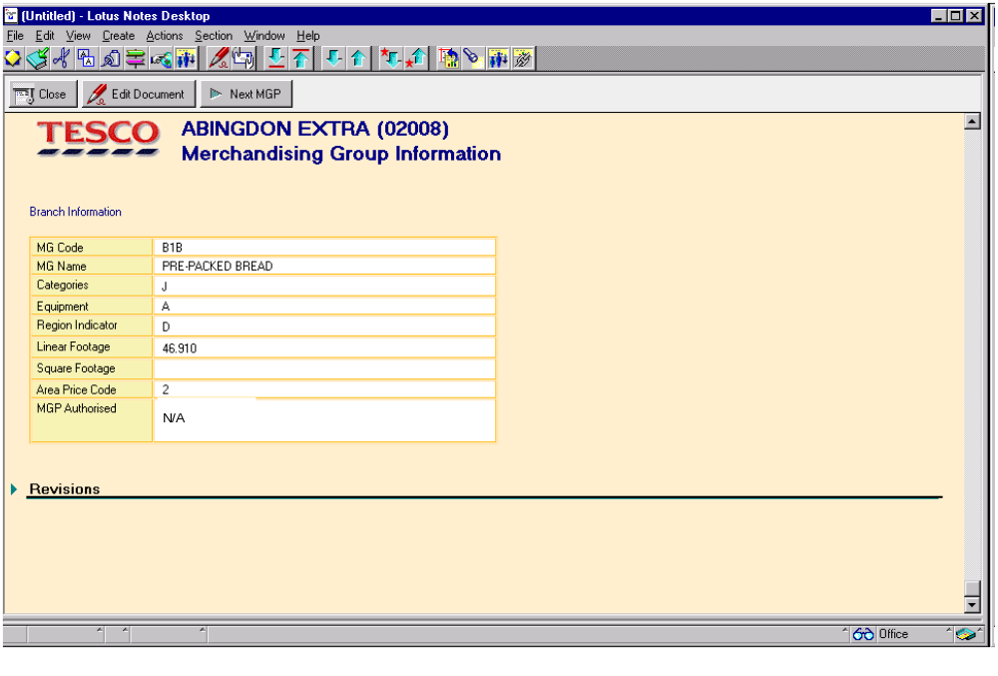

Field Descriptions
There is no change to the fields on this screen except that the authorisation indicator will be shown as N/A unless the store is in the Republic of Ireland or it is an Express.

Description of Screen Function
The screen shows the space and range details for a merchandising group store three weeks in advance of actual change.

Validation and error handling
The only change to the validation is User cannot change the authorisation indicator unless the store is in the Republic of Ireland or it is an Express.

Ranging Control System - Controls Component
The Controls Component of the Ranging Control System is being extended by two new screens so that the Operations Team can maintain the parameters needed by the Target Space component.. The Target Space component is accessed from an option on the main menu screen of the Ranging Control System.

The screens will meet the standards for the Ranging Control system, as defined in the Business System Design Document - Screen Design Standards.

Menu Screen

Navigation
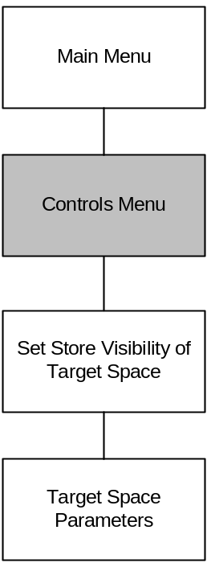

Clicking on the 'Controls' option from the Main Ranging Controls menu screen accesses the Controls Menu screen. Clicking the 'Target Space' option on this screen can then access the Target Space parameters.

Screen Layout
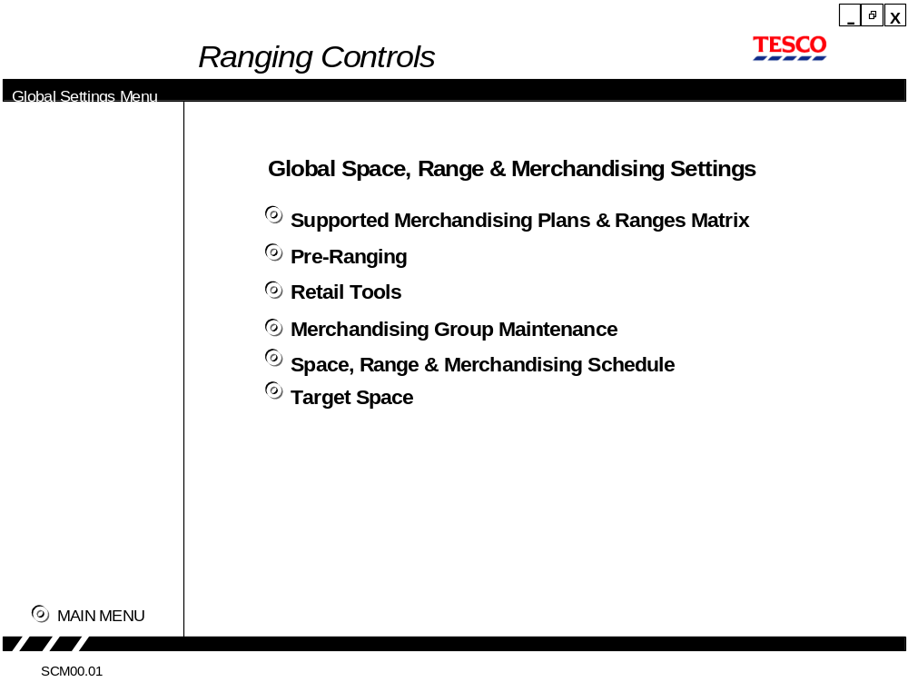

Field Descriptions
There are no fields on this screen

Description of Screen Function
This User can select the set of controls to maintain.

Validation and error handling
There is no validation or error handling associated with this screen.

Setting Store Visibility of Target Space

Navigation
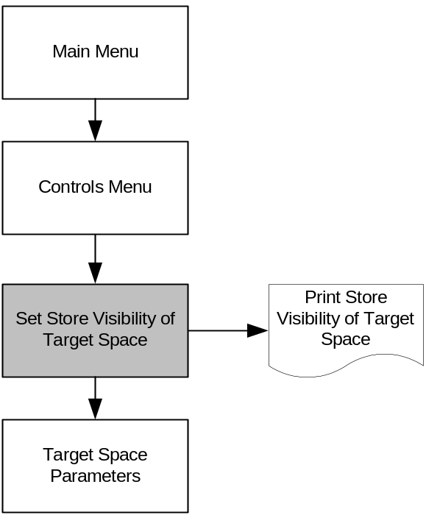

When the User selects the Target Space Controls option from the Controls menu they are presented with the screen to 'Set the Store Visibility of Target Space'. If the User needs to change any of the general parameters for Target Space they will select that option from the left-hand navigation pane.

When the 'Confirm' button is clicked on this screen all the changes made to the screen are applied to the Database and the results grid refreshed. The 'Cancel' button will discard all changes and empty the result grid. The Print button allows the User to print the result grid.

The left-hand navigation panel can only be used to navigate away from this screen if the User hasn't made any changes.

Screen Layout
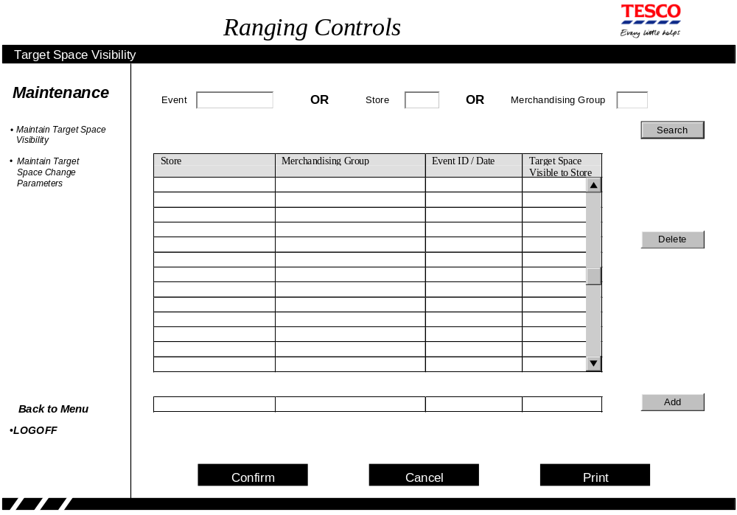The screen is initially empty

Field Descriptions
Field | Description | Comments
Search Fields
Event | The Event ID that the user wants to work on | This maybe blank
Event Name | The name of the event from the Space, Range and Merchandising schedule. | This is directly under the Event ID edit box and is filled in once the event id is entered.
Store | Store number that the user wants to work on | Maybe blank
Store Name description | The store name from the store reference database | This is directly under the store edit box and is filled in once the event id is entered.
Merchandising group code | Merchandising group code entered on the previous screen | The user may enter the merchandising department or section code instead. This field maybe blank
Results Grid
Store | The Store number and name for any store specific changes | This will field contains 'ALL' for all merchandising group changes. This field cannot be changed
Merchandising group | The merchandising group code for any merchandising group changes | This will field contains 'ALL' for all store changes. This field cannot be changes
Event ID / Date | The event id for a merchandising group change or the change date for a store change | This cannot be changed.  This is always blank when the User searches by Event ID.
Target Space Visible in store | Either 'Y' or 'N'
Add Line
Store | The Store number that the change applies to or 'ALL' if the change applies to a merchandising group
Merchandising group | The merchandising group code that the change applies to or 'ALL' if the change applies to a store.
Event ID / Date | The event id for a merchandising group change or the change date for a store change
Target Space Visible in store | Either 'Y' or 'N'

Description of Screen Function
This screen allows the User to: -
- View the Store visibility of Target space indicator by Store or merchandising group over time.
- View the setting of the store visibility of Target space indicator for every merchandising group within an event
- Change the setting of the Store visibility of Target Space indicator for a future date.
- Delete a future change to the Store visibility of Target Space Indicator

To view the target space visibility the User either enters the store or merchandising group into the search field and the system responds by filling in the result grid with the Target Space visibility setting requested. The grid will contain any changes made during the previous year, the current setting and any future changes. The historical entries are shown in Italics and the current entry is in Bold. The entries appear in the grid within date sequence, within merchandising group, if more than a single merchandising group is being reported.

To view the setting of the target space visibility as a result of an event the User enters the Event ID into the search field and the system responds by filling in the result grid for every merchandising group within the event. The value of the indicator is shown as value held against the Event ID, if a change has been entered, or the value held against the previous event for that merchandising group or if there are no entries for the merchandising group it will be reported as 'N'.

To change the setting of the Target Space visibility indicator at a future date the user enters the details into the Add Grid below the Result Grid clicks the 'Add' button. The system will then validate the entry and if it is valid move the details into the result grid but the change will not be committed to the Database until the User clicks the Confirm button. The user will either enter a change for a merchandising group within all stores or a change for all merchandising groups in a store. If the change is for a merchandising group within all stores it must be associated with an event of the Space, Range and Merchandising schedule whereas the actual effective date must be entered for a change for all merchandising groups in a store. A change associated with an Event will become effective in all stores on the earliest launch date for that merchandising group within the Event. This means that it is possible for the visibility of Target Space to change for a store even if the store is not part of an event.

To delete a future change to the Target Space Visibility indicator the User must first either enter the Event ID, the store or the merchandising group code so that the entry to be deleted is in the result grid. Once the entry to be deleted is in the result grid it should highlighted and then removed by clicking the 'Delete' button. This will remove it from the result grid but not actually delete it from the Database until the User clicks the 'Confirm' button.

Validation and error handling
Search Fields
Event | If the event doesn't exist on the Space, Range and Merchandising schedule then error 111
Store | If the store doesn't exist on the Store reference database or will be closed prior to the implementation date then error 112
Merchandising group code | If not present in the MGM system then error 113

Deletions
Event ID / Date | If the date is not in the future then error 5  This validation applies either to the date in the result grid or the earliest date derived from the Space, Range and Merchandising schedule based on the Event ID and merchandising group

Changing the Target Space Visibility setting
Store | If the store doesn't exist on the Store reference then error 112
Merchandising group code | If not present in the MGM system then error 113
Event ID / Date | If the event doesn't exist on the Space, Range and Merchandising schedule then error 111  If the date is not in the future then error 5  This validation applies either to the date in the Add line or the earliest date derived from the Space, Range and Merchandising schedule based on the Event ID and merchandising group
Target Space visibility | If neither Y or N then error 18

Target Space Parameters

Navigation
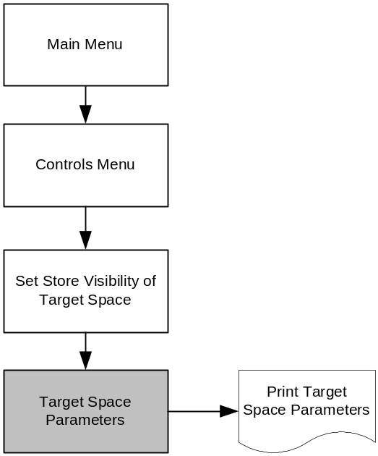
The screen to change the parameters associated with the Target Space application iss accessed by either clicking on the 'Maintain Target Space Change Parameters' link on the left-hand navigation menu.

When the 'Confirm' button is clicked on this screen all the changes made to the screen are applied to the Database. The 'Cancel' button will discard all changes and refresh the result grid from the Database. The Print button allows the User to print the result grid.

The left-hand navigation panel can only be used to navigate away from this screen if the User hasn't made any changes.

Screen Layout
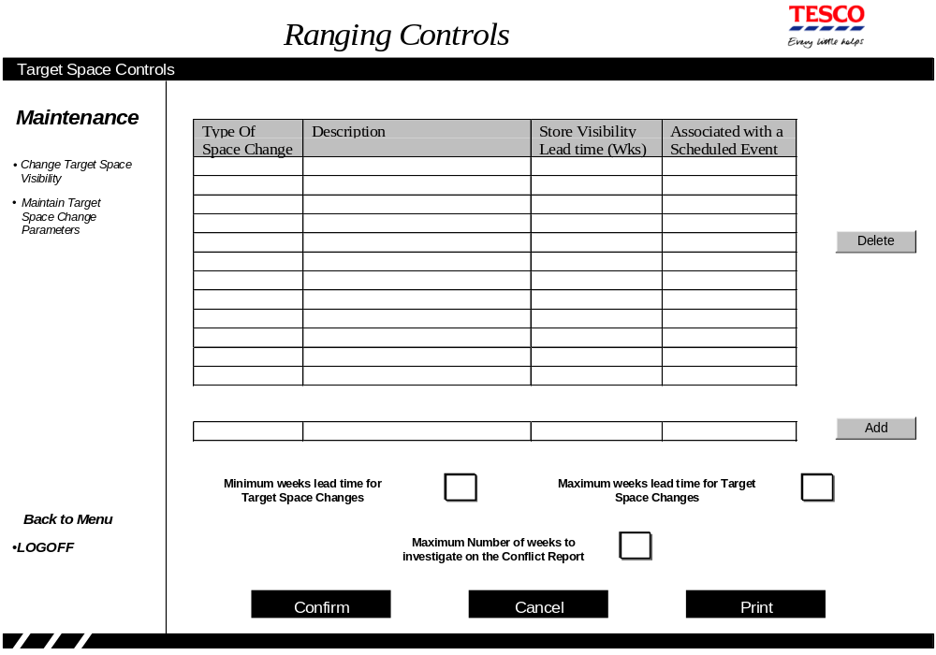
When the screen is initially displayed it will list all of the different types of Space Change that have been currently defined to the system.

Field Descriptions
Field | Description | Comments
Type of Space Change code | A short description to identify the reason for a space change | e.g. UKBE, NEW PLAN
Description | A longer description for a space | e.g. Support a New Merchandise Plan
Store visibility lead time | The number of weeks before a change in target space when the new target space is made visible to the store
Associated with a scheduled event | Whether the target space change must be linked to an Event on the Space, Range and Merchandising schedule
Minimum weeks lead time for a Target Space Change | A target space change shouldn't be entered of amended if the implementation date is less than the minimum lead time
Maximum weeks lead time for a Target Space Change | A Target Space change shouldn't be entered into the system if the implementation date is more than this number of weeks in the future.
Maximum number of weeks to investigate on the Conflict report | The parameter used to limit the number of weeks that can be requested for the Target Space conflict report | Expected to be set to 6 initially

Description of Screen Function
This screen allows the User to: -
- Change the minimum or maximum lead-time for a Target Space change.
- Change the maximum number of weeks that can be reported on the Conflict report
- Change the long description of a 'Type of Space Change' and the Store visibility lead-time
- Add a new 'Type of Space Change' to the system..
- Delete a 'Type of Space Change' if it is no longer required.

To change the either the minimum or maximum lead-time parameters or the maximum number of weeks that can be reported on the conflict report the User enters the new value into the relevant edit-box and then clicks the confirm button.

To change the long description of a 'Type of Space change' or the Store visibility lead-time the User must over-type the relevant entries on the result grid and then click the 'Confirm' button to apply the changes.

To add a new 'Type of Space change' the user enters the details into the Add Grid below the Result Grid and clicks the 'Add' button. The system will then validate the entry and if it is valid move the details into the result grid but the change will not be committed to the Database until the User clicks the Confirm button.

To delete a 'Type of Space change' the User highlights the entry in the result grid and then removes it must first either enter the Event ID, the store or the merchandising group code so that the entry to be deleted is in the result grid. Once the entry to be deleted is in the result grid it should highlighted and then removed by clicking the 'Delete' button. This will remove it from the result grid provided that that there are no Target Space changes for that that type of space change within the system. The details are not actually deleted from the Database until the User clicks the 'Confirm' button.

There is no facility to change the 'Type of Space change' code so if it needs to be changed the User must first delete the existing entry and add a new entry.

Validation and error handling
Amending the general parameters
Minimum Number of Weeks Lead time | If not numeric then error 2
Maximum Number of Weeks Lead time | If not numeric then error 2
Maximum Number of weeks to be investigated on the Conflict report | If not numeric then error 2
 | If the maximum number of weeks lead time is not greater than the minimum number of weeks lead time then error 114

Amending type of Space change details
Description | If not entered then error 3  If the Description matches an existing description then error 8
Store Visibility Lead time | If not numeric then error 2  If not less then the maximum lead time
Associated with a Scheduled Event | If neither 'Y' nor 'N' then error 115
Adding a new type of Space change
Type of Space Change code | If not entered then error 3  If the 'Type of Space change' already exists then error 7
Description | If not entered then error 3  If the Description matches an existing description then error 8
Store Visibility Lead time | If not numeric then error 2  If not less then the maximum lead time
Associated with a Scheduled Event | If neither 'Y' nor 'N' then error 115

Deleting a type of Space change
Type of Space Change 116 | If there are any Target Space changes for this 'Type of Space change' then error

Store facing system - Space and Merchandising System (GR)
The Space and Merchandising system is being enhanced to show more than one future planned space change and to provide a new screen to allow the Space, Range and Merchandising assistants to review the Local Ranging Policy for each merchandising group. There are also some other changes to the processing behind the screens due to the new business rules regarding a store's ability to determine their local range.

The existing Head Office screen within the Space and Merchandising system is no longer required as it has been replaced by the Target Space component within the Ranging Controls system.

The screens will follow the existing standards used by the Space and Merchandising System.

Merchandising Group Summary

Navigation
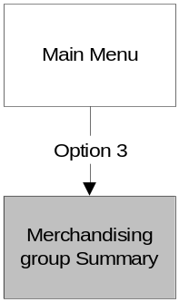
There is no change to the existing navigation for this screen.

Screen Layout

GR520/05.0 MERCHANDISING GROUP SUMMARY 02/03/06 Page 10
2329 Merch Group: I__ Current Wk01
Range ¦--------------------- Today ----------------------¦ Range ¦--- Planned Changes ---¦
Class Count Value of Change in Var from Var Class Value of Mods
Merchandising Group Matching Local of Mods and Value of Range Class from used in Range Class
Code Description Method Choice Mods Range Class Mods on LW Space Target Wk01 Effective week

_ R1D FROZEN FISH MATCHED Y 11 7.5 F +0.1 F
_ R1E FROZEN POTATO PRODUCTS MATCHED Y 8 5.4 G +0.1 G CENTRE 4.7 F Wk03D1
STORE 4.0 E Wk04D1
CENTRE 4.0 E WK10D4
_ R1H ICE CREAM MATCHED Y 6# 5.0 H H ! CENTRE 5.0 H Wk52D1
_ R1K PREMIUM POTATO PRODUCTS MATCHED Y 4 3.2 G -0.2 G CENTRE 2.7 E Wk03D1
_ R1L VEGETARIAN MATCHED Y 3 3.0 F F
_ R1M PIZZA MATCHED Y 11 7.5 G +0.1 G
_ R1N YORKSHIRE PUDDINGS MATCHED Y 1 1.2 A +0.5 A
_ R1Q FROZ PEAS/PREMIUM VEG MATCHED Y 5 3.4 F +0.5 +0.1 F CENTRE 3.4 F Wk03D3
_ R1R LOLLIES & PREM ICE CREAM MATCHED Y 11# 8.4 G +0.4 G ! CENTRE 7.0 F Wk52D1
_
_ S1E TEA MATCHED N 8 7.5 J +0.5 J
_ S1F COFFEE/BEVERAGES MATCHED N 9 9.0 J J
_ S1G BREAKFAST CEREALS MATCHED Y 26 26.0 K +4.0 +6.0 K
----------------------------------------------------------------------------------------------------------------- * MORE PAGES *
Key: #= Mixed Equipment, ?= Space changed today Range Class Cal'd overnight, != No merchandise plan available for your equipment
Options: B to Browse Fixture details by Merchandising Group, F to enter a future space change, M to see supported Range classes
PF3/Previous Screen, PF4/Menu, PF7/PageBack, PF8/PageFwd
The screen has been changed to show more than one Planned Space change.

Field Descriptions
The only new field is:-
Field | Description | Comments
Local Choice | This field contains either 'Y' or 'N' depending on the merchandising group's Local Choice indicator maintained in the MGM system

Description of Screen Function
This screen allows the Space, Range and Merchandising assistants to review the space assigned to each merchandising group and any changes planned for the future.

The screen will include all merchandising groups with recorded space and all merchandising groups with either a current or future space target effective in the next few weeks, greater than 0 Mods, or a planned space change entered by the store. This means that if a merchandising group doesn't have any space recorded and the current space target isn't visible to the store then the only details shown for the merchandising group are the merchandising group code and description.

The screen will also show all future planned space changes that become effective over the next few weeks (both from the centre and the store) rather than just the first change from the centre and the current local ranging policy. The lead-time for a change to be visible in store will be controlled via a parameter maintained within the Ranging Control System at the Centre. The variance from Target will only be shown if the target visibility, maintained by the Space Team, permits it.

If the Target Space change is due to an event on the Space, Range and Merchandising Schedule then the change will only be visible if the event has been approved and the lead-time of the change is within the defined number of weeks.

Validation and error handling
The only change to the validation is that the User can only switch to the screen to view supported merchandise plans if they either have space currently recorded for the merchandising group or the centre have currently set a Space Target greater than zero Mods. If the User attempts to access the supported merchandise plans screen the system should respond with error message.

"No supported plans for this merchandising group currently available for your store"

Supported Merchandise Plans

Navigation

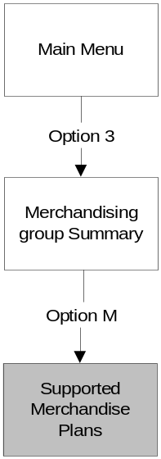
There is no change to the navigation for this screen

Screen Layout
GR570/05.0 SUPPORTED MERCHANDISE PLANS 02/03/06
PAGE 01
2329 Merchandising Group R1E - FROZEN POTATO PRODUCTS
Region - National
The standard equipment for this Merchandising Group is FGD - Frozen Full Height Glass Door

Your equipment for this Merchandising Group is FWL - Frozen Well and the Value of Mods is 5.4

RANGE CLASS
A B C D E F G H I J K
FGD Frozen Full Height Glass Door
Nos of Mods 1 2 - 3 4 - 5 6 7 8 -
Width (1 mod = 760) 760 1520 - 2280 3040 - 3800 4560 5320 6080 -
Value of mods 1 2 - 3 4 - 5 6 7 8 -

FWL Frozen Well
Nos of Mods 2 3 4 5 6 7 8 9 11 12 -
Width (1 mod = 1220) 2440 3660 4880 6100 7320 8540 9760 10980 13420 14640 -
Value of mods 1.34 2.01 2.68 3.35 4.02 4.69 5.36 6.03 7.37 8.04 -

-------------------------------------------------------------------------------------------------------------------
PF3/Previous Screen, PF4/Menu, PF7/PageBack, PF8/PageFwd
There is no change to the current screen

Field Descriptions
There is no change to the current screen

Description of Screen Function
The screen allows the store user to review the supported merchandise plans so that when changing space they can ensure that there will be a plan available.

Validation and error handling
There is no change to the current validation and error handling.

Update Future Fixture details

Navigation
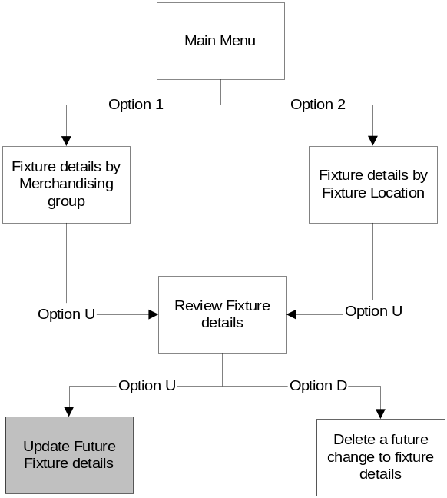
There is no change to the existing navigation for this screen

Screen Layout
GR61A/07.0 UPDATE FIXTURE DETAILS (NOTE FUTURE DATES CAN BE ENTERED) 02/03/06
2195 TPXE5000
Effective Base Base No of Resv Merchandising Group
Date Shelf Shelf Spine Shelves Ind
Aisle Side Mod dd - mm - yy Equipment Type Width Depth Height inc base Y/N Code Description
WS X 29 02 - 03 - 06 STD Standard Ambient 1330 670 1680 5 N W2A RED WINE

----------------------------------------------------------------------------------------------------------------------------------
To plan a future change in details for an existing fixture, enter future date above

PF3/Previous Screen, PF4/Menu, PF12/Cancel
*** PRESS 'ENTER' TO CONFIRM CHANGES, PF3/12 TO CANCEL ***

Field Descriptions
There is no change to the fields on this screen

Description of Screen Function
This screen allows the store user to enter a planned change to a fixture. If the merchandising group assignment is changed this doesn't actually change the assignment but instead deletes the existing product map on the effective date to allow the store to re-product map the fixture and hence assign the correct merchandising group.

Validation and error handling
The only change to the validation is that when assigning a different merchandising group to a fixture the system checks that either the store will have a space target or that the store is allowed to make local ranging decisions for the merchandising. The system always checks the space target and local ranging policy that will be in effect a few days after the effective date. The number of days in advance is five days more than the Planned Space to CBI parameter within GR

Reserved Merchandising Group List

Navigation
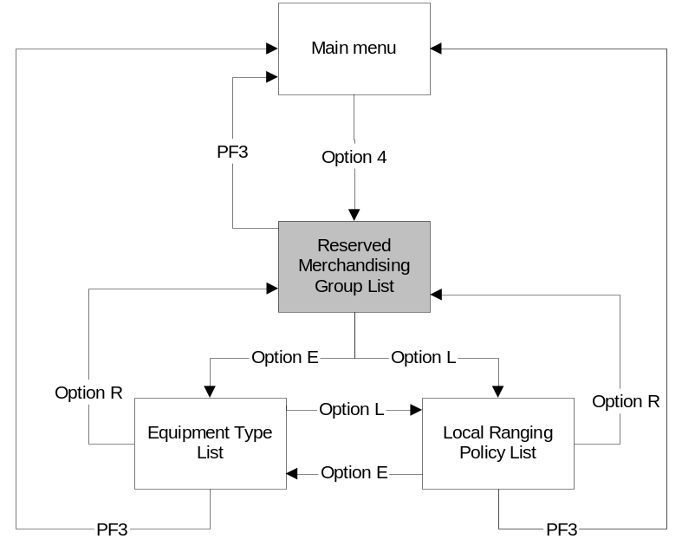
A new navigation option has been added to the screen to allow the User to access the screen that lists the Local Ranging Policy.

Screen Layout

GR530/03.0 LIST OF RESERVED MERCHANDISING GROUPS 02/03/06
Page 01
Enter R to List Reserved Merchandising Groups, E to List Equipment Descriptions, L to List Local Choice Merchandising Groups _

Code Description Code Description Code Description
--- ------------------------------------ --- ------------------------------------ --- ------------------------------------
A1A GROCERY PROMOTION MAIN A3A NON FOOD PROMOTION U1F HAIR ACCESSORIES
A1B GROC PROMOTION SECONDARY A3C TELECOMS PROMOTION U1G PHOTOGRAPHIC FILM
A1E ETHNIC PROMOTION A3D BIKE PROMOTION U1H SPORTS INJURY
A1M BWS PROMOTION MAIN A3E BABY PROMOTION U1J SEWING AIDS
A1O BWS PROMOTION WINE TOWER A5Z NON STANDARD PROMOTION U1K TESCO BABY CARE
A1P BWS PROMOTION GOAL POSTS B1M CREATE A CAKE U1M TESCO PERSONAL FINANCE
A1Q BWS PROMOTION CHILLED C1H PERMANENT SEASONAL SPACE U1N TRAVEL INSURANCE
A1S H&B PROMOTION MAIN C1S POWER AISLE 1 SEASONAL U1T BIG NITE IN
A1U H&B MIDDLE END C1T TOURIST PRODUCTS U2A PETCARE
A2A ISB PROMOTION MAIN C2K FLEXI MAT FIXTURES U2E TESCO BRAND CARDS
A2C PLANT BAKE PROMO MAIN C2S POWER AISLE 2 SEASONAL U2M WINE & PARTY ACCESSORIES
A2J CHILLED PROMOTION MAIN C3S NON FOOD SEASONAL END U2N CONFECTIONERY
A2M MEAT & POULTRY PROMOTION D1G METRO SAVOURY SNACKS U3A CHECKOUT SNACK FIXTURE
A2P PRODUCE PROMO CHILLED D2H SANDWICHES U6A HAIR ACCESS/SEWING AIDS
A2Q PRODUCE PROMO AMBIENT U1B RAZOR BLADES V1G NONFOOD CLEARANCE
A2R FROZEN PROMOTION U1E SHOE CARE V1Q INSTANT TRAVEL INSURANCE
------------------------------------------------------------------------------------------------------------------ * MORE PAGES *

PF3/Previous Screen, PF4/Menu, PF7/PageBack, PF8/PageFwd

Field Descriptions
There is no change to any of the fields on this screen

Description of Screen Function
This screen allows the User to review the reserved merchandising groups

Validation and error handling
'L' is now a valid entry to switch screens

Equipment Type List

Navigation
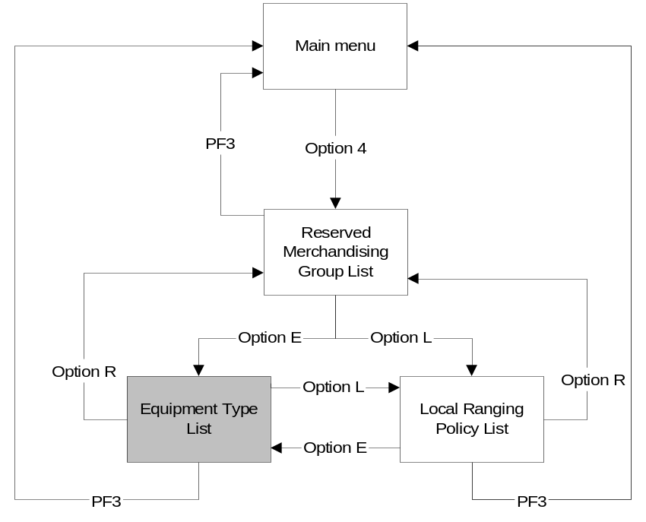
A new navigation option has been added to the screen to allow the User to access the screen that lists the Local Ranging Policy.

Screen Layout
GR530/03.0 EQUIPMENT DESCRIPTIONS 02/03/06
Page 01
Enter R to List Reserved Merchandising Groups, E to List Equipment Descriptions, L to List Local Choice Merchandising Groups _

Code Description Code Description Code Description
--- ------------------------------------ --- ------------------------------------ --- ------------------------------------
??? Dimensions Outside Recognised Limits HLF High Level Fixture WVD Verco Doors
CGG Grab & Go Counter Shelves LDR Ladder Rack ZIG Ziggeracks
CLG Clothing Gondola LFD Low Front Dairy
CLW Clothing Back Walls LLD Low Level Dairy
CNT Counters LLF Low Level Fixture
CPB Clothing Power Bin MDD Multideck Dairy
CTB Clothing Table MD6 Six Shelf MDD Meat + Poultry (Only)
CVF Clothing Value Fixture NPM Newspaper & Magazine Rack
CWM Clothing Wall Mod OTH Other Fixture
DUP Duplex RIM Roll-In Milk
EPU End Panel Unit SHG Shirt Gondola
FGD Frozen Full Height Glass Door SLD Slimline Dairy
FLP Plant Stand SOW Shelves Over Well
FLR Flower Stand Round Buckets STD Standard Ambient
FLS Flower Stand Square Buckets SVN Non SVTP Promotional Ends
FWL Frozen Well SVT SVTP Promotional Ends
------------------------------------------------------------------------------------------------------------------

PF3/Previous Screen, PF4/Menu, PF7/PageBack, PF8/PageFwd

Field Descriptions
There is no change to any of the fields on this screen

Description of Screen Function
This screen allows the User to review the different equipment types.

Validation and error handling
'L' is now a valid entry to switch screens

Local Ranging Policy List

Navigation
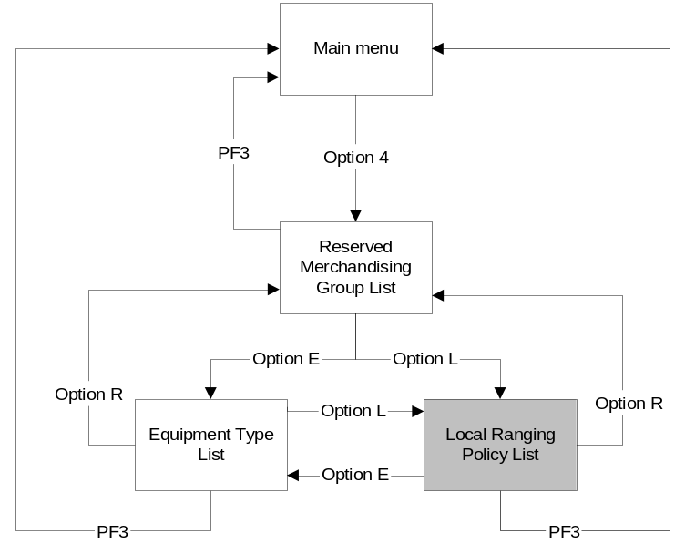
Typing 'L' in the option field on either the Reserved Merchandising Group List screen or the Equipment Type List screen produces this screen.

While browsing this screen the User can quickly locate any part of the merchandising hierarchy by entering it into the merchandising group field. The User can also navigate through the list using the standard PF7 and PF8 keys.

The User exits the screen by entering: -
- 'R' to transfer to the Reserved Merchandising List screen
- 'E' to transfer to the Equipment Type List screen
- PF3 or PF4 to return to the main GR Menu

Screen Layout
GR530/03.0 LIST OF LOCAL CHOICE MERCHANDISING GROUPS 02/03/06
Page 01
Enter R to List Reserved Merchandising Groups, E to List Equipment Descriptions, L to List Local Choice Merchandising Groups _
Merchandising Group ___
Code Description Code Description
--- ---------------------------------------------------- -- --------------------------------------------------------
B1B PRE-PACKED BREAD |  | F1A EGGS
B1E PRE-PACKED CAKE |  | G1A CANNED VEGETABLES
B1F PRE-PACKED CREAM CAKES |  | G1B SOUP
B1G P.PCKD WARBURTONS (SEL) |  | G1C CANNED BEANS/PASTA
B1J KOSHER BAKERY (SELECTED) |  | G1D RICE & COOKING SAUCES
B1K SINGLE P/P CREAM CAKES |  | G1E OILS
B1L CELEBRATION CAKE | Until 01/12/2006 | G1F HERBS/SPICE/SALT/SAUCES
B1M CREATE A CAKE |  | G1G ASIAN GROCERIES (SEL)
B2A READY TO EAT/FRUITED |  | G1H WEST INDIAN GROC. (SEL)
B2B TOASTING/CONTINENTAL |  | G1I STOCKS/STUFFINGS/GRAVY
B2C BREADS OF THE WORLD |  | G1J KOSHER GROCERIES (SEL)
B2D ROLLS |  | G1K GREEK GROCERIES (SEL)
B2G ISB SWEET |  | G1L CATERING PACKS
B2H ISB BREAD |  | G1M CARB CONTROL
B3B BAKERY TIERED TABLE PIE |  | G1N WHOLEFOODS
B3C BAKERY TIERED TABLE CAKE |  | G1O ORGANIC GROCERY | From 01/02/2007

------------------------------------------------------------------------------------------------------------------ * MORE PAGES *

PF3/Previous Screen, PF4/Menu, PF7/PageBack, PF8/PageFwd

The screen lists all the merchandising groups where the store is currently allowed to make a local choice or will be able to make a local choice in the near future.

Field Descriptions
Field | Description | Comments
Merchandising Group | Any part of the merchandising hierarchy | Entered by the User to position this entry as the first entry on the screen.
Code | Merchandising group code
Description | Merchandising group description
Dated Column | The date of a change to the Local choice rules for a merchandising group and whether a store Local choice will be allowed. | If Local choice is currently allowed but won't be later it is listed as "Until dd/mm/yyyy". If local choice is currently not allowed but it will be later then it is reported as "From dd/mm/yyyy"

Description of Screen Function
This screen provides the User with a list of the merchandising groups where they can decide to make a local choice regarding the range they stock either now or in the future.

To assist the user when reviewing the Local Ranging Policy they may enter any part of the merchandising hierarchy into the merchandising group field to position the screen on that part of the merchandising hierarchy. The User can also navigate through the list of merchandising groups by using the PF7 and PF8 in the same manner as other screens within the Space and Merchandising system.

If there are any future changes to the Local Ranging Policy these are only shown on this screen if the change is due to take place within the lead-time of making the change visible and the associated Event on the Space, Range and Merchandising Schedule has been approved.

Validation and error handling
Option | If not 'E', 'R' or 'L' then display error  '*** ABOVE HIGHLIGHTED FIELDS IN ERROR ***'

Request a Merchandise Plan

Navigation
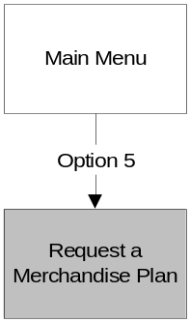
There is no change to the existing navigation for this screen

Screen Layout
GR540/01.0 REQUEST A MERCHANDISE PLAN 02/03/06
2102 TPXE5000

Merchandising Group ___

Effective Date (dd-mm-yy) 02 - 03 - 06

----------------------------------------------------------------------------------------------------------------------------------
Enter data above and press "Enter"

PF3/Previous Screen, PF4/Menu

Field Descriptions
There is no change to any of the fields on this screen

Description of Screen Function
This screen allows the User to request a Merchandise Plan to be printed for a date in the future.

Validation and error handling
A merchandise plan can only be requested for a merchandising group if the store either currently as space recorded for it or there is a space target greater than zero mods in existence for the effective date. If this isn't the case display the error message:

"You currently have no space recorded or planned for this merchandising group".

Request a Space Exception Report

Navigation
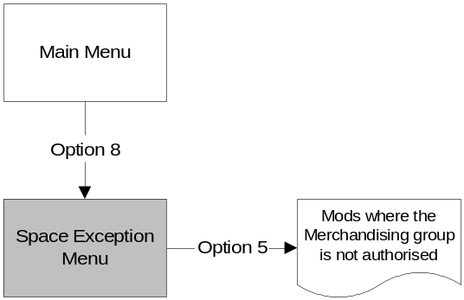

Option 5 - "Mods where the Merchandising Group is Not Authorised" is only applicable to ROI stores and Expresses.

Screen Layout
Option 5 has been removed for all stores except those in the ROI and all Express Stores.
GR560/02.0 REQUEST A SPACE EXCEPTION REPORT 02/03/06
2102 TPXE5000
Count of
Mods
1. Mods with no Merchandising Group assigned 0

2. Mods with unrecognised dimensions and/or equipment 0

3. Mods with no Product Map 1

4. Mods where the Product Map is more than 26 weeks old 0

5. N/A

6. Mods with shelves not Product Mapped 0

7. Summary of the Mods with any of the Space Exception issues 1

8. N/A

9. N/A

Enter Option: _

PF3/Previous Screen
Note that a Mod may be counted in more than one category

Field Descriptions
There is no change to any of the fields on this screen

Description of Screen Function
This screen provides the User with a summary of all the Space exceptions in store and allows the User to request a report so that they can correct the problems.

The option "Mods where the Merchandising Group is Not Authorised" now only applies to Expresses and any store in the ROI.

Validation and error handling
If the User selects Option 5 and it is not shown as N/A for their store they will receive the following error message.

"This report is not applicable to your store"

Head Office Edit Screen for Space
The Head Office Edit Screen for Space is no longer required and should be removed from the system. This is currently the only Head Office screen within the Space and Merchandising System and therefore the GRHOSCRN will no longer be required.

Navigation
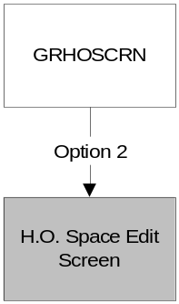
The Screen is accessed via Option 2 of the GR Head Office sign-on screen.

Screen Layout
GR???/??.? HEAD OFFICE - STORE & MGP MAINTENANCE Current Wk18 14/07/05

Store 2042 Ayr Extra Scotland 3 Trading

MGP D2O ORGANIC DAIRY Area price Code 2 Scottish Extra Y

Matching Method – FIXED would match using National Extra E and Low Front Dairy.

Value Total Nos -- Equipment -- Var Var Change
Effect Range of Width of Nos from from on LW
Week Class mods (mm) Mods Type Ind of Plan Target

Today's 3.00 3750 3 LFD H 1 0.00 -1.00
_ Weekly F 3.00 3750
_ Fixed F 3.00 3750
_ Target G 4.00 5000 -1.00

Planned Store
_ Centre 36 05 G 4.00

------------------------------------------------------------------------------------------------
Key : M to see supported plans, U to update
PF3/Previous Screen, PF4/Menu
This screen is being removed

Field Descriptions
This screen is being removed

Description of Screen Function
This screen is being removed

Validation and error handling
This screen is being removed

Detailed Report Design
The reports illustrated within BSD do not represent the final version of the reports but do identify all of the information that will be on the final report.

Ranging Control System -Target Space Component
The Target Space Component of the Ranging Control System consists of six reports that allow the Space Team to keep a record of their work. The reports are produced via the 'Print' on each of the screens within the Target Space component of the Ranging Control system.

The reports will meet the standards for the Ranging Control system, as defined in the Business System Design Document - Report Design Standards.

Upload Summary and Exception Report

Navigation

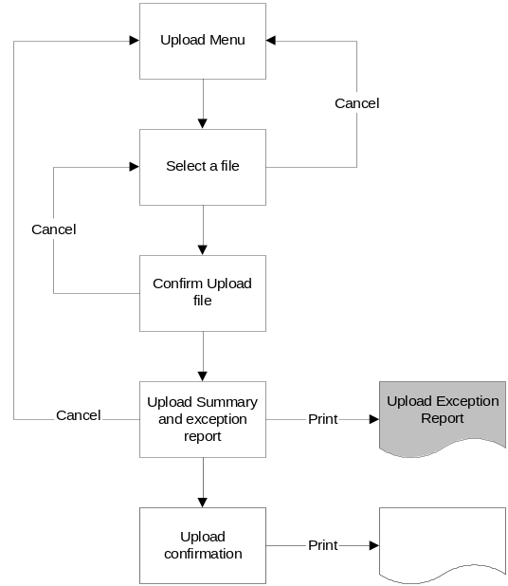

The report is produced anytime the user wishes to have a hard copy by clicking the 'Print' button on the Upload Summary and exception Screen.

Report Layout

Target Space Changes
Spreadsheet Upload Exceptions
Event | Store | Merchandising Group Code | Change Type | Action Indicator | Implementation Date | Value of Mods | Number of Mods | Equipment Type | Range Class | Comment

The report should be in the same sequence as the screen.

Field Descriptions
Field | Description | Comments
Event ` | The Event id from the spreadsheet
Store | The store number from the spreadsheet
Merchandising Group Code | Merchandising group code from the spreadsheet
Change Type | Change Type from the spreadsheet
Action Indicator | The action indicator from the spreadsheet
Implementation Date | The implementation date from the spreadsheet or calculated from the event, merchandising group and store cluster containing the store | If the implementation date has been obtained from the schedule it is shown in brackets..
Value of mods | Value of Mods from the spreadsheet | May contain two decimal places
Number of Mods | Number of Mods from the spreadsheet | Always an integer
Equipment Type | Equipment type from the spreadsheet
Range class | Range class from the spreadsheet
Comment | Description of the error | The reasons for the errors are described in 4.1.4.5 and the text of the error is in 8.2.1 Error Codes

Report Description
The report provides a hard copy of the errors found when validating the Target Space spreadsheet prior to the upload.

Upload Confirmation Report

Navigation

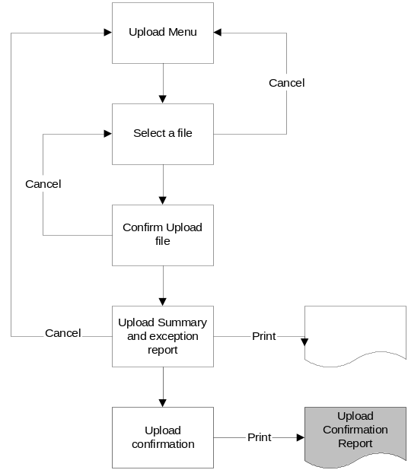

The report is produced anytime the User wishes by clicking the 'Print' button on the Upload Confirmation Screen

Report Layout

Target Space Changes
Spreadsheet Upload Confirmation
Event | Store | Merchandising Group Code | Change Type | Action Indicator | Implementation Date | Value of Mods | Number of Mods | Equipment Type | Range Class
Number of Rows Loaded 9999
The report is in the same sequence as the screen.

Field Descriptions
Field | Description | Comments
Event ` | The Event id from the spreadsheet
Store | The store number from the spreadsheet
Merchandising Group Code | Merchandising group code from the spreadsheet
Change Type | Change Type from the spreadsheet
Action Indicator | The action indicator from the spreadsheet
Implementation Date | The implementation date from the spreadsheet or calculated from the event, merchandising group and store cluster containing the store | If the implementation date has been obtained from the schedule it is shown in brackets
Value of mods | Value of Mods from the spreadsheet | May contain two decimal places
Number of Mods | Number of Mods from the spreadsheet | Always an integer
Equipment Type | Equipment type from the spreadsheet
Range class | Range class from the spreadsheet
Number of Rows Loaded | The number of rows on the spreadsheet

Report Description
The report provides the user with a hard copy of the Target Space changes loaded from the spreadsheet.

Report Target Space Changes

Navigation
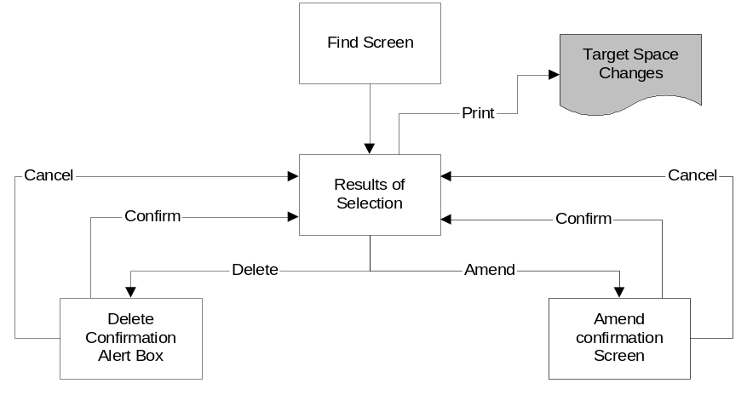
The Target Space changes report is produced by clicking on the 'Print' button on the 'Results Selection Screen' after choosing the contents of the report via the 'Find' screen.

Report Layout

Store | Merchandising Group | Change  Type | Implementation Date | Value of Mods | Number of Mods | Equipment Type | Range Class

The report is the same sequence as the screen it was requested from.

Field Descriptions
Field | Description | Comments
Store | Store number and name
Merchandising group code | Merchandising group code and description
Change Type | The change type of the target space change
Implementation Date | The date that the Target Space change is effective in store | If the target space change is due to a scheduled event this is calculated from the schedule and the store clusters and shown in brackets.
Value of Mods | The Target Space should equate to the value of Mods for the merchandising group in the store | The current target space change details.
Number of Mods | The Target space for the merchandising group in store is the number of Mods of the specified equipment type | The current target space change details.
Equipment Type | The type of equipment that the store should use to implement the target space | The current target space change details.
Range Class | The Range class associated to this amount of Space for the merchandising group. | The current target space change details.

Report Description
The report provides a hard copy of the current values within the Target Space system.

The User entering the search criteria into the 'Find' screen to control the contents of the report and then can either printing the entire contents of the 'Results' Grid or just selected entries controls.

Validation against Business Rules - Summary Report

Navigation
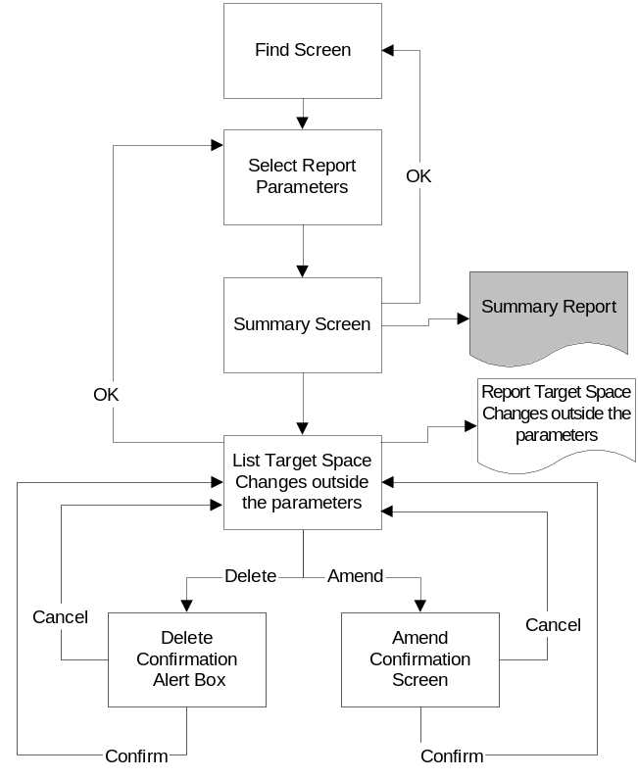
The summary report is produced by clicking on the 'Print' button on the Validation against Business Rules - Summary Screen.

Report Layout
Target Space Changes
Validation against Business Rules - Summary report
Event 20060902003 - Wine and Beer
Store: ALL | Merchandising Group ALL
Number of increases in Target Space | 102
Number of decreases in Target Space | 24
Number of instances where Target Space doesn’t change | 500
Total Number of Target Space Changes | 626
Number of instances where Target space is changing from zero | 32
Number of instances where Target space is changing to zero | 3

If the report has been requested for a UKBE space target change rather than one associated with an Event on the Space, range and Merchandising schedule then Implementation date will be shown on the report rather than the Event ID and description.

If the store and/or merchandising hierarchy code was entered into the 'Report Parameters Screen' then the store number, store name, merchandising hierarchy code and description will be printed instead of the literal 'ALL'.

Field Descriptions
Field | Description | Comments
Event | The Event ID entered on the 'Select Report Parameters' screen | This will only appear on the report if entered on the parameter screen
Event Name | The name of the event from the Space, Range and Merchandising schedule. | This will only appear if an Event ID was entered on the parameter screen.
Implementation Date | The implementation date entered on the previous screen | This will only appear on the report if entered on the parameter screen.
Store | Store number entered on the 'Select Report Parameters' screen. | This will only appear on the report if entered on the parameter screen otherwise ALL
Store Name description | The store name from the store reference database
Merchandising hierarchy code | Merchandising hierarchy code entered 'Select Report Parameters' screen. | This will only appear on the report if entered on the parameter screen otherwise ALL
Merchandising hierarchy code description | Merchandising heirarchy code description from MGM
Number of increases in target Space | The count of the number of instances where the target space for the selection criteria is increasing compared to the value in effect immediately before this date
Number of decreases in target Space | The count of the number of instances where the target space for the selection criteria is decreasing compared to the value in effect immediately before this date
Number of instances where target Space doesn't change | The count of the number of instances where the target space for the selection criteria is increasing compared to the value in effect immediately before this date | This figure only includes instances where a target space change has been entered, therefore if a target space exists for store 2008 and implementation date 06/10/2006  And there is a target space change for G1D then this figure will not include all other merchandising groups.
Total number of Target Space changes | The total number of target space changes that meet the selection criteria
Number of instances where target Space is changing from zero. | The count of the number of instances where the target space for the selection criteria is greater than zero but was zero immediately before this date | This includes all instances were there is a target space change and one didn't exist beforehand
Number of instances where target Space is changing to zero. | The count of the number of instances where the target space for the selection criteria is now zero but was greater than zero immediately before this date

Report description
This report provides the User with a hard copy summary of the type of space changes entered for a scheduled Event or those entered on a particular implementation date for a UKBE space change.

Validation against Business Rules - Detailed Report

Navigation
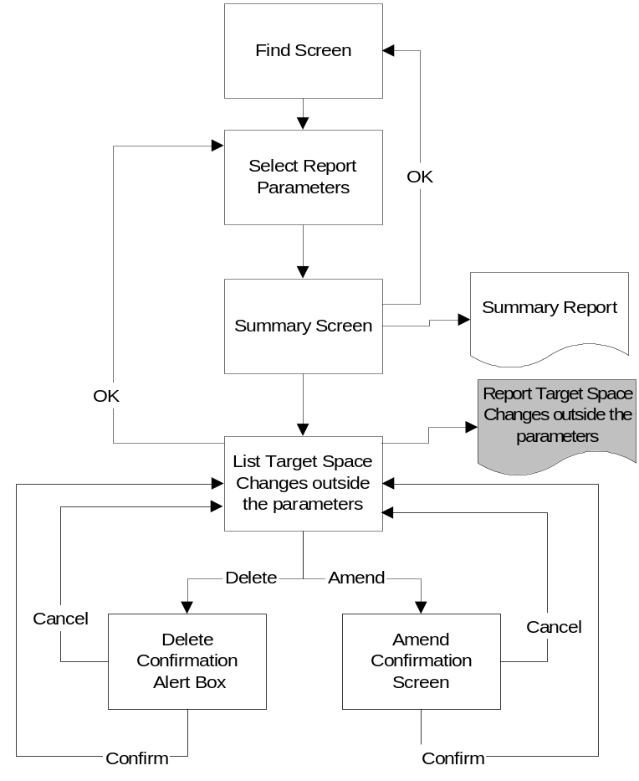
The report of Target Space changes outside the normal parameters is produced by clicking on the 'Print' button on the 'List Target Space changes outside the parameters' screen.

Report Layout

Target Space Changes
Validation against Business Rules - Summary report
Event 20060902003 - Wine and Beer
Store | Merchandising Group | Change  Type | Current Target |  |  |  |  | New Target
Store | Merchandising Group | Change  Type | Value of Mods | Number of Mods | Equipment Type | Range Class |  | Value of Mods | Number of Mods | Equipment Type | Range Class | Comment
2020 | B1B | New | 2.0 |  |  | C |  | 1.0 |  |  | B | Decrease
2329 | B1B | New |  | 5 | STD | E |  |  | 4 | STD | D | Decrease
2329 | G1A | New | 8.9 |  |  | G |  |  | 8 | STD | F | Decrease
2661 | G1A | New |  | 7 | STD | F |  | 4.8 |  |  | D | Decrease

Field Descriptions
Field | Description | Comments
Event | The Event ID entered on the 'Select Report Parameters' screen | This will only appear on the report if entered on the parameter screen
Event Name | The name of the event from the Space, Range and Merchandising schedule. | This will only appear if an Event ID was entered on the parameter screen.
Implementation Date | The implementation date entered on the previous screen | This will only appear on the report if entered on the parameter screen.
Store | Store number
Merchandising group code | Merchandising group code
Change Type | The change type of the target space change
Current Value of Mods | The Value of Mods that exists on the day prior to the Target Space change
Current Number of Mods | The Number of Mods that exists on the day prior to the Target Space change
Current equipment Type | The type of equipment that exists on the day prior to the Target Space change
Current Range Class | The Range class that exists on the day prior to the Target Space change.
New Value of Mods | The new Target Value of Mods
New Number of Mods | The new target Number of Mods.
New equipment Type | The new type of equipment.
New Range Class | The new Range class.
Comment | Identifies how the Target Space is changing | The five possible values for this are:  Increase  Decrease  No Change  Changing to zero  Changing from zero  If the target space is changing to or from zero then that message must take precedence over the more general Increase or Decrease Message

Report Description
This report provides the User with a hard copy of any target space changes that have been identified as outside the expected Business Parameters for the change. This report would generally be used to highlight the stores were a merchandising group was decreasing target space despite the fact that the overall objective of the event was to increase the space for that particular merchandising group.

The report could also be used to provide a complete copy of all of the changes for an event but it would be better for the User to access the Data Warehouse for this information.

Target Space Conflicts Report
The term Space Conflict is used to describe the situation where there is more than one Target Space changes for the same store and merchandising group within a short time period.

Navigation
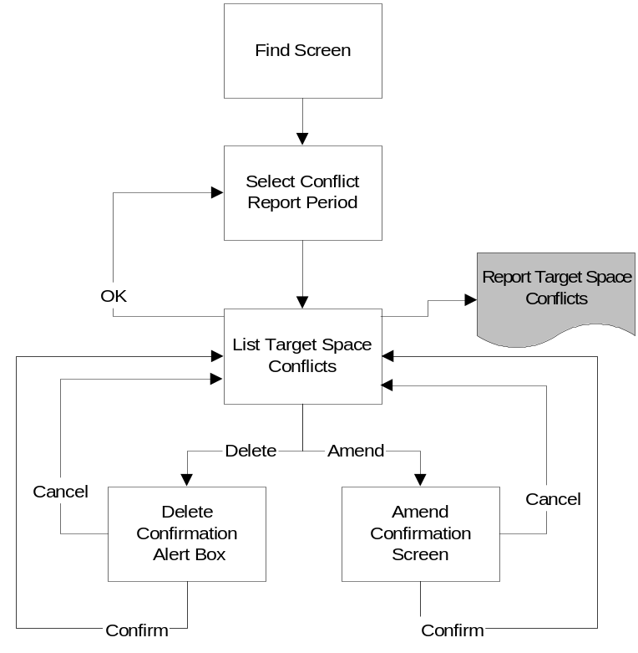

Clicking the 'Print' button on the 'List Target Space conflicts Screen' produces the report of Target Space Conflicts.

Report Layout

Target Space Changes
Space Conflicts between dd/mm/yy snd dd/mm/yy
Event 20070301004 - Rice and Pasta
Store | Merchandising Group | Change  Type | Implementation Date | Event ID | Value of Mods | Number of Mods | Equipment Type | Range Class
2329 Cheshunt Extra | G1D Rice | UKBE | 14/02/2007 |  |  | 6 | STD | E
2329 Cheshunt Extra | G1D Rice | NEW | 03/03/2007 | 20070301004 | 7 |  |  | F

If the user is checking for conflict with a Scheduled Event then the Event details are included in the heading otherwise if the user has entered the store number then the store number and name will appear in the heading.

Field Descriptions
Field | Description | Comments
Report heading dates | The actual dates of the conflict window will be shown in the heading
Store | Store number and name
Merchandising group code | Merchandising group code and description
Change Type | The change type of the target space change
Event ID | The Event ID associated with this space change | This will remain blank if the type of space change is associated with a scheduled Event
Current Value of Mods | The Value of Mods that exists on the day prior to the Target Space change
Value of Mods | The Target Value of Mods
Number of Mods | The target Number of Mods.
equipment Type | The type of equipment.
Current Range Class | The Range class.

Report Description
The report provides the User with a hard copy of any instances where a merchandising group in a store has more than one target space change within a short time period.

The conflict dates in the heading will either be obtained directly from the Users input, calculated from the start date and the conflict window or based on the launch dates for an event and the conflict window.

Ranging Control System - Controls Component
The Controls Component of the Ranging Control System is being extended by two new reports so that the Operations Team can keep a record of the parameters used by the Target Space component.. The Target Space component is accessed from an option on the main menu screen of the Ranging Control System.

The reports will meet the standards for the Ranging Control system, as defined in the Business System Design Document - Report Design Standards.

Report Store Visibility of Target Space

Navigation
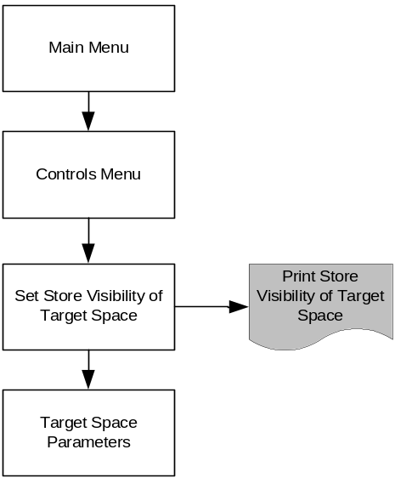

Clicking the 'Print' button on the maintenance screen for Store Visibility of Target Space produces the report showing the Store Visibility of Target Space.

Report Layout
Target Space Parameters
Store Visibility of Target Space for XXXXXXXXXX

Store | Merchandising Group | Event ID / Date | Visible to Store

Field Descriptions
Field | Description | Comments
Heading | This will either contain the store, merchandising hierarchy or Event ID depending what the User entered into the Target Space Visibility Screen | The relevant description or name should be shown as well as the code.
Store | The Store number and name for any store specific changes | This will field contains 'ALL' for all merchandising group changes.
Merchandising group | The merchandising group code for any merchandising group changes | This will field contains 'ALL' for all store changes.
Event ID / Date | The event id for a merchandising group change or the change date for a store change | This is always blank when the User report shows the setting for an Event.
Target Space Visible in store | Either 'Y' or 'N'

Report Description
The report shows the store visibility of Target Space: -
- By Store over time.
- By Merchandising hierarchy over time
- For every merchandising group within an event on the event date

The report shows exactly the same information as the Target Space Visibility screen.

When reporting the store visibility of Target Space over time the report contains any changes made during the previous year, the current setting and any future changes. The historical entries should be shown in Italics and the current entry is shown in Bold. The report is in date sequence, within merchandising group, if more than a single merchandising group is being reported.

Target Space Parameters Report

Navigation
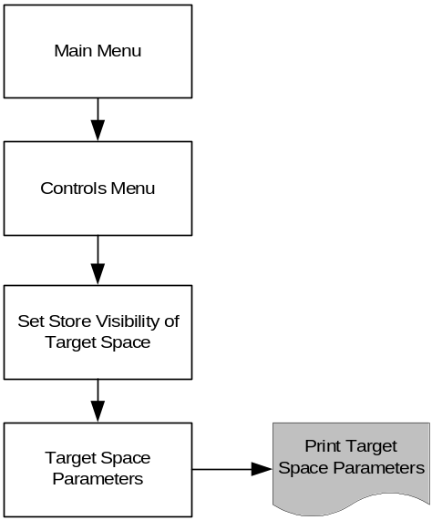
The Target Space Parameters can be reported by clicking on the 'Print' button from the Target Space Parameters screen.

Report Layout
Target Space Parameters
Minimum lead time 99 weeks |  | Maximum lead time 99 weeks
Type Of Space Change | Description | Store Visibility Lead time (Wks) | Associated with a Scheduled Event

Field Descriptions
Field | Description | Comments
Minimum weeks lead time for a Target Space Change | A target space change shouldn't be entered of amended if the implementation date is less than the minimum lead time
Maximum weeks lead time for a Target Space Change | A Target Space change shouldn't be entered into the system if the implementation date is more than this number of weeks in the future.
Type of Space Change code | A short description to identify the reason for a space change | e.g. UKBE, NEW PLAN
Description | A longer description for a space | e.g. Support a New Merchandise Plan
Store visibility lead time | The number of weeks before a change in target space when the new target space is made visible to the store
Associated with a scheduled event | Whether the target space change must be linked to an Event on the Space, Range and Merchandising schedule

Report Description
The report provides the Operations Team with a hard copy of the current Target Space parameters.

Store facing system - Space and Merchandising System (GR)
Two of reports within the Space and Merchandising system are being changed to cater for the new Local Choice rules and another report will now only be available for certain stores.

The reports will follow the existing standards used by the Space and Merchandising System.

Merchandising Group Summary

Navigation
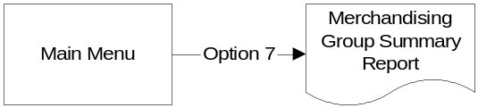
There is no change to the existing navigation to request this report.

Report Layout

GRXF35/ BRANCH REPLENISMENT SYSTEMS 02/03/06 Page 10
MERCHANDISING GROUP SUMMARY REPORT FOR STORE : 2329 CHESHUNT 2 Current Wk01
Range ¦--------------------- Today ----------------------¦ Range ¦--- Planned Changes ---¦
Class Count Value of Change in Var from Var Class Value of Mods
Merchandising Group Matching Local of Mods and Value of Range Class from used in Range Class
Code Description Method Choice Mods Range Class Mods on LW Space Target Wk01 Effective week

_ R1D FROZEN FISH MATCHED Y 11 7.5 F +0.1 F
_ R1E FROZEN POTATO PRODUCTS MATCHED Y 8 5.4 G +0.1 G CENTRE 4.7 F Wk03D1
STORE 4.0 E Wk04D1
CENTRE 4.0 E WK10D4
_ R1H ICE CREAM MATCHED Y 6# 5.0 H H ! CENTRE 5.0 H Wk52D1
_ R1K PREMIUM POTATO PRODUCTS MATCHED Y 4 3.2 G -0.2 G CENTRE 2.7 E Wk03D1
_ R1L VEGETARIAN MATCHED Y 3 3.0 F F
_ R1M PIZZA MATCHED Y 11 7.5 G +0.1 G
_ R1N YORKSHIRE PUDDINGS MATCHED Y 1 1.2 A +0.5 A
_ R1Q FROZ PEAS/PREMIUM VEG MATCHED Y 5 3.4 F +0.5 +0.1 F CENTRE 3.4 F Wk03D3
_ R1R LOLLIES & PREM ICE CREAM MATCHED Y 11# 8.4 G +0.4 G ! CENTRE 7.0 F Wk52D1
_
_ S1E TEA MATCHED N 8 7.5 J +0.5 J
_ S1F COFFEE/BEVERAGES MATCHED N 9 9.0 J J
_ S1G BREAKFAST CEREALS MATCHED Y 26 26.0 K +4.0 +6.0 K
----------------------------------------------------------------------------------------------------------------- * MORE PAGES *
Key: #= Mixed Equipment, ?= Space changed today Range Class Cal'd overnight, != No merchandise plan available for your equipment

The report has been changed to show more than one Planned Space change.

Field Descriptions
The only new field is:-
Field | Description | Comments
Local Choice | This field contains either 'Y' or 'N' depending on the merchandising group's Local Choice indicator maintained in the MGM system

Report Description
This report provides the Space, Range and Merchandising assistants with the same information as the Merchandising group summary screen.

Summary of Mods with Space Exception Issues Report

Navigation
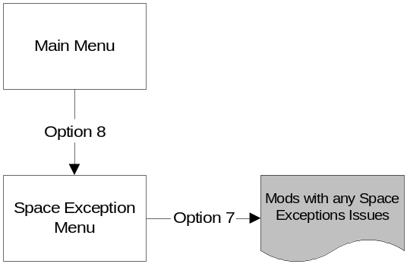

There is no change to the method of requesting this report.

Report Layout
Option 5 has been removed for all stores except those in the ROI and all Express Stores.
GRXE60 BRANCH REPLENISMENT SYSTEMS 04/04/06
PAGE 1
SPACE EXCEPTION REPORT FOR STORE - 2329 CHESHUNT 2
- 7. SUMMARY OF MODS WITH ANY OF THE SPACE EXCEPTION ISSUES

ACTION REQUIRED :
This is a summary of all issues - refer to the separate reports for instructions on how to resolve

AISLE/  SIDE  MOD  ------- | MOD  SEQ  NO  --- | EQUIP  TYPE  ----- | BASE  SHELF  WIDTH  ----- | BASE  SHELF  DEPTH  ----- | SPINE  HEIGHT  ------ | VALUE  OF  MOD  ----- | NO OF  SHELVES  INC.  BASE  ------- | RESV  IND  ---- | LATEST  PRODUCT  MAP DATE  -------- | NO OF  SHELVES  NOT  MAPPED  ------- | TOTAL  MAPPED  TPNBS  ------ | MERCHANDISING
 |  |  |  |  |  |  |  |  |  |  |  | GROUP  CODE  ----- | DESCRIPTION  ---------------------------------
03 R 02 |  | STD | 1250 | 800 | 1380 | 1.04 | 5 |  | 13 JAN 05 ? |  | 11 | P2A | AMBIENT ORGANIC
03 R 03 |  | STD | 1250 | 800 | 1380 | 1.04 | 5 |  | 14 OCT 04 |  | 4 | P5F | GROWING HERBS
03 R 04 |  | STD | 1250 | 800 | 1380 | 1.04 | 5 |  | 16 OCT 04 |  | 1 | P5F | GROWING HERBS
03 R 05 |  | STD | 1250 | 800 | 1380 | 1.04 | 2 |  | 08 NOV 04 ? |  | 2 | P5E | ONIONS & SQUASHES
03 R 06 |  | STD | 1250 | 800 | 1380 | 1.04 | 2 |  | NOT MAPPED |  | 1 | P5E | ONIONS & SQUASHES
03 R 07 |  | STD | 1250 | 800 | 1380 | 1.04 | 2 |  | NOT MAPPED |  | 1 | P5E | ONIONS & SQUASHES
03 R 08 |  | STD | 1250 | 800 | 1380 | 1.04 | 2 |  | NOT MAPPED |  | 1 | P5G | POTATOES
03 R 09 |  | STD | 1250 | 800 | 1380 | 1.04 | 3 |  | NOT MAPPED |  | 1 | P5G | POTATOES
03 R 10 |  | STD | 1250 | 800 | 1380 | 1.04 | 3 |  | NOT MAPPED |  | 1 | P5G | POTATOES
03 R 11 |  | STD | 610 | 800 | 1380 | 0.51 | 5 |  | NOT MAPPED |  | 1 | P5G | POTATOES
 |  |  |  |  |  |  |  | PAGE CHECKED BY …………………………………………………………………………………………………………………… DATE ……………………….
KEY : # = FUTURE DATED CHANGE, * = OVERSHELF DEPTHS ENTERED, ? = MIXED MAP DATES ENTERED

Field Descriptions
There is no change to any of the fields on this report

Report Description
The report lists all of the Mods in the store where there are one or more space exceptions. The Space, Range and Merchandising assistants use the report on the shop floor to check each of the Mods and resolve all the issues..

The report will no longer list mods where the merchandising group is authorised for the store unless it is an Express or in the Republic of Ireland.

System Processes

Target Space and local ranging policy lead-time
There are a number of processes that need to know the future target space and local ranging policy rather than the current values. The actual lead-time for this is held as the Planned Space to CBI parameter within the Space and Merchandising system.

These processes include: -
- Changing the merchandising group assigned to a fixture
- Product Mapping
- Cascading merchandise plans
- Updating authorisation on the Corporate Branch Information System

Make future changes to Target Space visible to the store
Once a Target Space change has been entered into the system there is normally a period of time when it won't be visible to the store so that any further changes to the target space can be made without any impact on the store. There will be a point when the changes to Target Space must be made visible to the store. The actual lead-time for this is controlled by a parameter and whether or not the Event has been approved.

Once the Target Space change is visible to the store it is essential that any further change to the Target Space be communicated to the store as soon as possible and certainly no later than the next morning. This change may just be a change to the Target Space but equally could be a change to the effective date, either directly or due to a change to the implementation date of the Event on the Space, Range and Merchandising schedule. It is possible that if the implementation date has changed that either the Target Space should be visible when it wasn't before or alternative it must no longer be visible to the store as the new implementation date is now beyond the end of the store visibility window.

Applying changes to Target Space
There are a number of system processes that need to assume, in advance of the implementation date, that the store will change the space allocated to a merchandising group according to the New Target Space. These processes include building a centrally planned range and the reporting of forthcoming range changes via the Retail Tools. If there is any change to either the Target Space or implementation date (either directly or due to a change to the implementation date for an event on the Space, Range and Merchandising schedule) then that change must be applied to these other process as well.

Product Mapping
The system must use the details downloaded by product mapping the fixtures to assign a merchandising group to a fixture. The existing process to do this doesn't need to change significantly however the fixture assignment must be re-examined whenever any of the following happens: -
- The store product maps any products on the fixture
- Any of the products on the fixture change merchandising group (main or supplementary)
- The links between main and supplementary merchandising group are changed
- The target space for any of the merchandising groups or supplementary merchandising groups that have a product on the fixture changes from or to 0.
- The Local ranging policy is changed for the merchandising group assigned to the fixture
- .
- There is a change to the number of days lead-time for applying changes to the Space target

If a product belongs to both a supplementary and a main merchandising group it will be assigned to the main merchandsising group unless the store has a space target greater than zero for the supplementary merchandising group

A fixture cannot be assigned to a merchandising group or a supplementary merchandising group if the store doesn't have a space target greater than zero unless the store is allowed to make a local choice regarding their range.

It must be noted that when checking the current space target the system needs to look forward a number of days and use whatever space targets will exist then. The actual number of days is a support maintained parameter (Planned Space to CBI) within the Space and Merchandising System (GR).

Range to Space processing
The Range to Space processing within the Space and Merchandising system assigns a Range class to the merchandising group in store based on the current space recorded if the merchandising group is 'Matched'. Currently it will assign a Range Class of 'A' to every merchandising group in store that is authorised but doesn't have any space recorded against it. This development will change this so that any 'Matched' merchandising group that doesn't have a space target will not be assigned a Range Class, whereas a ‘Matched’ merchandising group that has a space target but no recorded space will be assigned a Range Class of 'A'.

If the merchandising group isn't 'Matched' the Range Class will be set to the value entered with previous Target Space change unless the Target Space was for zero Mods in which case the system won't assign a range class.

Cascading Merchandise Plans
The system that cascades the merchandise plans to the stores must cascade a plan to every store that should stock the merchandising group after the Space, Range and Merchandising event. This means a store will receive a merchandise plan if either: -
- The merchandising group has a space target within the next few weeks (Planned Space to CBI parameter held within the Space and Merchandising system)
- Or the store has space recorded for the merchandising group and local ranging is allowed.

Commercial Range Support Tool (CRST)
The CRST system must only include stores that have a target space for the merchandising group in place on the event date in the historical sales performance figures and in the count of stores by cluster that will be stocking the merchandising group.

Pre-Ranging
The Pre-Ranging system is being enhanced as part of the same phase of the Range Control System as Planned Space and Authorisation so the full detail of the changes will be included within the Pre-ranging 2 BSD.

Prospace
Prospace should only include the sales from a store if the store will have a space target of at least 1 Mod on the day of the event.

Corporate Branch Information System
The authorisation indicator will no longer be visible within the Corporate Branch Information System for Extras, Superstores or Metros, unless the store is in the Republic of Ireland however the authorisation indicator will still be set. This will allow other system to continue to function without having to change at the same time as this change is implemented. The authorisation indicator will be set to 'Y' if one of the following applies: -
- The store has a space target greater then zero for the merchandising group
- The store is allowed a local choice for a supplementary merchandising group and none of the main merchandising groups have a space target greater than zero
- The store is allowed a local choice for the main merchandising group and any linked supplementary merchandising group has not already been set as authorised due to either of the above conditions

If none of the conditions apply the authorisation indicator for the merchandising group in the store should be set to 'N'.

This setting must be based on the value of the space target and local ranging policy that will be in effect in the next few days (based on the Planned Space to CBI parameter within the Space and Merchandising system

The existing process to pass the planned space change and planned range class to CBI in advance of the effective date will continue however it will now be the target space change and range class that is passed to CBI.

The Corporate Branch information system will continue to be the source of merchandising group in store information for the other mainframe systems. It is now valid for a merchandising group in store not to have a range class so any merchandising group in store that is authorised must be passed to the other system irrespective of the range class.

CR Automation and Retail Tools
The detailed BSD for CR Automation and the Retail tools will be produced by the Retail Range team however the first principle is that the Local Ranging Indicator, maintained within the Merchandising Group Maintenance setting is used to drive the merchandising group setting for: -
- The Mandatory Blocking Control in CR
- The Range matching tool
- The RAG parameters

The second principle is that a store's compliance to it space target cannot be monitored unless the space team have made the space target visible to the store via the Ranging Control System.

Data Warehouse
The Data Warehouse will contain all target space values that have been in effect for the past two years and all future target space settings. Any changes or deletions to target space will be made available to the Data Warehouse the day after they were entered into the Target Space application. When a Target Space change is amended or deleted the Data Warehouse will reflect the old value until the date of the change and then the amended figure from that date (i.e. historical data held in the Data Warehouse will not need to be changed).

There are currently existing tables on the Data Warehouse which hold a single planned space change and these will need to be enhanced to hold multiple changes to target space for each merchandising group in store.

The Data Warehouse will also hold details of past and future changes to the Local Ranging Policy.

CRS Merchandise Plan Coverage Report
The CRS Merchandise Plan Coverage report will only include stores where the centre has recommended that the merchandising group be stocked by the store. This is achieved by excluding any store that doesn't have a space target for the merchandising group from the calculation.

Hard-lines allocation (MM) system
The Hard-lines allocation system should be enhanced to refer to the local ranging policy and future space target rather than authorisation, however in the short term it may continue to use the authorisation indicator within the Corporate Branch Information system to drive the processing. . The authorisation indicator within the Corporate Branch Information system will be set based on any changes to target space or changes to the Local Ranging Policy (See Section above).

Range ODS
The Range ODS needs to know about all future target space due to a Space, Range and Merchandising event once the event has been approved and all other changes as soon as they have been entered. The Range ODS will use this information to build the future planned product range.

Stock Record System (SRS)
The Stock Record System will continue to use the Corporate Branch Information system to determine the area price code. It may need to be changed to ensure that it continues to function when no stores are authorised for a merchandising group but there is still stock in the business for any product that used to belong to a merchandising group that now isn't authorised in any store.

SOLUTION ISSUES & RISKS

Risks

Risk | Consequences | Likelihood | Impact | Next steps
Operational issues may impact document signoff by Day Job team, due to heavy commitment required to sign off phase B projects with Space and Retail projects | Risk that signoff process will not be completed in line with the milestones and development will be delayed | M | H | Issue plan for stakeholders to understand weekly commitment over the next three months to sign off phase B, plus Space and Retail projects
Aggressive timelines for delivery; no contingency in the project plan if required | Increased probability of process or system design error, or milestone slippage | H | H | Weekly review of milestone plan and project progress with team  Monthly progress review with stakeholders
Assumptions that there are no additional requirements to support the Republic of Ireland may not be valid | Additional requirements for Republic of Ireland have not been captured and may cause slippage to the milestones | M | M | Get stakeholder feedback on requirements from ROI point of view  Review Ranging Controls work with ROI team
The Project has implications for other systems and teams (e.g Data Warehouse), who may not have the resource to accommodate the changes required within the time frames needed | The project will not meet its current milestones | M | H | Communicate to the teams concerned.

Issues
Issue | Impact | Next steps
Additional To-Be processes not fully worked through with Programme and Day Job teams, to establish detailed systems requirements for System Design stage | M | Work through detailed requirements with Programme team when Process Document is issued, and feed back to Day Job team
Accurate equipment type data not available in Ranging Controls until Space Recommendations tool is delivered | L | Use ‘value of mods’ for changes to store space targets in interim, as at present
Changes to the design of the Supported Merchandise Plans and Ranges Matrix will be required as a result of the system design for this project | M | Review Supported Merchandise Plans and Ranges Matrix design then Planned Space and Authorisation design is signed off
There will be two different process to control whether a store can stock a particular merchandising group as the authorisation will still be maintained on CBI for certain stores | L | The training will need to cover this in enough detail for all members of the Space Team to be clear on the correct process to use.

Standards

Screen & Report Design
For the standards to be adopted for screen and report design see the design documents provided separately.

Error Handling

Error Codes

Common system message
Msg. No. | Message | Trigger
1 | Data entered must be alphabetic | Numerics detected in alpha field
2 | Data entered must be numeric | Alpha characters detected in numeric field
3 | Please enter data into highlighted fields | Incomplete data
4 | Invalid date format | Date validation failed
5 | Invalid date. Date must be greater than today | Failed date validation – date too old
6 | Invalid date. Too far in the future | Date validation failed – date too far in future
7 | Code already exists | Dept code validation failed
8 | Description already exists | Description validation failed
9 | Description is too long | User attempts to enter data after the end of the field is reached
10 | The description entered is the same as an existing one. Do you wish to proceed? | Duplicate description found
11 | Choosing another task at this point will lose all changes made. Do you wish to proceed? | Another option selected from the menu bar prior to pressing the “proceed” button
12 | Cancelling at this point will lose all changes made. Do you wish to proceed? | Cancel button selected
13 | If you logoff at this point will lose all changes made. Do you wish to proceed? | The logoff button is selected prior to pressing the “proceed” button
14 | Are you sure? | To confirm that selected action is correct
15 | No details found | No details found that match the search criteria
16 | Invalid Tesco year/week number | The Tesco week number is not valid
17 | File not found | The selected file doesn't exist
18 | Invalid field xxxxxxxxx | The field contains invalid data
30 | Transaction successful | All data successfully validated and processed

Target Space Component Specific Messages
The Target Space Component specific messages can be split into three different types of message: -
E | - | Error Messages
I | - | Informational Messages
R | - | Report Messages

Each of the different types of error message is reported slightly differently and provides the user with different options. These are described in section 8.2.2 Message Handling.
Msg. No. | Message | Type | Used on Screen | Ref. Section | Trigger
211 | Event Id not on the schedule | R  E  E  E  E  E  E | Confirm Upload File  Add a single change too Target Space  Find an existing Target Space Change  Validation Against Business Rules - Selection Screen  Validation against Business Rules - Summary Screen  Space Conflict Parameters  Space Conflicts List | 4.1.4  4.1.7  4.1.8  4.1.10  4.1.11  4.1.13  4.1.14
212 | Field xxxxx must be blank | R  E | Confirm Upload File  Add a single change too Target Space | 4.1.4  4.1.7
213 | Warning - Date within minimum lead time | R  E  E  E  E | Confirm Upload File  Add a single change too Target Space  Find an existing Target Space Change  Validation against Business Rules - List Screen  Space Conflicts List | 4.1.4  4.1.7  4.1.8  4.1.12  4.1.14
214 | Invalid Store number | R  E  E  E | Confirm Upload File  Add a single change too Target Space  Space Conflict Parameters  Space Conflicts List | 4.1.4  4.1.7  4.1.13  4.1.14
215 | Invalid merchandising group | R  E | Confirm Upload File  Add a single change too Target Space | 4.1.4  4.1.7
216 | Target Space change already exists | R | Confirm Upload File | 4.1.4
217 | Invalid Range Class | R  E  E  E  E | Confirm Upload File  Add a single change too Target Space  Find an existing Target Space Change  Validation against Business Rules - List Screen  Space Conflicts List | 4.1.4  4.1.7  4.1.8  4.1.12  4.1.14
218 | Store isn't include in store cluster associated with this event and merchandising group | R  E  E | Confirm Upload File  Add a single change too Target Space  Find an existing Target Space Change | 4.1.4  4.1.7  4.1.8
219 | Please enter either the 'value of mods' or the 'equipment type' and 'number of mods' | R  E  E  E  E | Confirm Upload File  Add a single change too Target Space  Find an existing Target Space Change  Validation against Business Rules - List Screen  Space Conflicts List | 4.1.4  4.1.7  4.1.8  4.1.12  4.1.14
220 | Both the equipment type and number of mods must be entered | R  E  E  E  E | Confirm Upload File  Add a single change too Target Space  Find an existing Target Space Change  Validation against Business Rules - List Screen  Space Conflicts List | 4.1.4  4.1.7  4.1.8  4.1.12  4.1.14
221 | More than one store entered | R | Confirm Upload File | 4.1.4
222 | More than one event entered | R | Confirm Upload File | 4.1.4
223 | Invalid equipment type | R  E  E  E | Confirm Upload File  Find an existing Target Space Change  Validation against Business Rules - List Screen  Space Conflicts List | 4.1.4  4.1.8  4.1.12  4.1.14
224 | No changes made | I  I  I | Find an existing Target Space Change  Validation against Business Rules - List Screen  Space Conflicts List | 4.1.8  4.1.12  4.1.14
225 | No rows selected | I  I  I | Find an existing Target Space Change  Validation against Business Rules - List Screen  Space Conflicts List | 4.1.8  4.1.12  4.1.14
226 | Target Space changes have already been updated. Please check your changes and re-apply | E | Amendment confirmation Screen | 4.1.9
227 | Date Range more than n weeks | E  E | Space Conflict Parameters  Space Conflicts List | 4.1.13  4.1.14

Ranging Controls - Target Space Parameter Specific Messages
The Target Space parameters within the Ranging Controls system may generate a number of messages that are specific to maintaining those parameters. All of these messages are E - Error Messages and should be handled as described in section 8.2.2 Message Handling.

Msg. No. | Message | Type | Used on Screen | Ref. Section | Trigger
111 | Event Id not on the schedule | E | Setting Store Visibility of Target Space | 4.2.2
112 | Invalid Store number | E | Setting Store Visibility of Target Space | 4.2.2
113 | Invalid merchandising group | E | Setting Store Visibility of Target Space | 4.2.2
114 | Minimum lead-time must be less than maximum lead-time | E | Target Space Parameters | 4.2.3
115 | Must be either 'Y' or 'N' | E | Target Space Parameters | 4.2.3
116 | This 'Type of Space change' is currently used by the Target Space application | E | Target Space Parameters | 4.2.3

Message Handling
Each of the schedule application error messages is handled as follows: -

Message Type | Reported by | Actions
Error | Alert Box with OK option | Acknowledge error and correct before proceeding
Information | Alert Box with OK option | Acknowledge warning and act on it later
Report | Message on a report | Spreadsheet row won't be loaded to the SCHEDULE

Login & Security
For the standards pertaining to the login procedure and security see the "flight-deck" BSD provided separately.

NON-FUNCTIONAL REQUIREMENTS
A comprehensive list of the Non-functional requirements can be found in the separate document that describes each of the Non-functional requirements that need to be met across all of the Infrastructure projects.

Appendix A
Abbreviations

Abbr. | Meaning | Description
GT&A | Global Technical & Architecture Team | Advise on technical architecture and tools
BSD | Business System Design document | Document describing the business information and processes in the old and required for the new system
UKBE | United Kingdom Business Expansion | Department that manages new stores, store extensions and re-fits
SRM | Space, Range and Merchandising | Department responsible Space, Range Class and Merchandising of the stores
NWT | Natural Work Team | Group drawn from different departments, all of whom have an interest in the Event. In this case it will usually be drawn from Merchandising, Commercial and the Space Team
RSM | Range, Space and Merchandising | Alias for SRM
Cat Review | New Merchandise Plan | A review during which MGPs and the Space allocated to MGPs, within stores, may be changed
GR | Space and Merchandising System | The system used in store to manage space
CBI | Corporate Branch Information System | The system used to record branch details

Appendix B
Definition of Terms

Term | Description
Ranging Controls | The application which encompasses all maintenance of the Space, Range and Merchandising Infrastructure
Planned Space Change | Centrally planned change of a store’s space, to take place some time in the future; usually this change is associated with an Event on the Merchandising Schedule
Cluster | A group of stores, grouped for ranging purposes
Store Range Group | Alias for Cluster
Range Class | A letter (A – Z) indicating the size of a Merchandising Group in a store and the Range Plan to be associated with it
Space, Range and Merchandising schedule | A diary of Merchandising Events and their associated attributes (Event Types, MGPs, Clusters)
Space Team | Department responsible for current and future space in stores
Reserved Merchandising Group | A merchandising group used just to identify space in store, normally for promotional products. If a reserved merchandising group is assigned to a fixture then the assignment won't change as a result of product mapping.

